Social Science Research and Instructional Council (SSRIC)
SSRIC is soliciting proposals from CSU faculty to place survey questions on an upcoming CALSPEAKS California public opinion survey. Each fellow will have up to three survey minutes (approximately 8 to 14 questions) on a 2022 CALSPEAKS survey. CALSPEAKS uses random probability sampling techniques to survey a representative sample of Californians. SSRIC welcomes applications from any social science discipline, and topics may include: (1) electoral politics at the national, state and local level; (2) public policy issues pertaining to the economy, education, health care, the environment, immigration, transportation, crime, gun control, abortion, gay rights, taxes, and others; (3) media, racial and social inequality, political institutions, marriage and family, public health, and others.
Each faculty fellow will work with CALSPEAKS staff and the Institute for Social Research (ISR) at Sacramento State, to review survey questions for clarity and readability. The fellowship includes: a) translation of fellow’s questions into Spanish; b) programming of survey questions into Qualtrics; c) fielding of data to the CALSPEAKS panel; d) response weighting of the survey; e) data set with fellows’ survey questions and panel demographic questions; f) code book and weighting report. Research topics selected should be of interest to policy makers of California, be relevant for responses of a cross-section or panel of Californian adults, and be appropriate for the interviewing method used by CALSPEAKS (namely, an online survey). After an embargo period of 16 months, fellow survey questions/data are archived here: https://calspeaks-dspace.calstate.edu/password-login (at present, for most CSU campuses you must be on campus to access this site).
Proposals should include a description of the type of project proposed with the fellowship, a brief review of the relevant literature including a bibliography, the specific questions proposed to be administered with CALSPEAKS, and your plans for the analysis of the data. Please do not include identifying information in your proposal, but DO include contact information for all coauthors in the body of your email. Proposals should be submitted electronically as pdf attachment.
PROPOSALS DUE February 28, 2022
Submit to: Michael Latner, CALSPEAKS Task Force Chair | mlatner@calpoly.edu

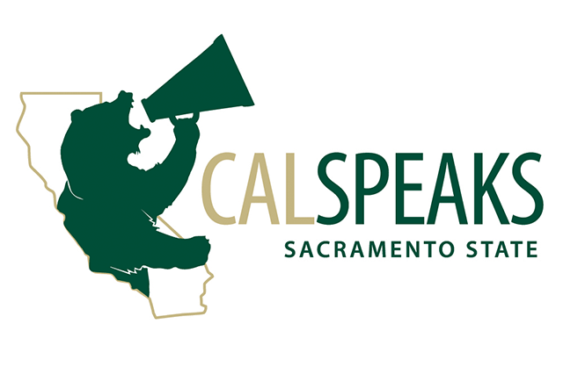
CALSPEAKS technical details (sampling, weighting, etc.)
https://www.csus.edu/center/institute-social-research/survey-research.html.

For questions about the CALSPEAKS Panel contact Kim Nalder | klnalder@csus.edu

