Exercise 1 – Exploring the Census Web Site

The purpose of this exercise is to get a sense of where different resources can be located on the Bureau of the Census web site.

1. Log on to the Census web page at: www.census.gov

2. In the right column locate the Find an Area Profile with Quickfacts option. Under Select a State select California.
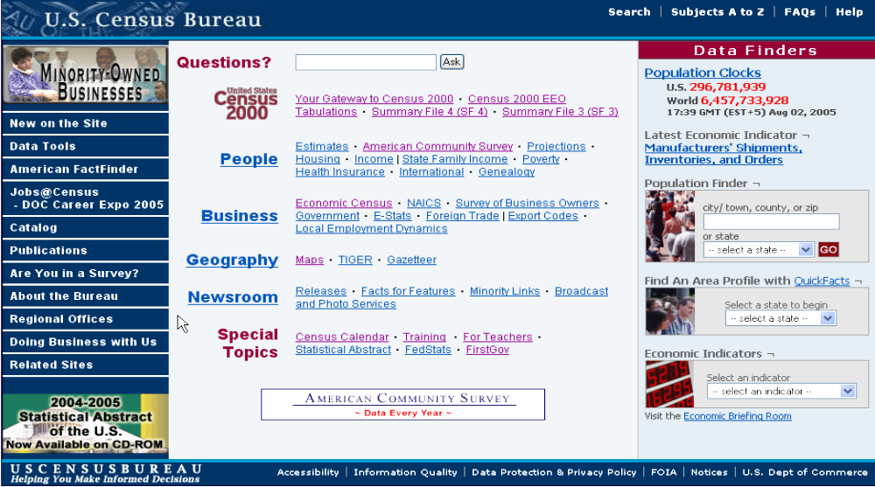
QuickFacts and QuickLinks

1. Now under the California Counties window (see above) select Los Angeles County from the list and select the Go button.
2. Compare some of the percents between the State and the County. It is often helpful to compare a place of interest to a larger total such as the state or the entire nation to get a sense of how your area varies from a reference value.

How does Los Angeles County compare in Percent Foreign-born, Homeownership, and Median Household Income to the State?

3. At the top of the page to the right of the California counties window, click on the selection map link to see the location of Los Angeles County within the State. When done, click the Back button on the Browser.
4. Select one of the More California data sets buttons at the top right of the page.
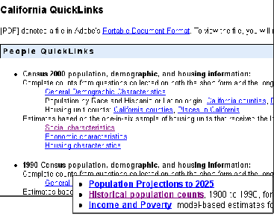
5. When the California QuickLinks page of other files appears, select from near the bottom, the Historical population counts link.

Look over this text file data set, then close it and browse over the Quicklinks web page to see what other data is available.

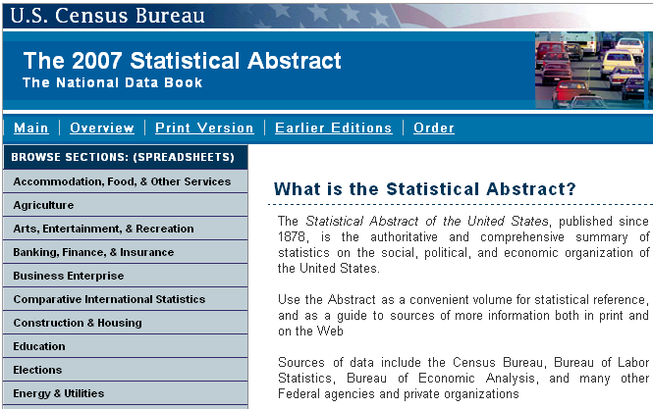
6. Finally, at the bottom of the California QuickLinks page under Other QuickLinks select the Statistical Abstract of the United States link. This document contains pdf files of the annual data compiled for the Abstract. Note on the left side panel below are links to various parts of the Abstract.

When done, use the Browser’s Back button to return to Home page and then click the American Factfinder page link from the left panel.
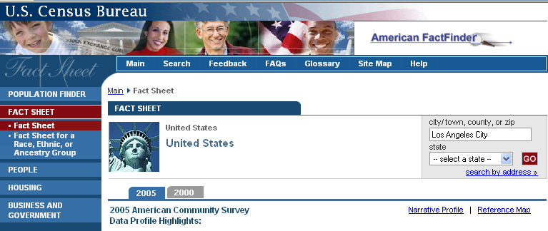
7. From the list of menu items on the left select the Fact Sheet button. The window below with statistics for the entire U.S. will open. Note that by default the latest American Community Survey data will appear in the table.

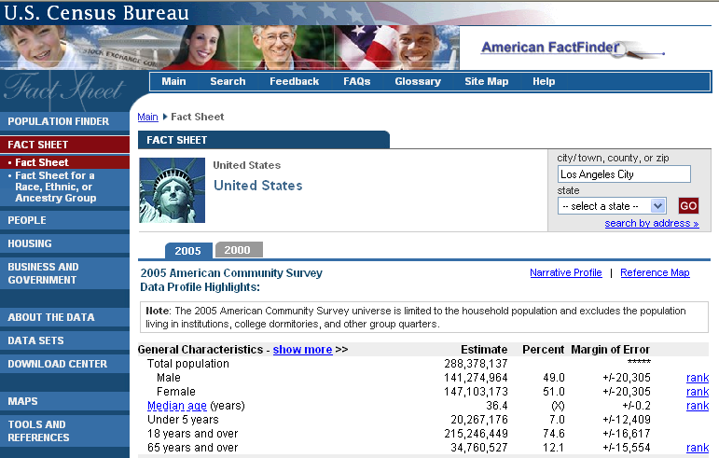
8. In the window below notice the Margin of Error for the ACS data. That means that 90% of the time the estimated value will fall within the Estimate plus or minus the Margin of Error value.
9. On the right side of the Fact Sheet page enter Los Angeles City in the city/town window. Then click Go. The U.S. fact sheet will be replaced by one for the City of Los Angeles in California.
10. On the right side of the data values select the Reference Map link.

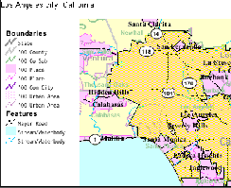
Look over the map of LA and then click the Close button.

11. Use the Back button to return to the Fact Sheet page.

12. Enter your ZIP code in the upper right box and click GO.

Because there is no ACS data for ZIP codes the data will change to Census 2000.

13. Locate the Median age item from the list and click on the map link on the right. A map of median age by census tract will appear.

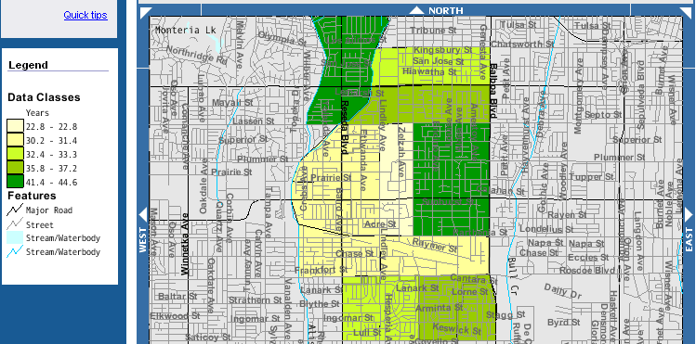

When done with the map, click the Back button on the Browser.

14. Now click on the Brief link to the right of Median age. A pdf file will open that contains an analysis of the variable for the United States. Read over some of the file and then close it.


15. Click on the small Home link at the bottom of the page to return to the main Census page.

16. From the left panel of the main window select the New on Site link.

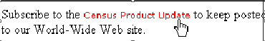
17. When the list of new items appears, scroll to the bottom and select the Subscribe to the Census Product Update link. From here you can put your email on a list server to receive notices of new census products.

If you want to be on either the press release list or the new product list follow the instructions to submit your email. Then use the Back button to return to the main census page.

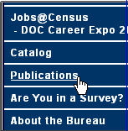
Publications

1. From the left panel of links select the Publications link. A list of subjects will appear from which you should select the Population link.

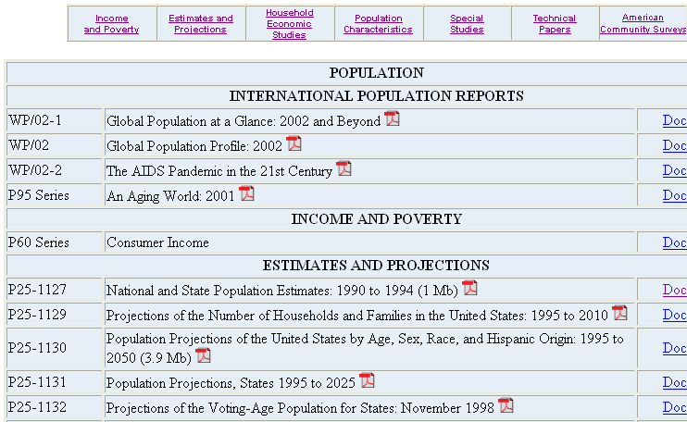
2. Scroll down the list of population topics and select any pdf file of interest to you. Check it out and then return to the main page.

Gateway to Census 2000 Link

1. From the main page click on the Your Gateway to Census 2000 link.
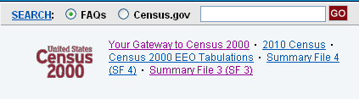
The Gateway contains many useful links including those to the summary files.

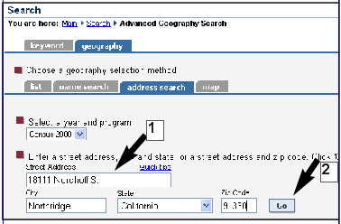
2. For now, select the Enter a Street Address link.

3. When the window below opens, enter the address of this campus (1) and select Go. (2)

4. In the next window select Census tract 1152.02 and click Go.

You will get a lengthy list of resources for the tract.

5. Select a few links shown below.
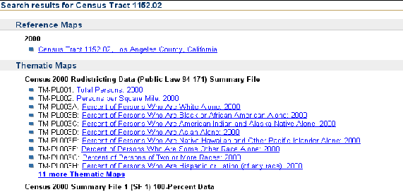
Below is a map of the tract that shows streets, tract IDs, and block numbers.
6. Return to the Gateway page and locate the Geographic Products and Information link from the center left column.

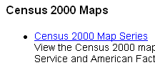
7. From the Map Products and Information page select the Census 2000 Map Series link.

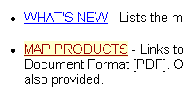
8. A list of products will appear from which you should select the Map Products link.

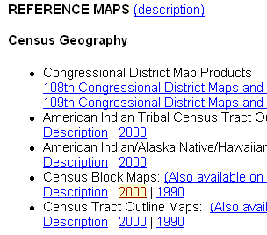
9. From the list of map products scroll down to the Reference Maps set and select the Census Block Maps: 2000 link.

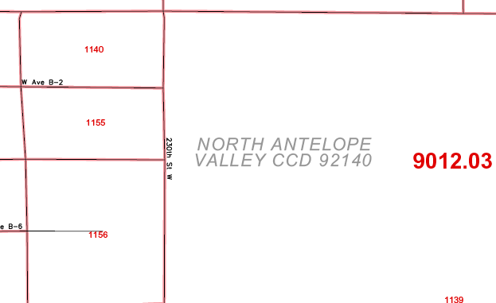
10. Select the State directory and then work your way down from to County to Los Angeles and select the following link:

A color map 33 x 36” in size in pdf format will open. If you need a paper copy of a map of census geography you can obtain one if you have a large-format printer.

11. Use the Back button to return to the Census Bureau Map Products page.

Map Products

The Bureau of the Census provides a number of other map products in both static and interactive form. The former often are suitable for printing on a color plotter.

1. Scroll down to the Map Gallery link at the bottom of the page.

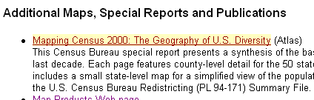
2. On the Map Gallery page scroll down and select the Mapping Census 2000: The Geography of U. S. Diversity link.

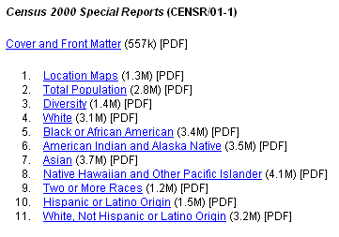
From the list of maps shown right examine a few of the maps in pdf format.

3. Return to the main Census Bureau web page and from the left panel select the American Facfinder link.

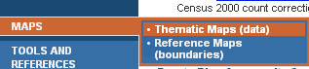
4. From the left panel of the American Facfinder page select the Maps – Thematic Maps link.
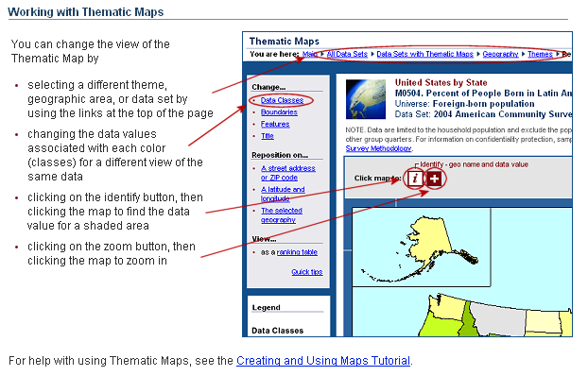
Review the explanation and try a few maps.

Under Change.. you can pick a different classing method, display different boundaries or features, and set a title. Under Reposition you may change the center point of the map. You may also click on a state to view the numbers associated with it. At the top of the map under the Display map by: window you may change the geographical units to counties or other areas. Also at the top of the map are a series of bars that will enable you to zoom in or out of the display by clicking on them.

5. Experiment with a few of these map features.

6. When satisfied with the operation of the interactive map, select the link at the top of the map frame named Data Sets with Thematic Maps.

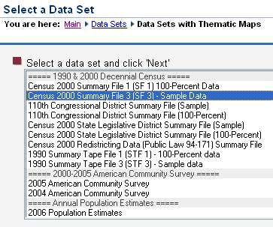
A window with a list of mappable data sets will open. The default file is ACS data from for the previous year.

7. Select the second item, SF3, and click the Next button.

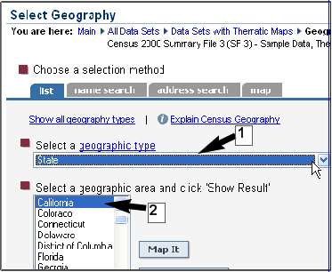
8. From the Select Geography window click on the arrow to the right of Nation (1) and scroll down to the State item in the popdown menu. Under Geographic Area select California. (2) Then click the Next button.

9. From the Select Theme window pick a variable of interest. Then click the Show Result button.

A map will appear (below is Percent Foreign-born). Note you may change the geographic detail from the Display map by window above the map. Adjust your map as desired and when done you may print it or save a copy in pdf format.

10. Under the Print/Download menu at the top of the page select the Download item.

11. From the Download window select the option Download the map and legend in pdf format. Then click OK.

12. When done, return to the main Census web page.

This concludes the introduction to the Bureau of the Census web site. Now would be a good time to review some of these materials, but choose your location or one of interest to you when you explore the resources.

In the next exercise you will learn how to download raw data.

