Exploring the U.S. Census

Eugene Turner
Department of Geography
California State University, Northridge
Northridge, CA 91330

(818) 677-3527
eturner@csun.edu

Exploring the U.S. Census

Table of Contents

Introduction
Organization
Data Sets

Chapter 1. Accessing the Digital Census

A. About the Census

B. Digital Census Data
Summary Files
Table Details
The American Community Survey

C. Public-Use Microdata Sample Files

D. Geography in Summary Files
SF3 Summary Level Code Hierarchy for Selected Geographic Units
Other SF3 Summary Level Codes
Codng Geographic Units - FIPS Codes

E. Census Comments
The Race Question
Hispanic Subgroups
Small-area Tabulations
Census Geography

F. Exploring the Census Web Site

Chapter 2. Place Description, Ranking, and Mapping

A. Some Basic Population Data Describing a City

B. Examining a Characteristic in All Cities - Ranking Places
Densely Populated Places
Ethnic Composition

C. Describing a Distribution with Statistics

D. Graphing a Distribution

E. Mapping a Distribution
Census Geography
Mapping Counts and Percents
Choropleth Maps
Graduated Symbol Maps
Dot Maps
Mapping with ArcGIS
Chapter 3. Analyzing Other Population Characteristics

A. The Sex Ratio

B. The Location Quotient

C. The Entropy Index

Chapter 4. Association between Two or More Variables

A. Cross Tabulations

B. Scattergrams

C. Correlation

D. Regression

Chapter 5. Describing the Age of Populations

A. Median Age

B. Dependency Ratios

C. Population Pyramids

Chapter 6. Population Growth

A. Describing Population Change

B. The Effect of Migration and Residential Mobility on Population Change

The Demographic Equation
Births and Deaths
Migration and Local Residential Mobility

C. The Challenge of Analyzing Change

Chapter 7. The Public-use Microdata Sample (PUMS)

A. Income Distribution Differences Among Ethnic Groups

B. Occupational Differences Among Ethnic Groups

Chapter 8. Describing the Relative Location of Populations

A. Service Areas

B. Centers of Population

The Mean Center
Population Potential

Appendices

A. State and County FIPS Codes
B. Summary File Segmentation
C. Summary Level Sequence Chart
D. Race Codes
E. Hispanic Codes
F. Ancestry Codes
G. State and Foreign Country Codes
H. Occupation Codes
I. Industry Codes
J. SF3 Table Description

Exercises

Ex 1. Exploring the Census Web Site
Ex 2. Accessing Census 2000 SF3 and SF4 Data and Data Bases at ICPSR
Ex 3. Introduction to Excel
Ex 4. Analyzing Census Data in Excel
Ex 5. Sex Ratio
Ex 6. Location Quotient
Ex 7. Diversity Index
Ex 8. Association between Variables
Ex 9. Dependency Ratio
Ex 10. Population Pyramid
Ex 11. Population Growth
Ex 12. Population Demographic Equation
Ex 13. Accessing Census 2000 PUMS Data
Ex 14. Analyzing Census 2000 PUMS Data
Ex 15. Mapping Census 2000 Data
Ex 16. Examining the Demographics of a Service Area
Ex 17. Downloading Raw Census Data

Tables

Chapter 2
Table 1. Ethnic Populations in Glendale, Los Angeles, and California, 2000
Table 2. Ranking of States Based on Census Variable Counts

Chapter 3
Table 3. Sex Ratios, 2000
Table 4. Sex Ratios by Age in California, 2000
Table 5. Location Quotient by Occupation and Class of Worker
Los Angeles County, 1990
Table 6. Diversity Scores

Chapter 4

Chapter 5
Table 7. Dependency Ratios, 2000

Chapter 6

Table 8. Greatest Mexican Population Changes in California Counties, 1980 – 1990 - 2000
Table 9. Population Change in California, 1990 – 2000
Table 10. Citizenship in California, 2000
Table 11. Country of Birth in California, 2000
Table 12. Residence in 1995 for California Residents in 2000

Chapter 7
Table 13. Income Distribution within Ethnic Groups
Table 14. Ethnic Employment for Males and Females in PUMA 5200

Chapter 8
Table 15. Distances from Tract 3019.00
Table 16. Mean Center of Glendale Tracts, 1980 and 1990
Table 17. Accessibility Index to Two Glendale Tracts

Exploring the U.S. Census

Introduction

The United States Bureau of the Census collects and publishes a wide range of statistics about the population, housing, economy, productivity, and government in the United States. Data on these subjects are periodically tabulated and released to give a better understanding of American society.

Among the most sought-after data are the statistics on housing and population collected every decade. Demographers, planners, businessmen, and social scientists use this information to track differences between locations and over time. Government agencies use the information to help them decide what needs to address and to allocate funding to various social programs.

This module explores the tabulations of the Census of Population and Housing and some of the basic techniques used to describe and analyze the data contained within it. These techniques form the basis of more sophisticated techniques used by a great many researchers in universities, in businesses, and in government. However, advanced procedures are beyond the introductory scope of this module, and students should consult other sources in texts and journal articles for information on sampling and statistical analysis.

Organization

The following chapter describes some of the resources that are easily accessible via the web site maintained by the Bureau of the Census. Most of these resources cover the censuses of 1990 and 2000, but data from earlier censuses are increasingly being converted to digital form and many of these can be accessed at the web site of the Interuniversity Consortium for Political and Social Research (ICPSR). See www.icpsr.com In Chapter 2 of this module various methods are presented for describing populations through counts, percentages, density, and mapping. Chapter 3 presents methods for looking at gender and ethnic components of the population, and Chapter 4 explores the age components. Chapter 5 illustrates ways of looking at change in the population between two censuses. Through data provided from the California Department of Finance, population estimates and migration statistics are provided between 1990 and 1997 for California counties. Chapter 6 presents a few simple ways of measuring the spatial components of the population. Chapter 7 investigates some of the ways that the PUMS database can be used to create special tabulations to control for factors such as gender, education, and income when trying to understand differences between groups. Finally, Chapter 8 introduces a few of the ways that spatial analysis might be done with census data. The methods introduced could be carried out with Excel. However, this opens a broad range of techniques now available with GIS software and suitable for separate modules.

Several important appendices have been attached which provide additional information on the content and structure of the digital census files. The codes for the selected variables will be especially useful after data have been downloaded for processing.

Seventeen exercises cover a variety of census related issues from locating and downloading data, to tabulating and analyzing tables, to creating charts and maps of the information. These exercises are intended to provide the user the opportunity to access digital information to answer basic kinds of demographic questions. Certainly not every demographic topic has been covered in this module and many could be added. For example, analysis of segregation, poverty, assimilation, and crowding to name but a few. Fortunately there are other modules that deal with some of these issues.

Over the last decade the U.S. Census has become easily accessible over the Internet. With the assistance of interactive software, not only technical documents, but data tables, graphs, and maps can be customized and downloaded. Data extracts can be downloaded in Excel or delimited formats and entire summary files can be accessed in raw form through Access and SAS software. For statistical analysis either SAS or SPSS may be used. One now has the ability to move the data files through various software packages as needs dictate.

For many of these exercises Excel will be used, and so the user should become familiar with it. For those not familiar with it, a basic introduction is included along with a few methods particular to handling census information.

Exercise 1 provides an overview of the resources available on the Census web site. Since this site seems to be constantly evolving, don’t be surprised if things in the exercise don’t exactly match the web pages in the future. As of May 2007, the exercise and the web pages are in agreement.

Exercise 2 demonstrates how to download data using the American Factfinder search engine. Essentially one selects a summary file and a level of geography and then a table is created. This can be downloaded in Excel format with rows and columns transposed from what is initially displayed. Remember that Excel only allows 255 columns and the number of geographic units typically exceeds that. Thus, the transposition is necessary.

Exercise 3 is an introduction to Excel and some of the capabilities that might be useful with census data. Experienced users may want to skip it.

Exercise 4 deals with analyzing data using Excel. Often simple descriptions and ranking of values are all that is needed. The creation of a bar graph and a frequency graph are introduced.

Exercise 5 demonstrates how to compute the Sex Ratio in Excel.

Exercise 6 introduces the calculation of the Location Quotient which is helpful in determining if a location has a more or less than expected share of a characteristic.

Exercise 7 demonstrates how to calculate a measure of diversity using the Entropy Index. It indicates how evenly numbered several groups are within an area.

Exercise 8 illustrates how a scattergram can be helpful for examining the association of two variables.

Exercise 9 focuses on calculating several forms of the Dependency Ratio. The ratio gives a sense of the relative population support a dependent group has in a location compared to the support in another location.

Exercise 10 shows how Excel can be used to prepare a population pyramid. This graphic device is very helpful in understanding the age and sex structure of a population.

Exercise 11 illustrates three methods for expressing the change in population over time. Each can result in a very different set of places having the most change.

Exercise 12 introduces the Demographic Equation. It is a useful tool in estimating the change in population in the years between the censuses. Resources at the California Department of Finance are explored.

Exercise 13 introduces the Public Use Microdata Sample data set and the IPUMS web site at the University of Minnesota for accessing this information. This web site provides PUMS data for a number of census decades as well as data for other countries.

Exercise 14 uses SPSS to aggregate PUMS data into useful tables for analysis. In this example tables of occupations for Asian Indian men and women are created to determine what occupational niches may exist. In a followup exercise income differences between Asian Indian men and women are explored.

Exercise 15 shows how to use ArcMap to create a map of census data.

Exercise 16 illustrates how to use ArcMap to select data that surround a site of interest. The characteristics of such a service area are important for marketing studies.

Exercise 17 demonstrates how to download raw census data and import it into Access for further extraction.

Data Sets

Only six databases have been extracted and included with this module. Because it is so easy to download census data from that web site, users may wish to obtain data that represents their own area of interest. The accompanying databases are:

1. Califcities.xls Selected race and housing variables from SF3 for all 1074 California cities.
2. CalifcitiesAgeSex.xls Sex by age from SF3 for all 1074 California cities.
3. Ex3_Excel.xls Selected ethnic variables for ten California counties
4. UScoPop80-00.xls Total and Hispanic populations for 1980, 1990, and 2000 for 3140 counties

The following files are located in the Mapping folder.
1. CAcensusex.dbf Data file to be joined to the California county boundary file
2. CAcensusVarIDs.xls More detailed labels of variable names in CAcensusex.dbf
3. CAco California county outlines
4. SFVtractPT Tract centroid file with associated data
5. SFVtracts Tract boundary file in the San Fernando Valley within Los Angeles
6. NewSites Three sites within the San Fernando Valley

Other Resources

CensusScope A data extraction program supported by the
Social Science Data Analysis Network (SSDAN)
http://www.censusscope.org/

Kids Count in the Classroom Project
A variety of tools, data sets, and modules for demographic analysis.
http://www.ssdan.net/kidscount/index.shtml

DataCounts! Exploring Society by the Numbers
Yet another SSDAN project with special data analysis software and
useful extractions from various censuses. A large number of modules
are available.
http://www.ssdan.net/datacounts/

See also two publications:
America By The Numbers: A Field Guide To The U.S. Population by William H. Frey, Bill Abresch, and Jonathan Yeasting

Investigating Change in American Society: Exploring Social Trends
with U.S. Census Data by William H. Frey

The Population Reference Bureau
Basic population information for the U.S. and the world.
http://www.prb.org/

The United Nations Population Information Network
A variety of reports, data sets, and other resources on
world population issues.
http://www.un.org/popin/data.html

Geolytics A company that sells repackaged census data for business.
A source for pre 1990 census information in common geographic units..
http://www.geolytics.com/

TGR2SHP and TGR2MIF
Free software written by Bruce Ralston that converts TIGER
files to boundary files.
http://tnatlas.geog.utk.edu/downloadfree.htm

Proximity A source for demographics, census mapping files, and various
resources. Some are free.
http://proximityone.com/maps2000.htm

UC San Diego Social Science Data Collection
Links to many census and demographic sources.
http://ssdc.ucsd.edu/ssdc/cen2k.html

Chapter 1

Accessing the Digital Census

A. About the Census

Over the decades the actual census questionnaire has undergone considerable modification. Changes have been made to its content, phrasing of questions, geographical units, and collection procedures. Though the censuses of 1980 and 1990 were very similar in the questions, the geographical units, and the tabulation of results, Census 2000 made a radical departure in the race category. See the discussion later in this section.

The last three censuses made extensive use of sampling that resulted in two questionnaires. On one, a basic short list of questions about gender, age, marital status, and housing was asked of everyone. The tabulated results are sometimes referred to as the 100 percent count or complete count data. On the other, additional details were asked of only about a one in six sample of households. Tabulations are often referred to as the sample count or sample data.

B. Digital Census Data

The Bureau of the Census reports the population and housing census information in two major digital formats. The first is now called a Summary File and it contains population aggregations for selected variables. In 1990 the term was Summary Tape File. The second is the Public-Use Microdata Sample (PUMS). This contains separate records for each household and individual. This file is very useful because it enables researchers to measure interrelationships between variables by person or housing unit rather than by geographical area. The researcher also has the ability to create custom tabulations.

In addition to population and housing, the Bureau of the Census provides a number of other tabulations such as government, business, foreign trade, manufacturing, and agriculture (moved to Dept. of Agriculture in 1996). There are also some historical population counts and special tabulations such as the county-to-county migration file. While important, these are beyond the scope of this module. Readers can browse the Subjects Index to look for numerous reports, studies, and data sets. ( http://www.census.gov/acsd/www/subjects.html )

1. Summary Files

The SF files are tabulations and cross-tabulations that correspond to much of the census information in published volumes. Data include items such as counts of persons and households, persons by race by sex by age, housing type by tenure, and so on. Summary Files come as four major types: 1, 2, 3, and 4. In addition, there is the Redistricting Data PL 94-171 Summary File which is the first release of census information after a census. It includes only basic race tabulations for persons over and under age 18.

SF1 and SF2 contain information from the complete-count questionnaire on gender, ethnicity, marital status, and a few housing variables. SF3 and SF4 contain information from the sample-count questionnaires on education, occupation, income, migration, etc. Because the sample-count contains more questions, these files are much larger than SF1 or SF2

Summary Files 2 and 4 have tables repeated for up to 250 or 1000 ethnic groups respectively. The only condition for suppression is that there must be at least 50 ethnic persons sampled in a geographic unit for the data to appear. Thus, in SF2 and SF4 there are numerous missing locations for small groups within smaller geographic units. Both may be very useful when census tabulations are desired for a specific ethnic group such as Japanese, Cubans, Germans, or Cherokee Indians.

In the figure shows the number of tables provided in each of the four summary file types. A P variable is a population tabulation and an H variable is a housing tabulation. If a variable is preceded by a PCT or HCT then it will not be reported for units finer than census tracts. Some tabulations are broken out by individual ethnic groups and these special tabulations have a suffix of A through I appended to the variable name. See below for a list.

Table Type and Number | SF1 | SF2 | SF3 | SF4
P | 171 |  | 160
H | 56 |  | 121
PCT | 59 | 36 | 76 | 213
HCT |  | 11 | 48 | 110
Race Crosstabs | 14 |  | 51
Race Categories |  | 250 |  | 1000

Ethnic Group Suffixes for Tables

A - White alone
B - Black alone
C - American Indian or Alaska Native alone
D - Asian alone
E - Hawaiian or Pacific Islander alone
F - Some other race alone
G - Two or more race alone
H - Hispanic
I - Non-Hispanic White alone.

2. Table Details

Before going too much further, it would be helpful to see something of the structure of a typical table. While it is easy to extract such data from the Census web site, you should be familiar with table structure in order to better use the resulting output or to understand how to extract data from raw census files should that ever become necessary.

Below is part of Table P6 on race from Summary File 3. Several important pieces of information are included in the label. The P6 indicates it is the sixth tabulation of population, the table title is Race, the [8] indicates there are eight items in the table, and the Universe indicates that the counts are based on the entire population. Many tables use subsets of the total population for the Universe. This table was generated for state totals at my request and the web page only displays the first ten states. I would have to click the Next button to see the next ten states.

This table was created for viewing on the screen. Data tables for downloading contain similar information, but the user must keep track of the labels and Universe population.
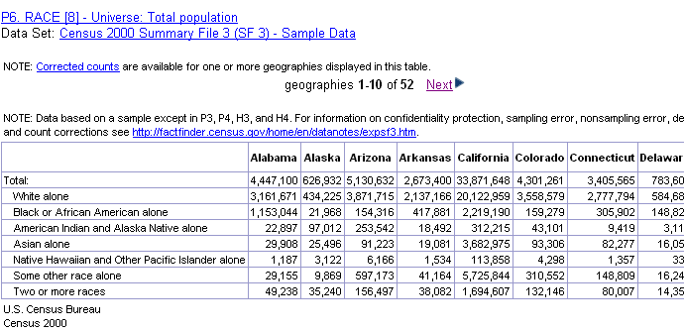

Below is a spreadsheet of data for two downloaded tables in Excel format from Summary File 3. The variables this time are reported for three different selected geographic units, the United States, California, and Los Angeles County. Note that each geographic unit has a SUMLEVEL code that identifies the type of geographic unit. Each also has a unique FIPS code (GEOID2) and a name that identifies the specific place. The GEOID2 code is critical if you plan on linking this data to geographic units in a mapping program.

The first table, Table 6 – Race, is the same as that shown above. P006001 is the first item in Table 6 and it is the value for the total population. Note these item values. The P006 indicates Population Table 6 and the 001 indicates it is the first item which in this case is the total population. These identifiers are important for data software that can not handle the lengthy column and row descriptions. The identifier definitions can be found in the summary file documentation.

The second table, Table PCT74B – Median Earnings in 1999 for Black Alone population 16 years and over with earnings in 1999, has 6 items that provide additional detail about the working Black population. Note the B suffix. This second table (and all other tables, for that matter) has a Universe that includes only Black or African American alone population 16 years and over with earnings in 1999. You need to be careful to use the proper Universe population in making subsequent calculations such as percents.

Each table has two identifiers, a brief variable name such as P006001 and a description such as Total population: Total. In programs like Excel the description is helpful in precisely defining the variable, but if the table is to be converted to a dbf format table care must be taken to drop the long identifier since the dbf column type is capable of handling only one line of labels of no more than eight characters each. Thus one might want to generate descriptive labels. P006001 might become Totpop and P006002 might become Totwhalo. The Universe could be cleverly worked into the table name such as SF3p6race_tot or SF3pct47b_16wearn.

One also must use care when summing rows of a table. Some of the variables are subtotals of the Universe that would cause a column sum to be inflated. For example, P006001 below amounts to the sum of all following rows within each of the three geographic units.

GEO_ID | Geography Identifier | 01000US | 04000US06 | 05000US06037
GEO_ID2 | Geography Identifier |  | 06 | 06037
SUMLEVEL | Geographic Summary Level | 010 | 040 | 050
GEO_NAME | Geography | United States | California | Los Angeles Co., California
P006001 | Total population: Total | 281,421,906 | 33,871,648 | 9,519,338
P006002 | Total population: White alone | 211,353,725 | 20,122,959 | 4,622,759
P006003 | Total population: Black or African American alone | 34,361,740 | 2,219,190 | 916,907
P006004 | Total population: American Indian and Alaska Native alone | 2,447,989 | 312,215 | 68,471
P006005 | Total population: Asian alone | 10,171,820 | 3,682,975 | 1,134,263
P006006 | Total population: Native Hawaiian and Other Pacific Islander alone | 378,782 | 113,858 | 27,221
P006007 | Total population: Some other race alone | 15,436,924 | 5,725,844 | 2,262,925
P006008 | Total population: Two or more races | 7,270,926 | 1,694,607 | 486,792
PCT074B001 | Black or African American alone population 16 years and over with earnings in 1999: Median earnings in 1999 ; Worked full-time; year-round in 1999 ; Total | 27,264 | 33,982 | 34,175
PCT074B002 | Black or African American alone population 16 years and over with earnings in 1999: Median earnings in 1999 ; Worked full-time; year-round in 1999 ; Male | 30,000 | 36,391 | 36,313
PCT074B003 | Black or African American alone population 16 years and over with earnings in 1999: Median earnings in 1999 ; Worked full-time; year-round in 1999 ; Female | 25,589 | 31,728 | 32,180
PCT074B004 | Black or African American alone population 16 years and over with earnings in 1999: Median earnings in 1999 ; Other ; Total | 9,930 | 11,601 | 12,229
PCT074B005 | Black or African American alone population 16 years and over with earnings in 1999: Median earnings in 1999 ; Other ; Male | 10,402 | 11,766 | 12,319
PCT074B006 | Black or African American alone population 16 years and over with earnings in 1999: Median earnings in 1999 ; Other ; Female | 9,554 | 11,459 | 12,161

In their raw form, all the tables are organized sequentially into a series of files for each state. Each file contains part or several of the tables depending on how many items are involved, but the intent is to break up the volume of data into manageable chunks. Thus, you do not download an entire summary file, but only the portion (file) that contains the table of interest to you for your selected state. Summary File 1 in raw form contains 39 files for the various tables and Summary File 3 contains 76. You would need to consult a figure that lists which population and housing tables are contained within which files. For example, Table 74B above for California is contained in the 52nd file, ca00052_uf3.zip. The file contains Tables 74A through 75C and its size is about 7 Mb.

The 1990 census was much like that of 2000 except that there were only P or H tables. There was for each summary tape file an A, B, or C tabulation that differed by the levels of geography that were included. The C tabulation, for example, covered the entire United States, but did not provide geographic detail below counties or places over 10,000 persons. For summary tape files 1 and 3 there also was a D tabulation for congressional districts. One structural difference within STF2 and STF4 is that ethnic tabulations were embedded as b records and totals as a records within the files. In 2000, the ethnic tabulations were represented as individual files.

3. The American Community Survey

In the mid-2000s the Bureau of the Census initiated a new file that will eventually replace SF3 and SF4. Called the American Community Survey, the file is based on an annual survey of 3 million households and will provide estimated counts for the previous year. For geographical units greater than 65,000 persons, the data will be reported annually. For units between 20,000 and 65,000 persons, the data will be based on a three-year average, and for units smaller than 20,000, data will be based on a five-year average. The results will be based on an accumulation of data that will be surveyed from household each month of the previous year rather than a single time period. For averaged data, the earliest year will be dropped from the average with each subsequent data collection. Group quarters will be handled separately and not included in the totals as in previous censuses. Recently, data has been published for the larger units, but the smaller units will not be published until 2010.

Although sampling has been a part of census statistics for some time, the American Community Survey makes this issue more evident than ever before. For each table, the Bureau of the Census publishes data containing the estimated values, the Margin of Error (MOE), and the standard error. These can be used to determine the statistical significance of a difference between two geographic areas.

For counts of the total population and for the population by age, sex, race, and Hispanic Origin, the Bureau of the Census recommends using the controlled population estimates that it generates in its Population Estimates Program. When these values appear in tables (see below) they contain a series of asterisks under the MOE column.

In the partial data profile for Los Angeles County shown below the estimated count of sex and age appear in the second column. The Margin of Error is based on a confidence interval of 90% which is a value the Bureau of the Census prefers. This means that if the survey was conducted 100 times, the estimated value would fall within the range surrounding the estimate 90 times. Thus for females aged 5 to 9 years the confidence interval extends from 721,324 to 741,026. Note that for larger samples the margin of error becomes proportionately smaller.

One could calculate the standard error of the estimate by dividing the MOE by 1.65. The standard error is that due to sampling and from it one could calculate a higher confidence interval of 95 or 99% by multiplying the standard error by 1.96 or 2.58 respectively.

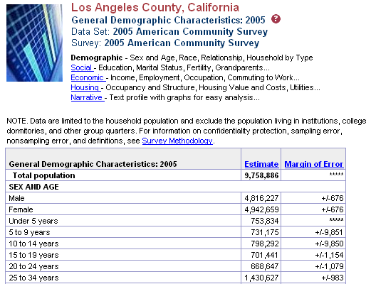

C. Public-Use Microdata Sample Files

There are two PUMS files, which contain data for either a 5% sample for all of the housing units in a state or a 1% sample of all the housing units in the United States. These data are particularly useful because they are for individual persons and housing units. In 1980 an estimate of the total number of persons in a state was obtained by multiplying the sample value by 20 or 100, but in 1990 and 2000 each person and housing unit received an individual weight that is used to estimate the total population. PUMS files provide considerable detail on a number of variables and the appendix lists the necessary codes to deal with these variables.

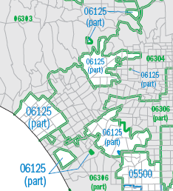
The 1990 and 2000 PUMS files contain a number of geographic areas called PUMAs (Public-Use Microdata Areas) or SuperPUMAs. See Appendix for a list of California PUMAs. PUMAs contain a minimum of 100,000 persons in the 5% sample and SuperPUMAs contain 400,000 persons in the 1% sample. In 1980 Los Angeles County had only 3 geographic units (Los Angeles City, Long Beach City, and the remainder of County). However, in 1990 and 2000 the county was divided into over 50 PUMAs that greatly expanded the geographic value of the PUMS data. In heavily populated places like the city of Los Angeles, PUMAs consist of aggregations of tracts while in other areas they may be aggregations of incorporated places. Unfortunately these places are often not contiguous. Note at right how PUMA 06125 in Los Angeles has been split among the cities of Santa Monica, Beverly Hills, Culver City, Marina Del Rey, and pieces of Los Angeles County.

The PUMS data set has a different structure than the Summary Files. It is arranged in a hierarchical structure in which both housing and person record types are found in the same file. Data for a housing unit appears first and then a person record follows for each person in the household. Each person record contains a household identifier and codes to indicate the position of that person in the household.

D. Geography in Summary Files

The boundaries used to aggregate census information have their origins in the TIGER files that the Bureau of the Census has been refining over the last 30 years. A TIGER file consists basically of descriptions of each street segment. A segment is usually the length of road between two intersections, but it may follow a city boundary, a stream, or a coastline. For each segment, variables describe the address ranges on both sides, the blocks, tracts, ZIP codes, Congressional districts, etc. on both sides, the street name, and the latitude and longitude coordinates of the end points. Using these files, the Bureau of the Census can determine which census unit a returned census form is in as well as the address coordinates. Also, from these files the boundaries of various geographic units can be created by looking for only those segments that have different area identifiers on each side. Those with the same value are eliminated. TIGER files are of little value to most people unless they have specialized software that can process the segments into other useful forms.

What makes the Summary Files large is that each of the tabulations is reported for multiple types of geographic units derived from TIGER files. These types are organized hierarchically from larger to smaller units and are defined by Summary Level Codes. When working with raw data one typically has to consult documentation to determine the appropriate code so that a desired set of geography can be extracted from all the geographic record types contained in a file. These codes are critical for extracting the proper records from the larger raw files and they can be found on page 4-1 of the census documentation. They also are important in grouping data should you download different types of geographic units at the same time.

The diagram from the Bureau of the Census below illustrates the hierarchy of the various geographical units for which they report data.
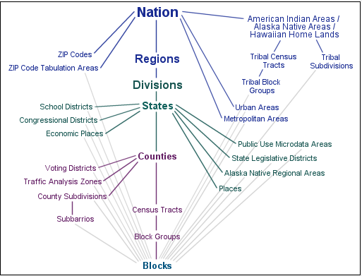
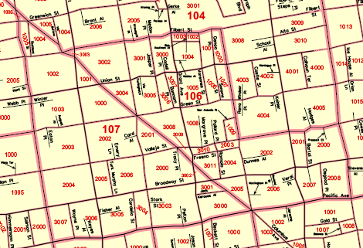
The map below shows census blocks and tracts (heavier lines) in San Francisco.
Examine the following extract (ordered by size of unit) of census geography definitions to better understand some of the more significant smaller geographic types:
Consolidated metropolitan statistical area (CMSA)
A geographic entity defined by the federal Office of Management and Budget for use by federal statistical agencies. An area becomes a CMSA if it meets the requirements to qualify as a metropolitan statistical area, has a population of 1,000,000 or more, if component parts are recognized as primary metropolitan statistical areas, and local opinion favors the designation. Example: Los Angeles--Riverside--Orange County, CA CMSA
Primary metropolitan statistical area (PMSA)
A geographic entity defined by the federal Office of Management and Budget for use by federal statistical agencies. If an area meets the requirements to qualify as a metropolitan statistical area and has a population of one million or more, two or more PMSAs may be defined within it if statistical criteria are met and local opinion is in favor. A PMSA consists of one or more counties (county subdivisions in New England) that have substantial commuting interchange. When two or more PMSAs have been recognized, the larger area of which they are components then is designated a consolidated metropolitan statistical area. Example: Los Angeles--Long Beach, CA PMSA
Metropolitan statistical area (MSA)
A geographic entity defined by the federal Office of Management and Budget for use by federal statistical agencies, based on the concept of a core area with a large population nucleus, plus adjacent communities having a high degree of economic and social integration with that core. Qualification of an MSA requires the presence of a city with 50,000 or more inhabitants, or the presence of an Urbanized Area (UA) and a total population of at least 100,000 (75,000 in New England). The county or counties containing the largest city and surrounding densely settled territory are central counties of the MSA. Additional outlying counties qualify to be included in the MSA by meeting certain other criteria of metropolitan character, such as a specified minimum population density or percentage of the population that is urban. MSAs in New England are defined in terms of minor civil divisions, following rules concerning commuting and population density. Example: Santa Barbara--Santa Maria--Lompoc, CA MSA
County and equivalent entity
The primary legal subdivision of most states. In Louisiana, these subdivisions are known as parishes. In Alaska, which has no counties, the county equivalents are boroughs, a legal subdivision, and census areas, a statistical subdivision. In four states (Maryland, Missouri, Nevada and Virginia), there are one or more cities that are independent of any county and thus constitute primary subdivisions of their states. The District of Columbia has no primary divisions, and the entire area is considered equivalent to a county for statistical purposes. In Puerto Rico, municipios are treated as county equivalents.
Census county division (CCD)
A subdivision of a county that is a relatively permanent statistical area established cooperatively by the Census Bureau and state and local government authorities. Used for presenting decennial census statistics in those states that do not have well-defined and stable minor civil divisions that serve as local governments.

Place
A concentration of population either legally bounded as an incorporated place, or identified as a Census Designated Place (CDP, comprising a densely settled concentration of population that is not within an incorporated place, but is locally identified by a name) including comunidades and zonas urbanas in Puerto Rico. Incorporated places have legal descriptions of borough (except in Alaska and New York), city, town (except in New England, New York, and Wisconsin), or village.

Town
A type of minor civil division in the New England states, New York, and Wisconsin and a type of incorporated place in 30 states and the Virgin Islands of the United States.

Census tract
A small, relatively permanent statistical subdivision of a county delineated by a local committee of census data users for the purpose of presenting data. Census tract boundaries normally follow visible features, but may follow governmental unit boundaries and other non-visible features in some instances; they always nest within counties. Census tracts average about 4,000 inhabitants and are designed to be relatively homogeneous units with respect to population characteristics, economic status, and living conditions at the time of establishment. They may be split by any sub-county geographic entity.

Block group (BG)
A subdivision of a census tract (or, prior to 2000, a block numbering area), a block group is the smallest geographic unit for which the Census Bureau tabulates sample data. A block group consists of all the blocks within a census tract with the same beginning number.
Example: block group 3 consists of all blocks within a 2000 census tract numbering from 3000 to 3999. In 1990, block group 3 consisted of all blocks numbered from 301 to 399Z.

Census block
A subdivision of a census tract (or, prior to 2000, a block numbering area), a block is the smallest geographic unit for which the Census Bureau tabulates 100-percent data. Many blocks correspond to individual city blocks bounded by streets, but blocks -- especially in rural areas - may include many square miles and may have some boundaries that are not streets. The Census Bureau established blocks covering the entire nation for the first time in 1990. Previous censuses back to 1940 had blocks established only for part of the nation. Over 8 million blocks are identified for Census 2000.
1. SF3 Summary Level Code Hierarchy for Selected Geographic Units

40 - State
50 - County
60 - County subdivision
70 - Place or place part
80 - Census tract
90 - Block group

The above geographic units may be split by a higher level unit. For example, many tracts are split by place boundaries and many places are split into separate, non-contiguous areas. However, if only data within a place is wanted, one would use a summary level of 80 to extract only tracts or parts of tracts that fell entirely within a specific city.

To accommodate the need for unsplit units such as would be found in most counties, additional records are available. It is these records (140 and 150) that geographers often seek for mapping contiguous geographic units within a county.

2. Other SF3 Summary Level Codes

160 - Place
140 - Census tract
150 - Block group
500 - Congressional district
170 - Consolidated city
390 - Metropolitan area
871 – ZIP code (ZCTA)

3. Coding Geographic Units - FIPS Codes

All geographic units have a standardized number identifier referred to as a FIPS (Federal Information Processing Standards) Code. The appendix lists FIPS codes for all U.S. states and counties. For named places such as MSAs, states, counties, and cities, the FIPS codes follow an alphabetical organization of the names. For example, in California, Alameda County has a FIPS code of 001 and Yuba County has a code of 115.

Often these FIPS codes are used to limit a search of the state records to a specific area of interest. Thus for all data within the State of California, one could limit the search area to Los Angeles County by specifying a county FIPS code of 037 and to only tracts by specifying a summary level of 140.

E. Census Comments.

1. The Race Question

In Census 2000, persons could indicate more than one race on the questionnaire, and fortunately only 2.4% of the national population did so. (4.7% of Californians did so) Of the multiracial population 93% indicated only two races and 32% indicated White plus Some Other Race. The latter Other category proved mostly to be Latino. Thus, most researchers use the tabulations for single-race only categories. See Overview of Race and Hispanic Origin: Census 2000 Brief ( http://www.census.gov/prod/2001pubs/c2kbr01-1.pdf )

This issue is particularly of concern to people trying to estimate changes since 1990. In 1990, persons were forced to choose only one race response, but in 2000 they could check as many as they wished. For larger groups such as Whites, Blacks, and Asians the difference between comparing the 1990 race count with the 2000 single-race only count or single race plus any other race count is not great. However, for small groups such as Asian subgroups like Thai or Hmong, the differences in percent change between using the single race only population versus the single race plus any other race can be very large. This topic, called Bridging, can be examined in greater detail at (http://www.census.gov/Press-Release/www/2001/raceqandas.html)

The question on race in the U.S. Census is separate from the question on Hispanic origin. People can indicate a particular race such as White, Black, American Indian, any of several Asian groups, or Other. Then they also may indicate if they are or are not of Spanish/Hispanic origin such as Mexican, Cuban, or Puerto Rican. Hispanics often indicate their race as white, yet Whites are commonly seen as distinct from Hispanics. Thus, tabulations based on the total reported White race are complicated by two distinctly different groups. To compensate for this it is usually better to use the non-Hispanic White category when tabulating data for "whites." This removes those persons of white race who indicated that they also were of Hispanic origin. In Census 2000 a number of tables have been included for this special race category.

2. Hispanic Subgroups

A problem has been noted in counts of small Hispanic subgroups like Dominican and Salvadoran. Apparently because of the wording in of the Hispanic question in Census 2000 many Hispanics in smaller groups chose to respond Other Hispanic rather than write in their subgroup as they did in 1990. Thus smaller counts have been noted in 2000 that seem to run counter to increases noted in immigration data. Larger groups like Mexican, Cuban, and Puerto Rican were listed on the Census 2000 questionnaire and do not appear to have this problem.

Another problem observed in 1990 was that there were far too many Hispanic Black persons in census tracts. This later proved to be related to the allocation of these characteristics to non-responding individuals, but the data was not updated.

3. Small-area Tabulations

In small areal units such as census tracts unusual results may appear because most if not all the population is in an institution such as a jail or college campus. It is sometimes helpful to identify and exclude such tracts from analysis.

Another problem when calculating change from 1990 is that many persons in institutions may be shifted between adjacent tracts between the last two censuses. Perhaps due to a change in the address of a college dormitory or jail, this often appears on a map as a large gain and loss in adjacent tracts.

4. Census Geography

Some geographical units undergo change between censuses. These include boundaries for places, ZIP codes, Congressional districts, school districts, tracts, block groups, and blocks. Although census tracts theoretically are only to be split if the population grows significantly or to be joined if the population drops, it is common for boundaries to be moved into adjacent tracts. Thus, comparison of data at the block group and tract level between two census decades can be complicated. The Bureau of the Census publishes equivalency tables to draw attention to where changes have occurred and some private companies redistribute the population into tracts with common boundaries. Typically, the numbers are redistributed based on percent of common area or are based on streets, but the new numbers are estimates and not actually based on the addresses of respondents to the census.

F. Exploring the Census Web Site

The Bureau of the Census web site provides a rich source of information in published and raw forms. There are various research reports that cover major variables like race, income, education, and marriage in the United States, summary tables of statistics for various geographic units, and printed maps of census units and selected variables. There are interactive programs that allow a user to generate a map or graph of desired data. And finally, there are the raw statistics and the digital boundary files for mapping that a user can download to produce custom tables, graphs, and maps.

B

C

D

E

A

The figure above shows the opening web page from the Bureau of the Census. Its look and content change as new products become available though the overall appearance has been relatively similar the last few years. On the left panel are links to various resources provided by the Bureau. In the center panel are links to specific tables, maps, and data sets and on the right are links to several search engines to help a user find data on a topic or place.

In Exercise 1 you will follow some of the links shown above. The first link, A, takes you to basic information on a place of interest. B is the link to the American Factfinder where data from the last two censuses can be found. C is the link to the new American Community Survey data. D is the link to various news releases and research documents on various population and housing subjects. E is the link to census reference maps in pdf format and to boundary file data for GIS programs.

G. Exercises

Ex 1. Exploring the Census Web Site
Ex 2. Accessing Census 2000 SF3 and SF4 Data and Data Bases at ICPSR
Ex 17. Downloading Raw Census Data
Chapter 2

Place Description, Ranking and Mapping

People often want very basic information about housing and population in specific areas like cities or counties. They want to know the number of children within a community, the level of poverty, the kinds of employment that people are engaged in, or the size and age of housing. Political representation and revenue sharing are allocated based on numbers of persons, and the amount of government spending is often based on the numbers of persons with a given characteristic. Through the use of tables, graphs, and maps one can say a great deal about the characteristics of the population and housing without having to resort to more elegant statistical methods and models.

Just acquiring the desired information is often not sufficient. To understand the meaning of the data, the values should be compared to a place of similar size or to a larger summary area such as an entire city, county, state, region, or the United States. This information helps one understand whether the acquired data values are greatly different from those of a much larger population. For example, data for the city of San Francisco could be compared to corresponding values for other cities in California or the State as a whole while values of California could be compared to either other states or national averages.

Furthermore, demographers frequently extract the same information for earlier censuses. In this way they get a sense about whether the current values represent increases or decreases from previous decades.

A. Some Basic Population Data Describing a City

As an example we will arbitrarily pick the city of Glendale, California. It has a census place FIPS code of 30000.

Table 1. Ethnic Populations in Glendale, Los Angeles, and California, 2000

Name | California | Glendale | Los Angeles
FIPS | _06 | 30000 | 44000
Area in Sq.mi. | 155,958.6 | 30.6 | 469.1
Total Pop. | 33,871,648 | 194,973 | 3,694,820
Density | 217 | 6,362 | 7,877
NhWhite Alone | 15,816,790 | 105,597 | 1,099,188
Latino | 10,966,556 | 38,452 | 1,719,073
Black | 2,263,882 | 2,468 | 415,195
Amer Indian | 333,346 | 629 | 29,412
Asian | 3,697,513 | 31,424 | 369,254
Pacific Isl | 116,961 | 163 | 5,915
Two Plus Races | 1,607,646 | 19,614 | 191,288
Male | 16,874,892 | 93,074 | 1,841,805
Female | 16,996,756 | 101,899 | 1,853,015
Male 65+ | 1,513,874 | 10,791 | 148,051
Female 65+ | 2,081,784 | 16,323 | 209,078
Avg Househld Size | 2.87 | 2.68 | 2.83
Avg Family Size | 3.43 | 3.27 | 3.56
% NH White Alone | 46.7 | 54.2 | 29.7
% Latino | 32.4 | 19.7 | 46.5
% Black | 6.7 | 1.3 | 11.2
% Amer Indian | 1.0 | 0.3 | 0.8
% Asian | 10.9 | 16.1 | 10.0
% Pacific Islander | 0.3 | 0.1 | 0.2
% Two Plus Races | 4.7 | 10.1 | 5.2
% Male | 49.8 | 47.7 | 49.8
% Male 65 years | 9.0 | 11.6 | 8.0
% Female 65 years | 12.2 | 16.0 | 11.3
% Foreign-born | 26.2 | 54.4 | 40.9
% Hisp Speak Eng Only or Very Well | 56.9 | 57.2 | 45.5
Med. HseHld Income | 47,493 | 41,805 | 36,687
% BA deg. or higher | 26.6 | 32.1 | 25.5
% Owner-occ HU | 56.9 | 38.4 | 38.6

Glendale is a city of about 31 square miles located just northeast of downtown Los Angeles. Its 2000 population was about 195,000.

Density - The population density of the city seems high compared to all California, but the state contains large, unsettled areas while most cities do not. Glendale does contain some unpopulated area in the Verdugo Mountains which contributes to its lower density than neighboring Los Angeles. Density computed this way assumes the population is spread evenly over the sampling area, but this is rarely the case.

Ethnicity - Non-Hispanic Whites are the largest group within the city population. Expressed as a percentage, non-Hispanic Whites constituted about 54% of the Glendale population while Hispanics and Asians accounted for 20% and 16% respectively. Compared to the State, Glendale has higher percentages of both whites and Asians and a substantially lower percentage of Blacks. If more detailed race data had been used, the relatively large Korean and Filipino communities within Glendale would have been evident within the Asian category.

What is somewhat unusual about Glendale is the very high percent of persons reporting two or more races. This may have been the result of some effort to do so at the time of the census, since in most areas this category is a mix of White and Latino persons and Glendale has fewer Latinos than other areas.

Family Size - An important indicator of the number of people in a household is the average number of people per household, but the number of people in an average family is also sometimes used. In Glendale the average family size and average household size are slightly lower than the State. This may be a result of an older population, more singles, or the larger White population, a group that tends to have smaller families.

Sex - There are fewer males than females in Glendale and the percent is lower than for all California. This may be another indicator of an older population in the city since the number of females tends to exceed the number of males in older age groups..

Other Variables – The last five items in the table represent characteristics that express something about the economic success and assimilation of immigrants in the population. Glendale has quite a high foreign-born population that would suggest the city is attractive to immigrants. Armenians, part of the non-Hispanic White population, have settled here in significant numbers. This is also reflected in the higher percent of non-Hispanic White population.

The percent of Latinos speaking English only or very well is also quite high and suggests this population could be more assimilated into American culture than some other areas.

The median household income is used since other members of a family often contribute to the support of a household. Glendale’s median household income is lower than the state, but better than neighboring Los Angeles.

Strongly correlated with income is education. Glendale has a somewhat better educated population with a higher percent of the persons age 25 or higher with at least a bachelor’s degree.

B. Examining a Characteristic in All Cities - Ranking Places

Often one wants to see how places rank according to a given characteristic. This sort of activity has become popular as authors have ordered places according to their being the best place to live, to do business, to attend college, or to retire. Once the ranking is done, those places that have very high or very low values can be examined in more detail to see if reasons can be determined for their position in the ranking.

When describing a population one has several choices for presenting the data, but usually one should look at both the actual counts, and, if the variable is a subset of a Universe or “population at risk,” the percent of the Universe. In other cases, one may also wish to look at the density of the count in order to discount differences in the size of the sampling areas. In other words, large areas will usually have greater counts simply because they cover more territory and not because there is any difference in the distribution of the counted population. Similarly, places with large total populations such as Los Angeles City and County, will always have greater counts of ethnic groups, seniors, youth, persons in poverty, and so on. Thus, analyses of only counts of these subgroups will typically result in an ordering of places that duplicates that of the Universe.

For example, in the table below the states have been ordered by the size of their populations. Note that the ranking by size on the other census variables is very similar. These are number of non-Hispanic Whites, males over age 65, females under age 13, males over age 15 never married, and occupied housing units.
Table 2. Ranking of States Based on Census Variable Counts

Geography | Totalpop | NHWhite | Male65 | Femle12 | MaleNMar | OccHUn
California | 1 | 1 | 1 | 1 | 1 | 1
Texas | 2 | 3 | 4 | 2 | 3 | 2
New York | 3 | 2 | 3 | 3 | 2 | 3
Florida | 4 | 4 | 2 | 4 | 4 | 4
Illinois | 5 | 7 | 7 | 5 | 5 | 6
Pennsylvania | 6 | 5 | 5 | 7 | 6 | 5
Ohio | 7 | 6 | 6 | 6 | 7 | 7
Michigan | 8 | 8 | 8 | 8 | 8 | 8
New Jersey | 9 | 10 | 9 | 10 | 9 | 10
Georgia | 10 | 13 | 13 | 9 | 10 | 11
North Carolina | 11 | 9 | 10 | 11 | 11 | 9
Virginia | 12 | 14 | 12 | 12 | 13 | 12
Massachusetts | 13 | 12 | 11 | 14 | 12 | 13
Indiana | 14 | 11 | 15 | 13 | 15 | 14
Washington | 15 | 17 | 18 | 15 | 14 | 15
Tennessee | 16 | 18 | 19 | 17 | 21 | 16
Missouri | 17 | 15 | 14 | 16 | 19 | 17
Wisconsin | 18 | 16 | 17 | 20 | 16 | 18
Maryland | 19 | 21 | 21 | 19 | 17 | 19
Arizona | 20 | 22 | 16 | 18 | 20 | 20
Minnesota | 21 | 19 | 20 | 21 | 18 | 21
Louisiana | 22 | 26 | 23 | 22 | 23 | 24
Alabama | 23 | 24 | 22 | 23 | 24 | 22
Colorado | 24 | 23 | 30 | 24 | 22 | 23
Kentucky | 25 | 20 | 24 | 26 | 26 | 25
South Carolina | 26 | 28 | 25 | 25 | 25 | 26
Oklahoma | 27 | 30 | 27 | 27 | 29 | 27
Oregon | 28 | 25 | 28 | 29 | 28 | 28
Connecticut | 29 | 29 | 26 | 28 | 27 | 29
Iowa | 30 | 27 | 29 | 31 | 31 | 30
Mississippi | 31 | 34 | 33 | 30 | 30 | 31
Kansas | 32 | 31 | 32 | 33 | 32 | 33
Arkansas | 33 | 32 | 31 | 34 | 34 | 32
Utah | 34 | 33 | 38 | 32 | 33 | 36
Nevada | 35 | 37 | 35 | 35 | 35 | 34
New Mexico | 36 | 42 | 37 | 36 | 36 | 37
West Virginia | 37 | 35 | 34 | 38 | 38 | 35
Nebraska | 38 | 36 | 36 | 37 | 37 | 38
Idaho | 39 | 40 | 41 | 39 | 43 | 41
Maine | 40 | 38 | 39 | 42 | 40 | 39
New Hampshire | 41 | 39 | 42 | 40 | 41 | 40
Hawaii | 42 | 50 | 40 | 41 | 39 | 43
Rhode Island | 43 | 41 | 43 | 43 | 42 | 42
Montana | 44 | 43 | 44 | 44 | 45 | 44
Delaware | 45 | 47 | 46 | 45 | 46 | 45
South Dakota | 46 | 44 | 45 | 46 | 47 | 46
North Dakota | 47 | 45 | 47 | 48 | 48 | 47
Alaska | 48 | 49 | 51 | 47 | 49 | 50
Vermont | 49 | 46 | 48 | 49 | 50 | 49
Wash. D.C. | 50 | 51 | 49 | 50 | 44 | 48
Wyoming | 51 | 48 | 50 | 51 | 51 | 51

One common way to control for the underlying population is to express the data as a percent of the Universe rather than as a count. To calculate a percentage one would multiply the subgroup count by 100 and then divide by the Universe. So if 5000 men are employed in construction and the Universe consists of 23,000 full-time civilian-employed males age 16 and older, the percent of men age 16 and older employed in construction would be 5,000 * 100 / 23,000 or 21.7 percent. Sometimes people are careless and forget to multiply the proportion by 100 to calculate the true percent. Also, people often forget to use the Universe and instead use the total population that includes people that are not potentially part of the variable of concern. In this case, using the total male population would include retired persons and those not in the work force and this could cloud any analyses of construction employment.

While the percent of males employed in construction is useful to know, one still needs to keep track of the actual numbers involved, because it is not uncommon to obtain very high percents from very low numbers. For example, if two males lived in an area and one was in construction, the percent employed in construction could be 50 percent, a very high number. People sometimes set a minimum threshold for areas to be included in the analysis of percents. For example, the Bureau of the Census sets a threshold of 50 sampled persons in an area before it will report the data from the sample questionnaire.

To examine a description of demographic characteristics of the United States see the following report:
http://www.census.gov/prod/2002pubs/censr-4.pdf

C. Describing a Distribution with Statistics

Rather than examine individual cases of a distribution researchers often seek summary statistics that capture the general nature of a set of data. These hopefully provide enough information to enable one to say if one set of data is likely to be different from another or whether a sample of data values is representative of the total population. These summary statistics include measures of centrality for the distribution such as the mean and median. The former is simply the sum of all values divided by the number of values and the latter is the midvalue in the distribution when all values are ordered from low to high. The median is insensitive to very extreme values, and so it frequently is used to summarize a census variable such as income.

Distributions are further described by measures of dispersion such as the range and standard deviation. These basically describe the amount of difference between the mean and individual data values. In other words, do the data values cluster closely about the mean or are they widely scattered? Additional measures of the skewness and peakedness of the distribution may also be made. Many of these serve as basic components of statistical tests of significance.

For the California City Population Density Data Set:

Mean = 4941.
Median = 3836.
Range = 24,500.
Standard Deviation = 3688.

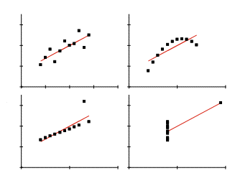
Because statistical values such as means, ranges, standard deviations, skewness, etc. summarize a distribution, it is possible to miss some important characteristics. In fact, some very different distributions can yield the same summary statistics as evidenced by Anscombe’s Quartet. At right are four distributions of two variables that have the same means, standard deviations, and regression equations. Thus, one should not rely totally on statistical measures since they give only a limited view of the distribution.

D. Graphing a Distribution

In addition to tables of data and statistical calculations, graphs have proved to be very useful tools for visually presenting the characteristics of a data set. One can quickly see clusters, gaps, and isolated values in a distribution when it has been graphed and this is particularly helpful when preparing to subject a data set to more advanced statistical procedures. Many statistics are based on a data distribution being normally distributed (being equally divided around the mean) and graphing the values reveals whether this is the case.

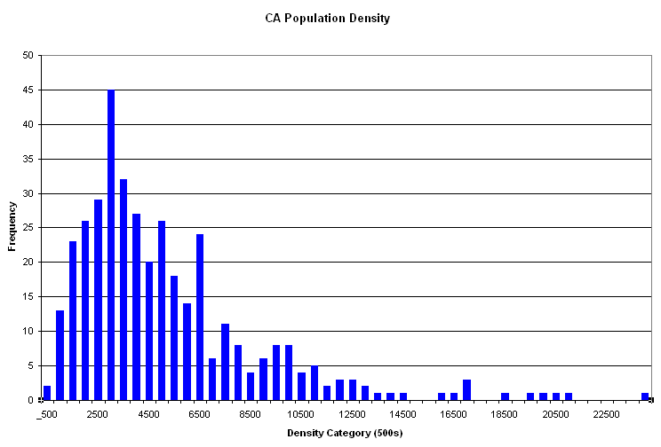
A simple way to get a first look at census data is to make a graph that shows the distribution of values from low to high. The frequency graph of the population density of California cities below shows the range of values expressed in steps of 500 along the horizontal X axis. The number or frequency of values in each group is shown on the Y axis. The form of the graph is fairly typical of census data with many values clustering near the lower end of the scale and a tale extending out to the right. This distribution is not “normal” in a statistical sense, and so a researcher might want to make some effort to adjust for this. The graph also reveals various clusters of similar values and, for mapping, one might look for breaks and low points in the categories as possible locations to create class breaks.

Graphs come in a variety of forms, but relatively few are typically used.
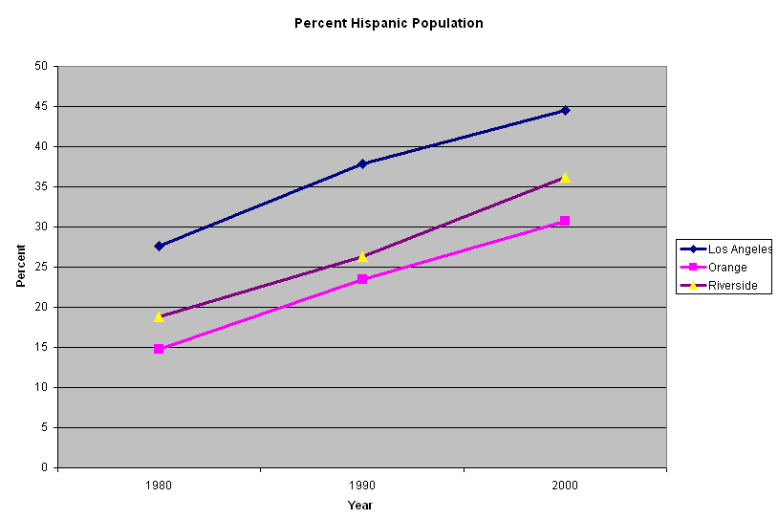
The line graph is used to present continuous data such as temperature, time, or money. In the graph below is a line graph of the percent Hispanic population for three counties in 1980, 1990, and 2000.

The vertical bar graph is often used to report aggregated data over time. In the following graph the number of Hispanics are shown for four counties at three different decades. While the order of the four counties can be changed, the three columns reflect counts at three time periods.
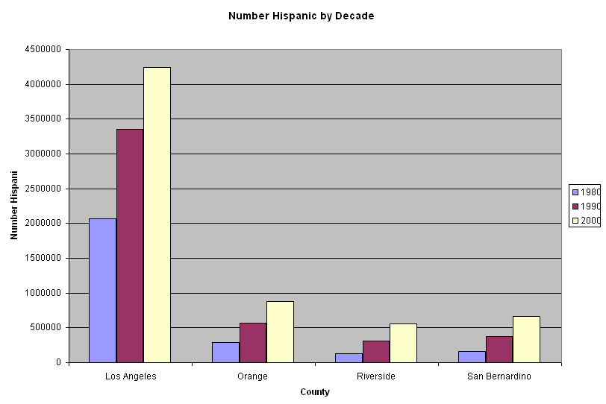

The horizontal bar graph is often used when comparing various geographic units. There is no strong justification for presenting the data in alphabetical order and so the geographic areas are sorted from high to low value in Excel so that the values of the individual counties can be compared more closely.

When creating graphs in Excel you should be aware of a few design issues. First, try to make the grid divisions even whole numbers to better aid interpolation of values. The Format Axis > Scale command allows you to control the grid spacing of the data. If you are creating several graphs for a single page, try to keep the scale of all axes the same so that the displays are comparable. Second, keep the focus of the graphic on the bars or lines and not on the grid, text, or cute embedded pictures. As Edward Tufte says, above all else, show the data. Third, try reducing the need for a legend by labeling the lines or bars on the graph. Many graphs have only one or two variables, and so a legend just complicates reading the graph. Generally try to label things horizontally so the graph doesn’t have to be rotated to be read. Fourth, avoid three dimensional graphics for one or two dimensional data. There is nothing more confusing that a 3D bar graph since it is difficult to tell where on the scale the top of the bar lies. Excel and other programs offer 3D graphics. Generally, forget them. There are other suggestions for designing graphs, but this should at least get you started. Finally, don’t hesitate to copy your Excel graph into a graphics program like Illustrator or Freehand. Then you can make various needed text and graphic changes.

E. Mapping a Distribution

Maps especially reveal spatial qualities that are rarely evident in statistical tabulations. A researcher may notice that certain places seem to occur near one another when values are sorted in a table, but maps provide this information in detail and at a glance. For example, one can see in the map of places below that the most densely concentrated cities occur in a limited number of locations around Los Angeles, San Francisco, Boston, New York, Washington, and Miami.
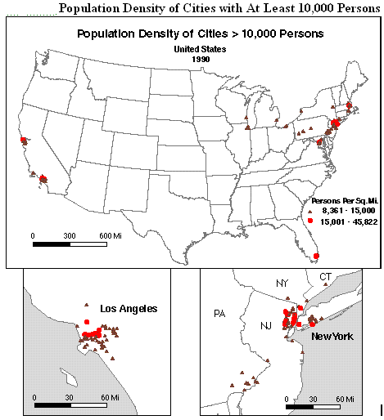

1. Census Geography

To produce maps one needs either a file of each boundary of each geographic unit or a single point to describe the centroid (spatial center) of the unit. Fortunately, the Bureau of the Census includes a latitude and longitude value for each of its described geographies. It also publishes the area of these units and that can be used to calculate the density of a variable within the unit.

The actual boundaries can be obtained in several ways: by using software that will generate them from the street segments in a census TIGER file, by purchasing them from one of several data vendors, or by downloading them (often for free) over the Internet. Usually boundary files provided by data vendors are better in quality than those from other sources. In addition, many geographic information systems (GIS) software packages include boundaries in their sample data for nations, states, counties and ZIP codes.

The Bureau of the Census reports its data for a range of statistical unit sizes, and so some thought needs to be given to the scope and the scale of a project. Does the research cover a region of the United States or just a neighborhood? The size of a statistical area used for analysis can be significant. It is important to realize that the results of analysis are applicable to only the selected units–not to individual people or to units of different sizes. For example, you can not claim that relationships exist among individuals based on your results using counties.

For local area analysis, tracts have long been a preferred areal unit while at the regional or national level counties have been used. Within a local area, block-level statistics are occasionally used to compare neighborhoods. However, tabulations of data from the sample questions are unavailable for blocks, and so analysis possibilities are more limited.

2. Mapping Counts and Percents

Examining patterns of counts of population on maps reveals only part of a picture. Such maps indicate where there are more or fewer people, but they may not indicate differences in the relative concentration of one group compared to another. For example, mapping the number of Hispanics indicates where the numbers are, but one also would expect to find more Hispanics where there are more people. Thus, similar to tables and graphs, using counts of population components yields maps that are often very much alike. It is usually more valuable to additionally map the percentage of the total population that is Hispanic to reveal where the group is proportionately more concentrated.
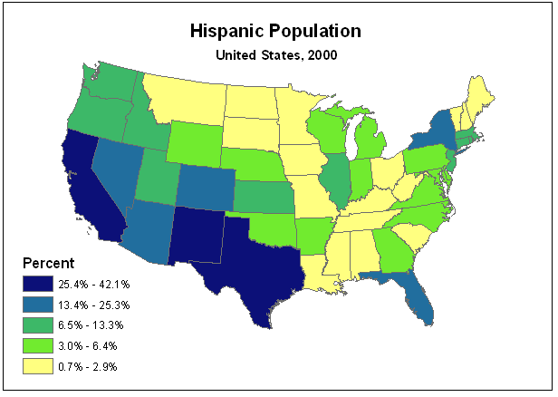
Mapping a group by density (i.e. dividing by the sampling unit area) may also be helpful since it readjusts the total population count for the varying areas of the statistical units. A potential problem with mapping population counts is that larger statistical areas generally contain larger numbers of a population.

Although a very large number of mapping styles are possible for portraying statistical information, in practice only a few are used. This is especially true when using computer software, which typically presents few mapping options. Following is a discussion of three common thematic mapping methods used with census data.

3. Choropleth Maps

The most common census mapping product is probably the choropleth map. Here the statistical areas are shaded in relation to the data values. The technique is very common with census data because values are reported for statistical areas. The values for the areal units are sorted and divided into four to eight classes. Each class is assigned a progressively darker or brighter tone such that a visual order is apparent that approximates increasing magnitude of the values. This would seem a straightforward relationship, but many people assign colors to categories in an almost random way.
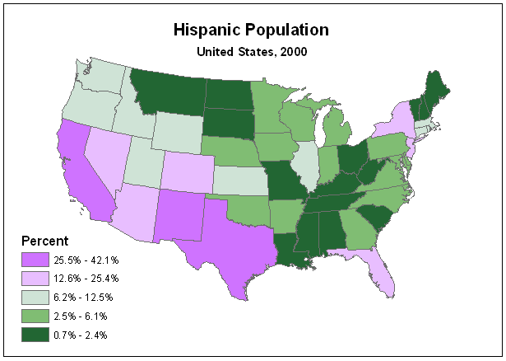
An alternative approach is to use a bi-variate color scheme that uses two hues that progressively darken as values depart from an average or selected base value. At right those states that have a percent Hispanic that is greater than the national percent of 12.5 are shown in purple and those states with a lower percent are shown in green.

A real challenge in choropleth mapping is to decide on an appropriate number of classes and on a method for selecting class breaks. There is no simple answer to this problem. As a rule of thumb the method proposed by George Jenks (the default method and currently misnamed "natural breaks" in ArcView) would be preferable to others. This method seeks to minimize variation between values within the classes. In many situations, especially when a number of maps are to be compared, quantile breaks are appropriate. An alternative method occasionally used is to compute the mean of the distribution and to create class breaks based on standard deviation values about the mean.

On choropleth maps data should be expressed as a ratio, index, percentage, or density. Such maps are not appropriate for showing counts of people. Simply stated, large areas tend to appear in higher classes not because of any data characteristic, but because larger areas encompass a greater portion of a population distribution. Obviously Texas will have more people than Oklahoma because it covers more area.

Another concern with the difference in size of the areal units on choropleth maps is that larger areas will visually dominate on the map and many of these are in rural areas with small populations. Often small but significant populations occur in very small areas such as the boroughs of New York or in Washington D. C. An inset map can be helpful in drawing attention to some of these smaller areas if they are not discernible on a map of a large area such as the entire United States.
4. Graduated Symbol Maps

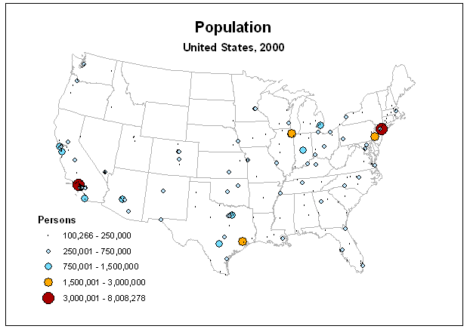
A second method often found in census mapping is graduated symbols. With this approach the area of a circle or square is made proportional to the value of an attribute. Graduated symbols may be used for point features such as cities and may represent counts of things. A frequent problem with this technique is that the range of values far exceeds the range that can be effectively presented on the map. Thus, it may be necessary to set a lower limit to be displayed. Values below the threshold are either not shown or are assigned a standard symbol. An alternative strategy available in some programs is to define a set of groups and then assign a single symbol size to all values falling within the range of a given group. This method, referred to as "range-graded symbols" invokes the classification schemes used for the choropleth map.

Some programs provide the option to create three dimensional spheres and cubes to portray the data, but these are less effective because people make judgments based on the actual areas covered by the symbols. The spatial location of such symbols also is less clear than for two-dimensional symbols. This also applies to the use of three dimensional symbols on graphs and so it is generally better to avoid using them even though they seem to “jazz” things up.

5. Dot Maps
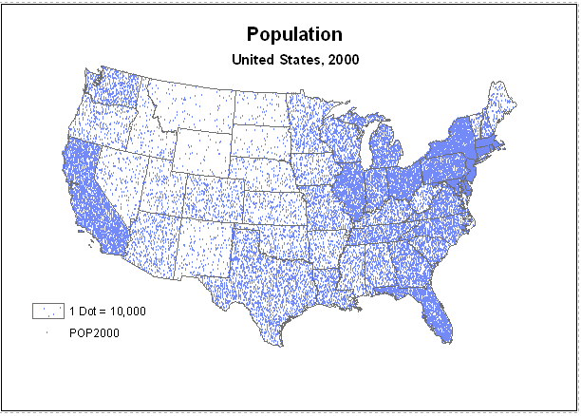
A third method is the dot map, a technique that requires the assignment of a given number of individuals to a dot. The dot is then located to represent the approximate location of a group of individuals. When done manually, additional maps and aerial photographs may be used to help determine the appropriate dot placement. It also permits the overlay of multiple distributions on the same map by using dots of different shapes or colors.

Unfortunately, computer programs can only locate the dots randomly within a statistical area as shown right. The patterns only begin to become meaningful when statistical areas shown on the map are very small. In other cases, the look of the distribution can be improved by moving the map to a graphic arts program where dots can be moved individually away from unpopulated areas within the statistical units.
6. Mapping with ArcGIS

The California State University currently has a site-license for ESRI software that includes a mapping/GIS package called ArcGIS. This package, or other GIS software, can be used to produce choropleth, graduated symbol, and dot maps from census data.

In Exercise 2 you will have the opportunity to download and process some census data from the Bureau of the Census web site.

F. Exercises

Ex 3. Introduction to Excel
Ex 4. Analyzing Census Data in Excel
Ex 15. Mapping Census 2000 Data
Chapter 3

Analyzing Other Population Characteristics

Because differences in the age, income, education, gender, ethnicity, and employment characteristics of the population may affect access to resources and social status, these population components are frequently studied in more detail or are controlled when studying an issue. For example, white males tend to earn higher incomes than white females or persons of many other ethnic groups, persons with higher education attainment tend to earn higher incomes, women predominate in older age groups, and men and women are often found in different occupations.

In this section you will examine a few of the measures commonly used to describe some of these population components.

A. The Sex Ratio

The gender component of the population is a significant element affecting many statistical tabulations. For example, there are important differences between men and women in the areas of employment, age, and income. It may be useful to control these elements in an analysis.

The sex ratio is an often-used measure of the difference in the number of men and women in an area. It is the ratio of males per 100 females and is simply calculated by dividing the number of males by the number of females and multiplying the ratio by 100. Scores higher than 100 indicate more males than females.

Table 3. Sex Ratios, 2000
 | Sex Ratios
Glendale | Los Angeles City | California
91.3 | 99.4 | 99.3

Several underlying factors may influence the sex ratio. For very large populations in developed countries such as the entire United States the ratio is less than 100, indicating that there are more females than males. However, when the ratio is examined across different age groups, the ratio is greater than 100 in the early age groups before dipping below 100 in the early 20s. This is because more males are born than females. However, in developed countries the proportion is soon reversed because males tend to die at a higher rate than females. After age 60 women are much more predominant than men. In the early twentieth century, men were predominant in the western United States because the majority of migrants into the region were young men. However, by 1990 the sex ratio was almost even - 99.5. However, state capitals with a large number of women in clerical and administrative jobs have lower sex ratios than other cities. Similarly retirement communities with large elderly populations have still lower ratios.

While Table 3 indicates that overall the total number of males and females in California is about the same, Table 4 presents the sex ratios by age category. As expected, males predominate up to age 44. After age 60 the proportion of females increases markedly. Among people age 85 and older, the table shows that women outnumber men two to one. The increase in the proportion of males from age 10 to age 24 is due to the male predominance among in-migrants, some of whom were in young families coming from other states or from countries like Mexico.

Table 4. Sex Ratios by Age
California, 2000
 | Sex Ratio
Age Group | California  2000
0-4 yrs | 105
5-9 yrs | 105
10-14 yrs | 105
15-19 yrs | 108
20-24 yrs | 110
25-29 yrs | 106
30-34 yrs | 106
35-39 yrs | 103
40-44 yrs | 101
45-49 yrs | 98
50-54 yrs | 96
55-59 yrs | 94
60-64 yrs | 91
65-69 yrs | 87
70-74 yrs | 79
75-79 yrs | 73
80-84 yrs | 65
85+ yrs | 46

See: Ex 5. Sex Ratio

B. The Location Quotient

While percentages provide an indication of the relative proportion of a population subgroup in different areas, the location quotient can be used to compare a local proportion to that of a much larger area. Location quotients can determine if an ethnic population or employment within a certain occupation or industry is relatively strong or weak in different areas.

A location quotient is calculated by first dividing the number of persons in a population subgroup by the total population within a local area. This ratio is then divided by the comparable ratio for a much larger area such as an entire state. For example, if 3000 out of 10,000 persons in a community were Hispanic (a ratio of .3) and 300,000 persons out of one million persons in a state were Hispanic (a ratio of .3), the location quotient would be 1. This would indicate that the community has the same proportion of Hispanics as the entire state. When the location quotient is greater than one, the community would have a higher concentration of Hispanics than the state. A score of 2.0 would mean that the community has twice the proportion of Hispanics as the state while a score of 0.25 would indicate the community has one quarter the concentration of the state.

In the table below various occupational categories and classes of employment are compared between Los Angeles County and the State of California. If the location quotient values were multiplied by 100 they would yield percentages. The location quotients in the first table indicate that Los Angeles County has about 1.5 times the proportion of State workers in private household and machine operator occupations as the state as a whole. Also, Los Angeles County has about half the proportion of workers in farming, forestry, and fishing occupations as found over the entire state. The second table reveals that, surprisingly, Los Angeles County has about two-thirds the proportion of state and federal government workers as the entire state.

Table 5. Location Quotient by Occupation and Class of Worker
Los Angeles County, 1990
Occupations | California |  | Los Angeles Co. |  | California |  | LA County |  | Location
(Table78) | Employed |  | Employed |  | Proportion |  | Proportion |  | Quotient
 | Persons Age 16+ |  | Persons Age 16+
Executive, Admin, Managerial | 1,939,417 | 555,616 |  | 0.139 |  | 0.132 |  | 0.95
Professional Specialty Occupations | 2,057,087 | 603,519 |  | 0.147 |  | 0.144 |  | 0.98
Technicians and Support | 527,367 | 141,767 |  | 0.038 |  | 0.034 |  | 0.90
Sales | 1,690,007 | 486,374 |  | 0.121 |  | 0.116 |  | 0.96
Administrative Support | 2,319,459 | 730,744 |  | 0.166 |  | 0.174 |  | 1.05
Private Household Services | 95,059 | 44,456 |  | 0.007 |  | 0.011 |  | 1.56
Protective Services | 235,799 | 65,721 |  | 0.017 |  | 0.016 |  | 0.93
Other Services | 1,402,919 | 406,436 |  | 0.100 |  | 0.097 |  | 0.96
Farming, Forestry, Fishing | 382,369 | 52,446 |  | 0.027 |  | 0.012 |  | 0.46
Precision Production, Repair | 1,548,625 | 462,923 |  | 0.111 |  | 0.110 |  | 1.00
Machine Operators | 797,300 | 345,158 |  | 0.057 |  | 0.082 |  | 1.44
Transportation and Moving | 480,057 | 142,276 |  | 0.034 |  | 0.034 |  | 0.99
Helpers, Laborers | 520,844 | 166,356 |  | 0.037 |  | 0.040 |  | 1.06
Total Employed 16+ | 13,996,309 | 4,203,792
Class of Worker | California |  | Los Angeles Co. |  | California |  | LA County |  | Location
(Table79) | Employed |  | Employed |  | Proportion |  | Proportion |  | Quotient
 | Persons Age 16+ |  | Persons Age 16+
Private for Profit | 10,000,783 | 3,134,368 |  | 0.715 |  | 0.746 |  | 1.04
Private not for Profit | 734,520 | 223,631 |  | 0.052 |  | 0.053 |  | 1.01
Local Government | 1,078,146 | 307,672 |  | 0.077 |  | 0.073 |  | 0.95
State Government | 499,399 | 100,286 |  | 0.036 |  | 0.024 |  | 0.67
Federal Government | 449,373 | 90,789 |  | 0.032 |  | 0.022 |  | 0.67
Self Employed | 1,173,375 | 329,115 |  | 0.084 |  | 0.078 |  | 0.93
Unpaid Family | 60,713 | 17,931 |  | 0.004 |  | 0.004 |  | 0.98
Total Employed 16+ | 13,996,309 | 4,203,792

See: Ex 6. Location Quotient
C. The Entropy Index

The entropy index (H) is a measure of the diversity of various groups in an area. If all component groups are equally present the index reaches a maximum. If only one of several groups is present it is 0. The maximum score increases with the number of groups used in computing the entropy index. However, it can be standardized to a maximum of 1 by dividing all values by the maximum possible score (i.e. all groups equally present in an area).
n
H = - Σ (Pk/P) ln(Pk/P)
k=1

Here Pk is the population of the subgroup and P is the total population.

In the table below five major ethnic categories have been tabulated for four California cities. The proportion of each group in its city divided by the natural log of the proportion is reported in the lower part of the table. The sum of the indexes for each city is the Entropy Index (H) which is reported in its raw and standardized values at the bottom. In the column labeled "Even" the raw scores (H) were then divided by the maximum score for five groups (1.609).

The cities of Los Angeles and San Francisco are found to be much more diverse than Glendale and Burbank (Table 6). Because of their large Asian and Hispanic populations, many cities in California are among the most ethnically diverse in the United States.
Table 6. Diversity Scores
 | Los Angeles |  | San Francisco |  | Glendale |  | Burbank |  | Even
 | Persons |  | Persons |  | Persons |  | Persons
NH Whites | 1,299,604 | 337,118 |  | 114,765 |  | 64,453 |  | 5
Blacks | 487,674 | 79,039 |  | 2,334 |  | 1,638 |  | 5
American Indians | 16,379 | 3,456 |  | 629 |  | 501 |  | 5
Asians & Pacif Is | 341,807 | 210,876 |  | 25,453 |  | 6,335 |  | 5
Hispanic | 1,391,411 | 100,717 |  | 37,731 |  | 21,172 |  | 5
Group Total 90 | 3,536,875 | 731,206 |  | 180,912 |  | 94,099 |  | 25
Ethnic | Los Angeles |  | San Francisco |  | Glendale |  | Burbank |  | Even
Groups | Persons |  | Persons |  | Persons |  | Persons
NH Whites | 0.368 | 0.357 |  | 0.289 |  | 0.259 |  | 0.322
Blacks | 0.273 | 0.240 |  | 0.056 |  | 0.071 |  | 0.322
American Indians | 0.025 | 0.025 |  | 0.020 |  | 0.028 |  | 0.322
Asians & Pacif Is | 0.226 | 0.359 |  | 0.276 |  | 0.182 |  | 0.322
Hispanic | 0.367 | 0.273 |  | 0.327 |  | 0.336 |  | 0.322
H | 1.259 | 1.254 |  | 0.967 |  | 0.875 |  | 1.609
Standardized H | 0.782 | 0.779 |  | 0.601 |  | 0.544

See: Ex 7. Diversity Index
Chapter 4

Association between Two or More Variables

Very frequently social scientists want to determine the strength of the association of two or more variables. For example, one might want to know if greater population size is associated with higher crime rates or whether there are any differences between numbers employed by sex and race. For categorical data such as sex, race, occupation, and place of birth, tables, called contingency tables, that show the counts of persons who simultaneously fall within the various categories of two or more variables are created. The Bureau of the Census reports many tables in this form such as sex by age by race or sex by occupation by region. For continuous data such as population, age, income, and housing the strength of the association can be measured through correlation statistics.

A. Cross Tabulations

Contingency tables such as that below are quite popular because they are easy to understand and can be used with nominal, ordinal, interval, or ratio data. In such a table it is easy to see the frequency of persons that belong to the categories of both variables. For higher measurement levels, the variables are typically coded into several categories such as less than 18 years, 18 to 64 years, and 65 and older.

One of the most common measures of association for contingency tables is Chi-square. With this statistic we compute the expected frequencies for the cells which would represent the case that there is no relationship among the variables. As the actual numbers depart from the expected values, the larger and more significant Chi-square becomes. The significance level of Chi-square depends on the number of observations and the number of cells in the table and so for census data, which often has very large counts, small deviations from the expected values will be statistically significant. Chi-square also expects at least 5 cases in each cell in order to estimate values reliably.

For this particular table one might expect the marital status of males and females to be about the same. However, the percent of widowed and separated females greatly exceeds that for men.

Table P18 – Sex by Marital Status for Persons >= Age 15
California, 2000 | Male: | Female: | Pct Male: | Pct Female:
Never married | 4,343,790 | 3,500,117 | 55.4 | 44.6
Now married: | 7,205,642 | 7,094,229 | 50.4 | 49.6
Married, spouse present | 6,226,504 | 6,244,539 | 49.9 | 50.1
Married, spouse absent: | 979,138 | 849,690 | 53.5 | 46.5
Separated | 256,459 | 386,211 | 39.9 | 60.1
Other | 722,679 | 463,479 | 60.9 | 39.1
Widowed | 278,180 | 1,179,638 | 19.1 | 80.9
Divorced | 1,017,057 | 1,457,510 | 41.1 | 58.9
Total California | 12,844,669 | 13,231,494 | 49.3 | 50.7
B. Scattergrams

Scattergrams graphically portray how closely changes in one continuous variable correspond to changes in another. In the example below the population values for the 593 metropolitan counties in the U.S. have been plotted on the x-axis and the corresponding crimes per capita have been plotted on the y-axis.

Scattergram of Population vs Crimes Per 100,000 Persons
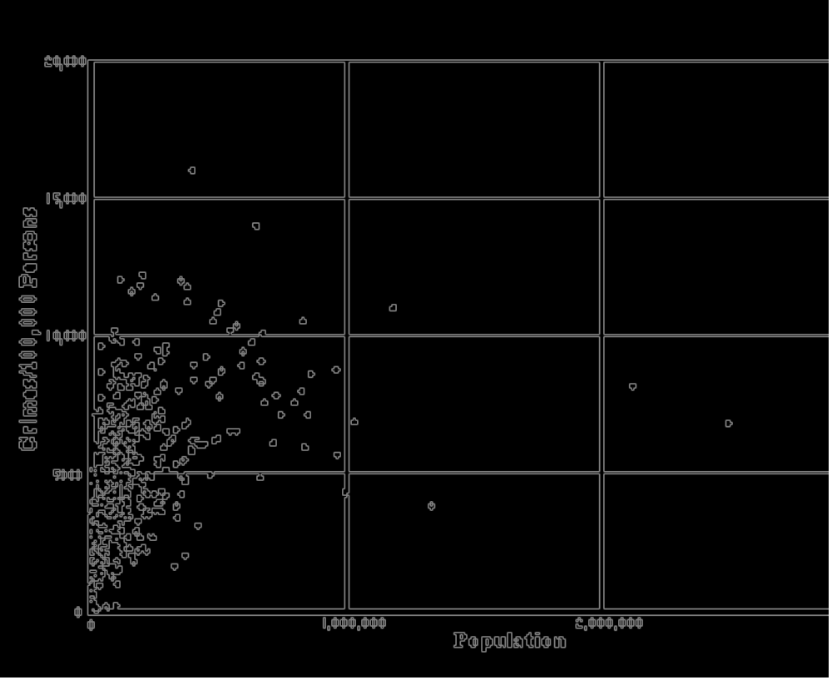

In this scattergram there does appear to be some association between higher crime rates and larger populations in counties. However, there is quite a bit of variability in this trend–a few cities with large populations have relatively low crime rates and a few small cities have relatively high crime rates. If the relationship was very strong, the points would spread out along a line and if it was very weak, the points would be scattered randomly over the plot. Very strong, almost linear, distributions may be found in physical relationships such as the increase in pressure in a container with an increase in temperature. However, such strong relationships are rare among social data.

C. Correlation

If a scatter of points does seem to exhibit a non-random trend, then one might choose to measure the strength and the direction of it through the use of correlation statistics. Correlation determines whether a relationship exists between two variables. If an increase in the first variable, x, always brings the same increase in the second variable,y, then the correlation value would be +1.0. If the increase in x always brought the same decrease in the y variable, then the correlation score would be -1.0. If an increase in x brought no regular change in y, then the correlation would be 0. In most calculations of correlation, an approximation of a linear relationship is assumed. However, the relationship could be curvilinear or cyclical, and so one should always examine a scattergram to see if the relationship between two values is non-linear.

There are several types of correlation measures that can be applied to different measurement scales of a variable (i.e. nominal, ordinal, or interval). One of these, the Pearson product-moment correlation coefficient, is based on interval-level data and on the concept of deviation from a mean for each of the variables. A statistic, covariance, is the product of the deviations of the observed values from each of their means divided by the number of observations. This mean deviation is divided by the product of the standard deviations of the two variables to get the correlation or:

Σ(X – ΣX/N) x (Y – ΣY/N)
r = N
SQRT [ Σ(X – X)2 ] x [ SQRT [Σ(Y – Y)2 ]
N N

The correlation statistic above is for the entire population. If a sample had been selected, the N would have been replaced by n-1.

Computing the Pearson product moment correlation for the crime and population data yields a correlation score of .449, which is only a moderate value. Another statistic, called the coefficient of determination, can be calculated to determine the percent of the total variance explained by the correlation between the two variables. The coefficient of determination is simply the square of the "r" or correlation coefficient. In this example, the coefficient of determination is only .202. Thus, about 20% of the variance between population size and crime rate is accounted for by the correlation between these two variables. This would suggest that other variables yet unaccounted for are causing 80% of the crime rate differences between cities..

Since the scatter of points rises steeply and then stretches to the right, a non-linear regression line may fit better than a straight line. Calculating the natural logrithm of the population generates a line that curves to the right. This increases the correlation coefficient to .605 and the coefficient of determination to .367. Thus, a non-linear form of correlation increases the percent of variance explained to about 37%. Apparently the crime rate does increase with population size, but at a decreasing rate.

Because all 593 metropolitan counties in the U.S. were used to compute the correlation statistic, there is less value to testing its significance. Had a sample of the counties been taken, one could consider the possibility that such a relationship could have occurred by chance. To test the significance of the relationship, one could assume that there is no relationship between population size of counties and the crime rate (null hypothesis) and that the value of r is due to sampling error. A statistic called the t statistic is commonly used to test the hypothesis that the correlation value is due to sampling error.

t = |r| x SQRT(n-2)
SQRT(1 – r2) [SQRT = square root]

If the 593 counties had been a sample, the t test yields a value of 12.204. Consulting a table of t-statistic values indicates that a score of 1.96 would be expected to occur by chance only 5% of the time and 3.922 only .01% of the time. The value of 12.204 is far beyond that and so the null hypothesis could be rejected. This means that there really is a relationship between city size and crime rate. However, city size only accounts for 20% of the variations in crime rate between cities.

There are a number of assumptions made about the data in correlation analysis which are not always met. For example, the observations should be selected randomly, they should be measured on the interval or ratio scale and be normally distributed, and they should be independent of each other. The latter condition may be a particular problem in samples that are geographically near to one another, however, large sample sizes can mitigate many of these problems. The size of the geographic units may also play a part in the correlation score. Termed the modifiable areal unit problem, the size of the unit areas may affect the correlations of the paired variables. Thus one needs to express these statistical associations and conclusions in terms of the areal units actually used rather than make a general statement on association between variables.

D. Regression

If the correlation between two variables is found to be significant and there is reason to suspect that one variable influences the other then one might decide to calculate a regression line for the two variables. In this example one might state that an increase in population results in an increase in the crime rate. Thus, the crime rate would be considered a dependent variable and the population size would be considered an independent variable. When plotting these variables, the dependent variable, crime, would be plotted on the y-axis and the independent variable would be plotted on the x-axis of a scattergram.

Regression expresses the relationship between the two variables as the equation for a line which best fits the scatter of points in a scattergram. The line minimizes the sum of the squared deviations of the dependent (y variable) from the line. From the equation one can estimate the value of y for a given value of x. Differences between the estimated and real y-axis values are residuals.

Regression of Population vs Crimes Per 100,000 Persons

The equation for the above regression line is

Crimes/100k = 3897.35 + 0.005149 * Pop

The farther a given dot is from the regression line, the larger the residual. The residuals are of special interest because they represent exceptions to the general association expressed by the regression line. In the example of city size and crime rate, identify the cities represented by the largest eight to ten residuals as they appear to you on the scattergram.

Points lying far above the regression line represent cities which have much higher crime rates than are expected based on their population size; points lying far below the line represent cities with much lower than expected crime rates.

Since it is possible that quite different scatters of points could produce the same line, it is also helpful to calculate the standard error of the estimate which provides an indication of the scatter of the points about the line. This value can be useful for comparing different samples.

SE of Est = SQRT (Σ(Y-ΣY/N)2
N

For this crime example the standard error of the estimate is 2252.9

The reliability of the regression model also may be tested with analysis of variance. With the F statistic one can determine how much of the total y variability is due to the regression line and how much is due to the residuals. If a large portion of the variance comes from the equation and the independent variable, then the model provides a good prediction of y and a high value of F.

(Σ(Y-ΣY/N)2
F = df
(Σ(Y-ΣY/N)2
n - df - 1

Where df is the degrees of freedom.

For the crime example, the F statistic is 148.94. The null hypothesis would state that the regression model fails to predict the variation in y and could, by chance, generate a value of 3.86 (from a table of F statistics) 5% of the time. Thus the null hypothesis can be rejected.

E. Exercises

Ex 8. Association between Variables

Chapter 5

Describing the Age of Populations

Of the population component variables, age is one of the most used in census cross tabulations and other population reports. This is because so much of human behavior, preferences, and lifestyles are linked to age. In certain age ranges people are more likely to attend school, be employed, and marry and have children. The total population of any place is composed of people in different age groups. A number of statistics have been developed to express the age composition of a population.

A. Median Age

The median age is often used as an indicator of the general age of people in some areas. It is the simplest and most widely used indicator of the age of any population. This figure can be compared to that of the same place at earlier time periods in order to monitor changes over time or it can be compared to other places and aggregations to evaluate relative differences. The problem with the median is that it masks the variability of population ages.

B. Dependency Ratios

Another age statistic is the Dependency Ratio. It provides an indication of the proportionate size of the economically dependent age groups that must be supported by the remaining population. Usually this is expressed as the sum of the number of persons between 0 and 14 years of age plus the number of persons 65 years of age and older divided by the number of persons between ages 15 and 64. A more informative approach is to disaggregate the Dependency Ratio into a Youth Dependency Ratio (numerator 0-14) and an Elder Dependency Ratio (numerator 65 and older).

The table below gives the number of people in the dependent and non-dependent age categories for the United States, California, and the City of Los Angeles. For the United States the Dependency Ratio (DR) is .512, the Youth Dependency Ratio (YDR) is .324, and the Elderly Dependency Ratio (EDR) is .188. The DR value would imply that there are about two people in the 15-64 age category for every one person in the dependent age categories. The proportion of elderly is about half that of the youth category. California has a somewhat lower DR than the U.S., meaning that there are relatively fewer people that are dependent. However, the state does have a higher YDR than the entire U.S. Los Angeles City is lower than California in all dependency ratios that means it has a greater proportion of its population in the 15-64 year old age group. Outside the United States in developing countries dependency ratios can be quite high.

Table 7. Dependency Ratios, 2000
 | United States |  | California |  | Los Angeles City | Glendale City
 | Persons |  | Persons |  | Persons | Persons
Less than 15 years | 60,253,375 | 7,783,683 |  | 839,417 |  | 36,030
15 - 64 years | 186,176,778 | 22,492,307 |  | 2,498,274 |  | 131,829
Greater than 64 years | 34,991,753 | 3,595,658 |  | 357,129 |  | 27,114
YDR | 0.324 | 0.346 |  | 0.336 |  | 0.273
EDR | 0.188 | 0.160 |  | 0.143 |  | 0.206
DR | 0.512 | 0.506 |  | 0.479 |  | 0..479

C. Population Pyramids

The most detailed population breakdown is provided by a population pyramid. This graphic device presents the percents of a population that are males and females in different age groups as a series of horizontal bars. Each bar represents an age group or cohort of the population. Bars are stacked with males on the left, females on the right and with youngest groups on the bottom progressing upward to the eldest groups.

The shape of the population pyramid is determined by a series of horizontal bars which eventually narrow to a pointed top. This occurs simply because people die over time thereby shortening the lengths of bars for successive age groups. Developing nations with high birth and death rates have a very wide base and concave sides which rapidly narrow to a peak. Developed nations with lower birth and death rates tend to have narrower bases and bars that remain fairly constant in width until old age begins to reduce the numbers of people. In many cases years of increased or decreased births show up as waves in the patterns of bars.

Normally the percentage of males in any area exceeds that of females for the youngest age groups and then females predominate older age groups. Because of migrations, wars, and changing birth rates over time, the shapes of the pyramids vary a great deal. For small geographical areas such as tracts, the presence of prisons, retirement homes, colleges, and hospitals with nurses living nearby can affect the shape of a pyramid.

The population pyramid below reflects the age and sex structure for the State of California in 1990. The very wide portion from about age 20 through age 45 is the so-called "baby boom" generation that began after World War II. Note the wider base that is mostly due to the "echo" effect of the baby boomers reaching child-bearing ages. The predominance of women in the older age groups is also quite evident.

Population pyramids suggest events for which planners and businesses need to be aware. For example, what are the implications of the baby boomers reaching retirement ages on social programs and purchasing patterns? What might happen to the economy if this large group begins to spend savings at retirement and cash in stocks, bonds, and mutual funds? What are the implications in housing if the group decides to sell homes and seek smaller living quarters? What is the implication of the children of baby boomers on schools and purchasing patterns?

D. Exercises

Ex 9. Dependency Ratio
Ex 10. Population Pyramid

Chapter 6

Population Growth

Population is constantly changing due to births, deaths, aging, and the migration of people with different social and cultural characteristics. Monitoring the growth and loss of population and the changes in the characteristics of the population is a major focus of demographic research.

Reporting change, however, is not just a matter of reporting the absolute change in the number of persons. It is often more important to know how many persons were gained or lost relative to the total number that were there initially. This is usually expressed as a percentage increase or decrease. It often reveals a very different result than is obtained from comparing absolute numbers.

Very commonly, smaller places experience the greatest percentages of change. Such change has a relatively greater impact in smaller places because of it. However, sometimes places are so small that percentages become misleading. For example, the highest percentage of American Indians in Los Angeles County in 1980 by far was in a tract with 12.5% of its population American Indian. A closer examination of this data revealed that there were only eight people in the tract, one of whom reported himself as American Indian. Thus, it is usually advisable to also report the absolute number of persons when reporting percentages. Of course, politicians lobbying for government support and urban promoters will use whichever figure best suits their needs when discussing change.

A. Describing Population Change

Table 9a below illustrates several expressions of population change between 1980, 1990 and 2000 for California counties. If one were to rank the counties by the gain in the numbers of Mexican origin persons from 1980 to 1990(first column), Los Angeles County gained nearly four times more Mexican origin people than the next county and nearly three times more in the following decade. However, for most of these counties the numbers in the 1990s showed a drop from the 1980s. In 1990 Los Angeles County claimed nearly a third of all Mexican origin persons who came to the State of California and in 2000 it claimed less than a quarter. Nearly half of the Mexican origin population increase in the entire United States occurred in California during the 1980s, but this declined to about a third in the 1990s.

Table 9b ranks the counties by percentage increase in the number of Mexican origin persons during the 1980s. Here a very different set of counties emerges. When ordered by number, urban counties show the most growth; but when ordered by percentage increase, mostly rural counties in the Sierra foothills, the eastern San Joaquin Valley and the northern mountain areas show the greatest gain. These counties had relatively few Mexicans, but they underwent the greatest percentage increase in Mexican origin persons relative to the number of Mexican origin persons that were there initially. In the following decade the number of resident Mexicans was greater and so the new arrivers did not have quite the same impact on the same counties. Also, the focus of increase shifted more to counties surrounding San Francisco Bay that are not shown in this table.

Table 9c shows the shift in the percentage of the total population that is Mexican origin between 1980 and 1990. Colusa County, for example, has had an increase of 12.8 percentage points in the total population that is Mexican origin. Those counties showing the greatest increase in the percentage Mexican are mostly agricultural counties. Mexican origin persons have had the greatest increase in the percentage of the total population there. In the 1990s the change in the percent Mexican was still positive, but the change in percent was less than in the previous decade..

Table 8a. Greatest Mexican Population Changes in California Counties
1980 – 1990 - 2000
Areaname | Change in  Number of Mexicans 80-90 | Change in  Number of Mexicans 90-00
UNITED STATES | 4,817,306 | 7,144,773
CALIFORNIA | 2,481,530 | 2,336,930
Los Angeles | 876,226 | 514,814
Orange | 242,346 | 237,678
San Diego | 210,778 | 189,739
San Bernardino | 179,345 | 210,614
Riverside | 159,812 | 193,637
Santa Clara | 77,011 | 69,640
Fresno | 76,104 | 85,040
Ventura | 57,001 | 54,295
Kern | 55,754 | 75,833
Tulare | 44,431 | 49,985

Table 8b. Percent Change in Mexican Population in California Counties
1980 – 1990 - 2000

Areaname | % Mexican Change 80_90 | % Mexican Change 90_00
UNITED STATES | 55.5 | 52.9
CALIFORNIA | 68.2 | 38.2
Amador | 320.1 | 13.5
Mono | 205.3 | 105.9
El Dorado | 177.7 | 64.7
Tehama | 169.1 | 70.3
Del Norte | 154.4 | 58.9
Lassen | 148.9 | 69.9
Nevada | 146.9 | 71.9
Mendocino | 146.3 | 72.4
Riverside | 144.9 | 71.6
Modoc | 139.7 | 48.7

Table 8c. Change in Percentage Points for Mexican Population
in California Counties, 1980 – 1990 - 2000

Areaname |  | %Tot Mex90 - %Tot Mex 80 |  | %Tot Mex00 - %Tot Mex 90
UNITED STATES |  | 1.6 |  | 1.9
CALIFORNIA |  | 5.2 |  | 4.4
Colusa |  | 12.8 |  | 11.1
Imperial |  | 9.4 |  | 2.0
Tulare |  | 8.3 |  | 8.0
Glenn |  | 8.2 |  | 7.9
Orange |  | 7.7 |  | 5.3
Santa Barbara | 7.7 |  | 5.9
Madera | 7.4 |  | 6.0
Monterey | 7.3 |  | 10.7
Kings | 7.1 |  | 6.7
Merced | 6.8 |  | 9.7

B. The Effect of Migration and Residential Mobility on Population Change

The Demographic Equation

Population change is often described with three important components: births, deaths, and migration. The basic equation showing the interrelationship of these components with total population change over a specific time is referred to as the Demographic Equation.

Pop Change = Births - Deaths + In-migrants - Out-migrants

The excess of births over deaths is called natural increase and the difference between in-migration and out-migration is called net migration. Distinguishing between natural increase and net migration provides important information on the forces behind population changes in any state or county.

The Demographic Equation provides a mechanism for estimating population between the decennial censuses. A number of agencies such as the California Department of Finance estimate population annually between the censuses. To estimate the state population they use the Drivers' License Address Change method which takes into account births, deaths, and other data distinctive to three age groupings. For the youngest age group, the Department of Finance uses changes in school enrollment by grades and for the people age 65 and older the agency uses changes in Medicare enrollment. Estimating the population ages 15 to 64 is done by measuring changes in drivers license addresses that have been adjusted with tax return data and immigration data. Substituting actual California state values for the period of 1990 to 2000 into the Demographic Equation:

Table 9. Population Change in California, 1990 - 2000

Pop. Change 90-2000 | 1990 Population | Births | Deaths | Net Migration
4,111,627 | 29,760,021 | 5,610,282 | 2,212,297 | 713,642

The 2000 population of California was 33,871,648. An interesting sidelight in this Department of Finance data are the values reported for net immigration (1,750,114) and net domestic migration (-1,230,892). This indicates that California had a large outmigration to other states during this seven-year period. The table shows that natural increase accounted for almost 3.4 million of the total population in California during these ten years. In contrast, net migration accounted for only 17 percent of California's growth.

Births and Deaths

The contribution of births or deaths to the population change is often expressed as a rate per 1000 persons. The Crude Birth Rate of any area (and the Crude Death Rate) are the number of births (or deaths) in a year multiplied by 1000 and divided by the total population of that area. Often the mid-year population is estimated for the denominator by averaging the beginning and ending populations. For the California data above we can compute an average Crude Birth Rate and Crude Death Rate over the ten year period:

5,610,232 births / 10 * 1000 / ((33,871,648 + 29,760,021) / 2) = 17.6 births /1000 persons per year
2,212,297 deaths / 10 * 1000 / ((32,957,000 + 29,944,000) / 2) = 7.0 deaths / 1000 persons per year

The birth rate may be further modified to take into account the fact that usually only women between ages 15 and 44 bear children. Using only this population yields the General Fertility Rate within a population.

These rates, however, do not take into account differences in the age structure of populations. This is a minor problem in interpreting Crude Birth Rates, but differences in age structure between countries has a very large effect on Crude Death Rates. The problem is overcome by calculating age-specific fertility rates (which can be combined to produce a Total Fertility Rate) and age-specific mortality rates (such as the Infant Mortality Rate and Life Expectancy).

Migration and Local Residential Mobility

Geographical mobility can include travel and seasonal circulations such as those of "snowbirds" or farm workers. However, most research focuses on residential moves that result in a change of permanent address. People move for a variety of reasons including the desire for better jobs, schools, and housing, being closer to relatives, or for living in a more attractive environment, perhaps near recreation.

There are two types of moves: migration and local residential mobility. These types differ according to the distance of the moves. Moves that are far enough to disrupt one's employment and social networks constitute migrations. Shorter moves, often to a different house in the same part of a city, are considered local residential mobility. In the United States, researchers usually consider a change of address or residence beyond the current county of residence to be a migration whereas movement within a county is considered local residential mobility. Local mobility shifts are typically driven by changing housing needs.

A problem with census data is that it measures movement only during discrete time periods such as the last five years. People indicate only their residence five years earlier even though they may have made several moves during that period.

Like birth and death, migration may also be expressed as a rate. California, for example, had a net migration rate during the 1990-2000 period of 24.0 persons per thousand.

713,642 * 1000 / 29,944,000 = 24.0 persons per 1000

(If the direction of the net migration had been out of California, the rate would have been negative.)

The Census Bureau creates several tabulations which are useful for exploring dimensions of migration. Table 10 below (derived from STF3, P21) indicates citizenship for persons in California. One would expect that over time immigrants would be assimilated into the larger population through naturalization. About 26% of the State's population in 2000 was born outside the United States. These are, by definition, immigrants. Of these, nearly 61% remained non citizens as of 2000.

Table 10. Citizenship California, 2000
 | U.S. Born | For. Born | For. Born
 |  | Naturalized | Non Citizen
Persons | 25,007,393 | 3,473,266 | 5,390,989
Percent of Population | 73.8% | 10.3% | 15.9%

Table 11 presents the region of birth for the California population (SF3, P21). This dimension of migration indicates lifetime shifts. Many of the people lived in several states before coming to California, but they did eventually live here in 2000. About 50% of the state's population was born in California. About 14% of the population was born in the South or Midwest while over 26% were born outside the United States.

Table 11. Country of Birth in California, 2000
 | Born in State | Born in | Born in | Born in | Born in | Born Outside
 | of Residence | NE U.S. | Midwest U.S. | South U.S. | West U.S. | U.S.
Persons | 17,019,097 | 1,612,380 | 2,489,648 | 2,087,408 | 1,425,187 | 8,864,255
Percent of Population | 50.2% | 4.8% | 7.4% | 6.2% | 4.2% | 26.2%

Table 12, tabulated for persons aged 5 and older, presents shifts that have occurred between a person's residence in 1995 and 2000 (SF3, P24). Over 50% of California's population aged 5 and older were living in the same house both years. Over 81% were living in the same county, and 91% were living in the same state five years earlier.

Table 12. Residence in 1995 for California Residents in 2000
Living in | Living in Diff. | Living in Different | Living in | Living in
Same House | House Same County | County Same State | NE U.S. | Midwest U.S.
15,757,539 | 9,714,481 | 3,087,987 | 251,506 | 267,664
50.2% | 30.9% | 9.8% | 0.8% | 0.9%
Living in | Living in | Living Outside
South U.S. | West U.S. | U.S.
419,140 | 510,654 | 1,389,723
1.3% | 1.6% | 4.4%

The U.S. Census has other tables that provide further information on migration and mobility of the population. However, it is not possible here to probe all the possible dimensions of migration and mobility. For even more detail, SF4 provides ethnic and age categories for migration and mobility data.

C. The Challenge of Analyzing Change

Analyzing demographic changes becomes particularly challenging when comparing census data from different decades and especially for areas smaller than counties. This is due to the changes that occur in the census itself that must be resolved so that differences reflect changes in the population rather than in the ways that data were collected. For example, in Census 2000 people were allowed to check more than one race whereas in earlier censuses they were forced to pick a single race. Thus, calculations of the change in numbers within race groups between Census 2000 and earlier censuses are much less certain.

There are many less obvious differences that occur in the questions such as the decision to include or exclude persons who responded “Other.” Even the way that non respondents are processed by the Bureau of the Census can have an impact on counts. For example, in 1990 many non-responding persons were classified Black Hispanic and assigned to areas where there were none.

In addition, decennial changes to the geographic boundaries used to report the census can impact total counts. Some of these are obvious as when a county or city is created or deleted, but other changes are less obvious such as repositioning an area in the alphabetical sequence of areas or making changes to an area’s boundary. Census tract boundaries are supposed to be stable, but many shifts of boundaries occur anyway.

Fortunately, the Bureau of the Census is thorough in discussing the process used to define and tabulate data into categories and it often provides a discussion of comparability with the earlier census. However, you must consult the appendices in the documentation that contain definitions of the variable that you plan to use in your research. This occasionally results in having to recombine detailed categories in one of the census decades so that a variable becomes comparable in two census periods.

For geographic data, the Bureau provides equivalency tables that can be helpful in pinpointing where discrepancies are likely to occur.

D. Exercises

Ex 11. Population Growth
Ex 12. Population Demographic Equation

Chapter 7

The Public-Use Microdata Sample (PUMS)

Of the various census tabulations, the PUMS data set provides the most detail albeit with a coarser geographic filter. Because the PUMS data set contains a five-percent sample of housing units and persons in those housing units, it is possible to create customized tabulations that control for age, gender, income, and other factors that may inadvertently influence the relationships between variables. Because data are at the individual level, it is possible to examine household relationships such as intermarriage and identified race of children of mixed-race parents as well characteristics of housing units such as year of construction or housing type occupied by specific racial groups. PUMS data, for example, could be used to explore the issue of income equity. Various minorities and women have complained that they do not receive the same incomes as white men even when education, age, gender, and occupation are controlled. Using PUMS, all these factors could be controlled to see if indeed women or minorities in specific jobs are paid equitably.

A. Income Distribution Differences Among Ethnic Groups

The table below presents the income frequency distribution of households by race and income category within PUMA 5200 (Burbank and San Fernando). It is a cross-tabulation of selected race categories by defined income categories. The data are for households whose heads are civilian-employed persons aged 16 and over. Several groups are identified: non-Hispanic whites; blacks; Indians, Aleuts, and Eskimos; Chinese and Taiwanese; Filipinos; Japanese; Asian Indians; and Koreans. Each cell contains the number of households, the column percentage, and the row percentage.

Table 13 shows the distribution of income among households of each of the race groups in terms of the percentage of households in each of the income categories. Of the two percentages shown in each cell, the lower one shows the percentage of the ethnic households in each income category. What is evident is the higher percentages of blacks in the low-income categories of $10,000 - $24,000 compared to non-Hispanic whites. Filipinos and Japanese have higher proportions in the higher income categories although some clusters of Filipino and Korean households are found in low income categories.

Table 13. Income Distribution within Ethnic Groups
RACE GROUP Page ETHNIC
Count |
Row Pct |NhW Blk InAlEs Chi+Tai Fil Jap AsInd Kor
Col Pct | Row
| 1 | 2 | 3 | 4 | 6 | 7 | 8 | 9 | Total
HHINC --------+--------+--------+--------+--------+--------+--------+--------+--------+
1 | 854 | | | 18 | | | | 20 | 892
<5 | 95.7 | | | 2.0 | | | | 2.2 | 2.7
| 2.7 | | | 5.9 | | | | 6.9 |
+--------+--------+--------+--------+--------+--------+--------+--------+
2 | 2357 | 45 | | 18 | | | | | 2420
5-9 | 97.4 | 1.9 | | .7 | | | | | 7.2
| 7.5 | 6.4 | | 5.9 | | | | |
+--------+--------+--------+--------+--------+--------+--------+--------+
3 | 1926 | 92 | | | | | | | 2018
10-14 | 95.4 | 4.6 | | | | | | | 6.0
| 6.2 | 13.0 | | | | | | |
+--------+--------+--------+--------+--------+--------+--------+--------+
4 | 2015 | 71 | 18 | 16 | 42 | 24 | | 20 | 2206
15-19 | 91.3 | 3.2 | .8 | .7 | 1.9 | 1.1 | | .9 | 6.6
| 6.4 | 10.1 | 7.5 | 5.2 | 9.8 | 8.7 | | 6.9 |
+--------+--------+--------+--------+--------+--------+--------+--------+
5 | 2206 | 158 | | 13 | 21 | 53 | | 23 | 2474
20-24 | 89.2 | 6.4 | | .5 | .8 | 2.1 | | .9 | 7.4
| 7.1 | 22.4 | | 4.2 | 4.9 | 19.2 | | 8.0 |
+--------+--------+--------+--------+--------+--------+--------+--------+
6 | 2224 | 39 | 56 | 21 | 21 | 13 | | 29 | 2403
25-29 | 92.6 | 1.6 | 2.3 | .9 | .9 | .5 | | 1.2 | 7.2
| 7.1 | 5.5 | 23.4 | 6.8 | 4.9 | 4.7 | | 10.1 |
+--------+--------+--------+--------+--------+--------+--------+--------+
7 | 2427 | 91 | 13 | 18 | 45 | 11 | 31 | | 2636
30-34 | 92.1 | 3.5 | .5 | .7 | 1.7 | .4 | 1.2 | | 7.8
| 7.8 | 12.9 | 5.4 | 5.9 | 10.5 | 4.0 | 54.4 | |
+--------+--------+--------+--------+--------+--------+--------+--------+
8 | 2153 | 31 | 29 | 49 | 34 | 42 | | | 2338
35-39 | 92.1 | 1.3 | 1.2 | 2.1 | 1.5 | 1.8 | | | 7.0
| 6.9 | 4.4 | 12.1 | 16.0 | 8.0 | 15.2 | | |
+--------+--------+--------+--------+--------+--------+--------+--------+
9 | 2300 | | 23 | 13 | 123 | | 26 | | 2485
40-44 | 92.6 | | .9 | .5 | 4.9 | | 1.0 | | 7.4
| 7.4 | | 9.6 | 4.2 | 28.8 | | 45.6 | |
+--------+--------+--------+--------+--------+--------+--------+--------+
10 | 1628 | 32 | 58 | | 39 | 13 | | 88 | 1858
45-49 | 87.6 | 1.7 | 3.1 | | 2.1 | .7 | | 4.7 | 5.5
| 5.2 | 4.5 | 24.3 | | 9.1 | 4.7 | | 30.6 |
+--------+--------+--------+--------+--------+--------+--------+--------+
11 | 3181 | 76 | | 50 | | 45 | | 34 | 3386
50-59 | 93.9 | 2.2 | | 1.5 | | 1.3 | | 1.0 | 10.1
| 10.2 | 10.8 | | 16.3 | | 16.3 | | 11.8 |
+--------+--------+--------+--------+--------+--------+--------+--------+
12 | 4342 | 71 | 18 | 58 | 30 | 44 | | 33 | 4596
60-79 | 94.5 | 1.5 | .4 | 1.3 | .7 | 1.0 | | .7 | 13.7
| 13.9 | 10.1 | 7.5 | 18.9 | 7.0 | 15.9 | | 11.5 |
+--------+--------+--------+--------+--------+--------+--------+--------+
13 | 1747 | | | 15 | 36 | | | 31 | 1829
80-99 | 95.5 | | | .8 | 2.0 | | | 1.7 | 5.4
| 5.6 | | | 4.9 | 8.4 | | | 10.8 |
+--------+--------+--------+--------+--------+--------+--------+--------+
14 | 1360 | | 24 | 18 | 36 | 15 | | 10 | 1463
100-150 | 93.0 | | 1.6 | 1.2 | 2.5 | 1.0 | | .7 | 4.4
| 4.3 | | 10.0 | 5.9 | 8.4 | 5.4 | | 3.5 |
+--------+--------+--------+--------+--------+--------+--------+--------+
15 | 562 | | | | | 16 | | | 578
150+ | 97.2 | | | | | 2.8 | | | 1.7
| 1.8 | | | | | 5.8 | | |
+--------+--------+--------+--------+--------+--------+--------+--------+
Column 31282 706 239 307 427 276 57 288 33582
Total 93.2 2.1 .7 .9 1.3 .8 .2 .9 100.0

B. Occupational Differences Among Ethnic Groups

In this second PUMS example a selected set of occupations have been defined. The number of males and females of ethnic groups in each of the occupations has been tabulated. Do certain ethnic groups tend to predominate in certain types of occupations? The table shows the percent of all ethnic persons employed in each occupation. This proportion could further be compared to the proportion of all persons employed within the occupation to see if the ethnic group is over represented or underrepresented within that particular occupation.

For this particular Burbank-San Fernando PUMA, Japanese males are well represented as executives and post office workers. Chinese men also are prominent in executive jobs and in food services. Korean men are prominent in sales, construction and medical operations while Mexican men are over represented in the health services, machine operations, and as helpers. Salvadoran men work as food preparers, in construction, and as laborers (helpers).

Among women Chinese are well represented in the category of executives, administrators, or managers and as laborers, Like male Japanese, Japanese women also are prominent in the former category. Cuban women are strongly represented as teachers and in technical sales. Black women are particularly strong in professional services, the post office, and health services. Filipino women are prominent in professional occupations and Mexican and Salvadoran women predominate as machine operators.

C. Exercises

Ex 13. Accessing Census 2000 PUMS Data
Ex 14. Analyzing Census 2000 PUMS Data
Table 14. Ethnic Employment for Males and Females in PUMA 5200
ETHNIC MALES Page ETHNIC Page 2 of 4
Count |
Row Pct |NhW Blk Chi+Tai Fil Jap Kor Mex PR Cub Sal
Col Pct | Row
| 1 | 2 | 3 | 4 | 6 | 7 | 8 | 9 | 10 | 11 | Total
OCC --------+--------+--------+--------+--------+--------+--------+--------+--------+--------+--------+
1 | 12860 | 277 | 289 | 250 | 224 | 232 | 5950 | 88 | 320 | 278 | 20768
ExecAdmMgt | 61.9 | 1.3 | 1.4 | 1.2 | 1.1 | 1.1 | 28.6 | .4 | 1.5 | 1.3 | 40.8
| 39.5 | 35.3 | 58.1 | 38.1 | 52.3 | 45.4 | 43.6 | 48.4 | 43.6 | 32.4 |
+--------+--------+--------+--------+--------+--------+--------+--------+--------+--------+
2 | 4175 | 117 | | 75 | 13 | | 328 | | 91 | 21 | 4820
Professional | 86.6 | 2.4 | | 1.6 | .3 | | 6.8 | | 1.9 | .4 | 9.5
| 12.8 | 14.9 | | 11.4 | 3.0 | | 2.4 | | 12.4 | 2.4 |
+--------+--------+--------+--------+--------+--------+--------+--------+--------+--------+
3 | 410 | | | 5 | | | 70 | | | | 485
Teach | 84.5 | | | 1.0 | | | 14.4 | | | | 1.0
| 1.3 | | | .8 | | | .5 | | | |
+--------+--------+--------+--------+--------+--------+--------+--------+--------+--------+
4 | 50 | 32 | | 21 | 24 | | | | | | 127
HlthTch | 39.4 | 25.2 | | 16.5 | 18.9 | | | | | | .2
| .2 | 4.1 | | 3.2 | 5.6 | | | | | |
+--------+--------+--------+--------+--------+--------+--------+--------+--------+--------+
5 | 6169 | 158 | 68 | 116 | 60 | 148 | 1160 | 50 | 117 | 94 | 8140
SaleTch | 75.8 | 1.9 | .8 | 1.4 | .7 | 1.8 | 14.3 | .6 | 1.4 | 1.2 | 16.0
| 18.9 | 20.2 | 13.7 | 17.7 | 14.0 | 29.0 | 8.5 | 27.5 | 15.9 | 11.0 |
+--------+--------+--------+--------+--------+--------+--------+--------+--------+--------+
6 | 104 | | 19 | | 45 | 15 | 127 | | | | 310
PostOf | 33.5 | | 6.1 | | 14.5 | 4.8 | 41.0 | | | | .6
| .3 | | 3.8 | | 10.5 | 2.9 | .9 | | | |
+--------+--------+--------+--------+--------+--------+--------+--------+--------+--------+
8 | 875 | 76 | | 24 | 20 | | 236 | | | | 1231
Serv | 71.1 | 6.2 | | 1.9 | 1.6 | | 19.2 | | | | 2.4
| 2.7 | 9.7 | | 3.7 | 4.7 | | 1.7 | | | |
+--------+--------+--------+--------+--------+--------+--------+--------+--------+--------+
9 | 580 | | 80 | 13 | | | 677 | | 44 | 115 | 1509
FoodPr | 38.4 | | 5.3 | .9 | | | 44.9 | | 2.9 | 7.6 | 3.0
| 1.8 | | 16.1 | 2.0 | | | 5.0 | | 6.0 | 13.4 |
+--------+--------+--------+--------+--------+--------+--------+--------+--------+--------+
10 | | | | | | | 20 | | | | 20
HealSr | | | | | | | 100.0 | | | | .0
| | | | | | | .1 | | | |
+--------+--------+--------+--------+--------+--------+--------+--------+--------+--------+
11 | 1019 | 55 | | 18 | 18 | | 307 | 24 | 86 | 19 | 1546
Mechan | 65.9 | 3.6 | | 1.2 | 1.2 | | 19.9 | 1.6 | 5.6 | 1.2 | 3.0
| 3.1 | 7.0 | | 2.7 | 4.2 | | 2.3 | 13.2 | 11.7 | 2.2 |
+--------+--------+--------+--------+--------+--------+--------+--------+--------+--------+
12 | 1550 | | | 16 | | 39 | 669 | | 26 | 81 | 2381
Const | 65.1 | | | .7 | | 1.6 | 28.1 | | 1.1 | 3.4 | 4.7
| 4.8 | | | 2.4 | | 7.6 | 4.9 | | 3.5 | 9.4 |
+--------+--------+--------+--------+--------+--------+--------+--------+--------+--------+
13 | 1410 | | 28 | 31 | 8 | | 961 | | | 78 | 2516
PrecProd | 56.0 | | 1.1 | 1.2 | .3 | | 38.2 | | | 3.1 | 4.9
| 4.3 | | 5.6 | 4.7 | 1.9 | | 7.0 | | | 9.1 |
+--------+--------+--------+--------+--------+--------+--------+--------+--------+--------+
14 | 1246 | | 13 | 26 | | 77 | 1589 | | | 60 | 3011
MachOp | 41.4 | | .4 | .9 | | 2.6 | 52.8 | | | 2.0 | 5.9
| 3.8 | | 2.6 | 4.0 | | 15.1 | 11.7 | | | 7.0 |
+--------+--------+--------+--------+--------+--------+--------+--------+--------+--------+
15 | 976 | 46 | | 11 | | | 698 | 20 | 29 | 55 | 1835
Trans | 53.2 | 2.5 | | .6 | | | 38.0 | 1.1 | 1.6 | 3.0 | 3.6
| 3.0 | 5.9 | | 1.7 | | | 5.1 | 11.0 | 4.0 | 6.4 |
+--------+--------+--------+--------+--------+--------+--------+--------+--------+--------+
16 | 1164 | 23 | | 50 | 16 | | 840 | | 21 | 57 | 2171
Helper | 53.6 | 1.1 | | 2.3 | .7 | | 38.7 | | 1.0 | 2.6 | 4.3
| 3.6 | 2.9 | | 7.6 | 3.7 | | 6.2 | | 2.9 | 6.6 |
+--------+--------+--------+--------+--------+--------+--------+--------+--------+--------+
Column 32588 784 497 656 428 511 13632 182 734 858 50870
(Continued) Total 64.1 1.5 1.0 1.3 .8 1.0 26.8 .4 1.4 1.7 100.0
SEX SEX Value = 1 FEMALE FEMALE
Count |
Row Pct |NhW Blk Chi+Tai Fil JapKor Mex PR Cub Sal
Col Pct | Row
| 1 | 2 | 3 | 4 | 6 | 7 | 8 | 9 | 10 | 11 | Total
OCC --------+--------+--------+--------+--------+--------+--------+--------+--------+--------+--------+
1 | 16906 | 291 | 292 | 497 | 352 | 356 | 8052 | 86 | 352 | 505 | 27689
ExecAdmMgt | 61.1 | 1.1 | 1.1 | 1.8 | 1.3 | 1.3 | 29.1 | .3 | 1.3 | 1.8 | 51.3
| 49.3 | 36.0 | 65.0 | 43.9 | 68.1 | 56.3 | 57.3 | 33.1 | 47.2 | 47.0 |
+--------+--------+--------+--------+--------+--------+--------+--------+--------+--------+
2 | 2529 | 83 | 27 | 155 | 42 | 10 | 137 | 19 | 26 | | 3028
Professional | 83.5 | 2.7 | .9 | 5.1 | 1.4 | .3 | 4.5 | .6 | .9 | | 5.6
| 7.4 | 10.3 | 6.0 | 13.7 | 8.1 | 1.6 | 1.0 | 7.3 | 3.5 | |
+--------+--------+--------+--------+--------+--------+--------+--------+--------+--------+
3 | 1160 | | | 11 | | | 303 | | 41 | 34 | 1549
Teach | 74.9 | | | .7 | | | 19.6 | | 2.6 | 2.2 | 2.9
| 3.4 | | | 1.0 | | | 2.2 | | 5.5 | 3.2 |
+--------+--------+--------+--------+--------+--------+--------+--------+--------+--------+
4 | 211 | 53 | | 31 | | | 29 | | | 21 | 345
HlthTch | 61.2 | 15.4 | | 9.0 | | | 8.4 | | | 6.1 | .6
| .6 | 6.6 | | 2.7 | | | .2 | | | 2.0 |
+--------+--------+--------+--------+--------+--------+--------+--------+--------+--------+
5 | 11006 | 227 | 92 | 304 | 104 | 180 | 2222 | 124 | 215 | 255 | 14729
SaleTch | 74.7 | 1.5 | .6 | 2.1 | .7 | 1.2 | 15.1 | .8 | 1.5 | 1.7 | 27.3
| 32.1 | 28.1 | 20.5 | 26.9 | 20.1 | 28.5 | 15.8 | 47.7 | 28.8 | 23.7 |
+--------+--------+--------+--------+--------+--------+--------+--------+--------+--------+
6 | 60 | 19 | | | | | 13 | | | | 92
PostOf | 65.2 | 20.7 | | | | | 14.1 | | | | .2
| .2 | 2.3 | | | | | .1 | | | |
+--------+--------+--------+--------+--------+--------+--------+--------+--------+--------+
7 | 81 | | | | | | 231 | | 13 | 18 | 343
PrHHS | 23.6 | | | | | | 67.3 | | 3.8 | 5.2 | .6
| .2 | | | | | | 1.6 | | 1.7 | 1.7 |
+--------+--------+--------+--------+--------+--------+--------+--------+--------+--------+
8 | 394 | | | 15 | | | 254 | | | | 663
Serv | 59.4 | | | 2.3 | | | 38.3 | | | | 1.2
| 1.1 | | | 1.3 | | | 1.8 | | | |
+--------+--------+--------+--------+--------+--------+--------+--------+--------+--------+
9 | 820 | 37 | 15 | 24 | | 34 | 333 | | | 18 | 1281
FoodPr | 64.0 | 2.9 | 1.2 | 1.9 | | 2.7 | 26.0 | | | 1.4 | 2.4
| 2.4 | 4.6 | 3.3 | 2.1 | | 5.4 | 2.4 | | | 1.7 |
+--------+--------+--------+--------+--------+--------+--------+--------+--------+--------+
10 | 175 | 70 | | 52 | | | 75 | 16 | 32 | 32 | 452
HealSr | 38.7 | 15.5 | | 11.5 | | | 16.6 | 3.5 | 7.1 | 7.1 | .8
| .5 | 8.7 | | 4.6 | | | .5 | 6.2 | 4.3 | 3.0 |
+--------+--------+--------+--------+--------+--------+--------+--------+--------+--------+
11 | 101 | | | | 19 | | | | | | 120
Mechan | 84.2 | | | | 15.8 | | | | | | .2
| .3 | | | | 3.7 | | | | | |
+--------+--------+--------+--------+--------+--------+--------+--------+--------+--------+
12 | 65 | | | | | | 13 | | | | 78
Const | 83.3 | | | | | | 16.7 | | | | .1
| .2 | | | | | | .1 | | | |
+--------+--------+--------+--------+--------+--------+--------+--------+--------+--------+
13 | 188 | | | 37 | | | 475 | | | 55 | 755
PrecProd | 24.9 | | | 4.9 | | | 62.9 | | | 7.3 | 1.4
| .5 | | | 3.3 | | | 3.4 | | | 5.1 |
+--------+--------+--------+--------+--------+--------+--------+--------+--------+--------+
14 | 292 | | | 5 | | 52 | 1632 | 15 | 43 | 136 | 2175
MachOp | 13.4 | | | .2 | | 2.4 | 75.0 | .7 | 2.0 | 6.3 | 4.0
| .9 | | | .4 | | 8.2 | 11.6 | 5.8 | 5.8 | 12.7 |
+--------+--------+--------+--------+--------+--------+--------+--------+--------+--------+
15 | 62 | 29 | | | | | 23 | | | | 114
Trans | 54.4 | 25.4 | | | | | 20.2 | | | | .2
| .2 | 3.6 | | | | | .2 | | | |
+--------+--------+--------+--------+--------+--------+--------+--------+--------+--------+
16 | 227 | | 23 | | | | 259 | | 24 | | 533
Helper | 42.6 | | 4.3 | | | | 48.6 | | 4.5 | | 1.0
| .7 | | 5.1 | | | | 1.8 | | 3.2 | |
+--------+--------+--------+--------+--------+--------+--------+--------+--------+--------+
Column 34277 809 449 1131 517 632 14051 260 746 1074 53946
(Continued) Total 63.5 1.5 .8 2.1 1.0 1.2 26.0 .5 1.4 2.0 100.0

Chapter 8

Describing the Relative Location of Populations

While the census can describe the population structure of a place at some point in time, it can also provide an understanding of the population structure among many places. The census data are tabulated in varying levels of detail over space, and very often important information can be gathered by looking at the areal differences in the population structure.

Maps do provide an important overview of the spatial relationships of a data set, but there are a number of other questions that are sometimes asked about spatial distributions. For example, one might want to locate the center of a distribution of customers for a warehouse, find the shortest route to a destination, form voting districts or school districts, or estimate what areas surrounding a city are most likely to grow and what facilities may be needed there. What makes these questions different from other demographic questions is that answering them requires knowledge of the location of features.

A. Service Areas

Because the census contains a latitude and longitude value for the center point of each geographic unit, various distance calculations can be made. One common calculation done by market researchers is to compute the number of persons or potential customers within a one-mile or a three-mile radius of a given location. This is helpful in deciding if a market is underserved or overserved by a given type of business.

Usually the centers of the geographic units in the census are specified in latitude and longitude and the Bureau of the Census provides both boundary files and centroids for its geographic units in this format. Unfortunately this also means that the values for latitude and longitude are not equivalent in distance. That is, since latitude and longitude are actually angular measures and the distance each covers along the surface of the earth is only nearly the same near the equator. Longitude decreases in distance to 0 as one goes toward the poles since lines of longitude all converge at a point there. In other words, at 60 degrees north or south of the equator, the actual ground distance of a degree of longitude is half the distance of a degree of latitude. Thus, one can not simply treat the values of latitude as equivalent to the values of longitude. Graphically this point is all too evident in many maps made without a projection and most mapping programs do not warn you that one should be chosen.

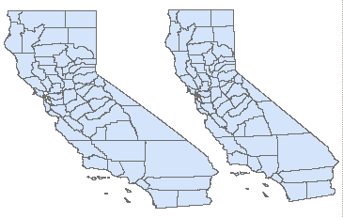
In the illustration of California the map on the left is unprojected and is increasingly stretched as one goes northward. The map on the right has been converted to a UTM projection for the state and is more correct in its proportions. This issue becomes serious when one attempts to make calculations that involve direction, distance, or area on the map.

For measurements, one must therefore either convert the latitude and longitude to grid values or utilize measurement equations that take earth curvature and latitude and longitude into account. These are more complex, but the results are useful.

To approximate the actual distance between points measured on the surface of the earth one may use the following equation:

Cos (Distance) = Sin (lat a) * Sin (lat b) + Cos (lat a) * Cos (lat b) * Cos (difference of long a and long b)

where "lat" is latitude and "long" is longitude and a and b are two points on the earth.

The final answer is multiplied by 69.11, the approximate number of miles per degree on the earth. The equation necessary to convert latitude and longitude differences into distance in miles on the surface of the earth is shown below. Note that degrees of arc must be converted to radians (i.e. a length of arc equal to the radius of its circle) for use in computer trigonometric functions. Thus 360o of a circle equals 2π radians. To convert degrees to radians multiply by π/180 and to convert radians to degrees multiply by 180/π.

For computational purposes, the above equation may be stated as:

= 180/π ∗ (ACOS ((SIN(π/180*lat_1) * SIN(π/180*lat_2)) + (COS(π/180*lat_1) * COS(π/180*lat_2) * COS(π/180*ABS(long_1 - long_2))))) * 69.11

where lat_1, long_1 and lat_2, long_2 are the latitude and longitudes of two points.

For relatively small areas, the earth may be treated as flat and the Euclidean distance equation (D = square root of the sum of the squares of the differences in x and y) may be used. However, one must still compensate for the shortened distance between degrees of longitude that occurs as one moves away from the equator. Below, the difference in degrees of latitude may be multiplied by 69.11 (miles in a degree) and squared. The difference in degrees of longitude must be multiplied by the cosine of the latitude, the radius of the earth (3959 miles) and one degree of the earth's circumference before it can be squared.

= sqrt( ( diff in lat * 69.11)2 + ((diff in long) * cos(lat) * Pi/180 * 3959)2 )

=SQRT (ABS(Diff_in_lat) * 69.11) **2 + (ABS(Diff_in_long) * COS(π/180*Lat)) * 3959)**2)

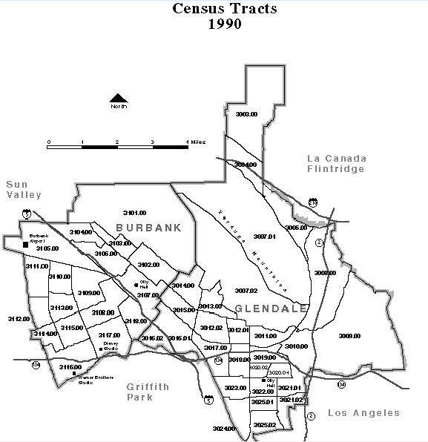

In the table below, Glendale Tract 3019.00 was selected as a site for a facility. We need to know how many people live within a one-mile radius of the selected tract. Using the tabled values of latitude and longitude for each tract centroid, the distance in miles from each tract to 3019.00 was calculated. The tracts were then sorted by increasing distance of their centroids from tract 3019.00. There are 59,905 people whose tract centroids are within a 1 mile radius of tract 3019.00.

The filter for inclusion or exclusion is whether a tract centroid falls within the circle radius. If more precision is required, one might use block-level data or use GIS software to overlay the ring onto the tracts and then allocate the population to the ring based on the amount of area of each tract that it covers.

Table 15. Distances from Tract 3019.00

Glendale Tract | Longitude | Latitude | Population | Distance in Miles
3019.00 | -118.247 | 34.155 | 6,123 | -
3020.00 | -118.245 | 34.149 | 10,389 | 0.5
3011.00 | -118.246 | 34.162 | 5,844 | 0.5
3018.00 | -118.259 | 34.153 | 6,969 | 0.7
3010.00 | -118.231 | 34.158 | 4,845 | 0.9
3022.00 | -118.247 | 34.142 | 8,791 | 0.9
3021.01 | -118.236 | 34.144 | 9,290 | 1.0
3012.01 | -118.260 | 34.164 | 7,654 | 1.0
3023.00 | -118.262 | 34.143 | 9,256 | 1.2
3025.01 | -118.249 | 34.138 | 8,966 | 1.2
3017.00 | -118.271 | 34.154 | 7,891 | 1.4
3021.02 | -118.236 | 34.135 | 6,668 | 1.5
3012.02 | -118.273 | 34.164 | 7,005 | 1.6
3007.02 | -118.262 | 34.178 | 5,459 | 1.8
3024.00 | -118.259 | 34.131 | 5,477 | 1.8
3025.02 | -118.250 | 34.129 | 7,101 | 1.8
3013.00 | -118.271 | 34.174 | 1,974 | 1.9
3008.00 | -118.220 | 34.185 | 6,668 | 2.5
3015.00 | -118.288 | 34.173 | 8,133 | 2.7
3016.00 | -118.293 | 34.164 | 10,667 | 2.7
3014.00 | -118.282 | 34.182 | 3,606 | 2.7
3009.00 | -118.200 | 34.162 | 6,800 | 2.7
3006.00 | -118.237 | 34.207 | 6,080 | 3.6
3005.00 | -118.231 | 34.216 | 9,060 | 4.3
3007.01 | -118.272 | 34.222 | 5,609 | 4.8
3002.00 | -118.238 | 34.228 | 4,655 | 5.1
3004.00 | -118.255 | 34.229 | 5,211 | 5.1
3001.00 | -118.235 | 34.242 | 5,744 | 6.0
3003.00 | -118.253 | 34.251 | 6,009 | 6.6

B. Centers of Population

Often it is desirable to look at an entire distribution of points and find a point that is located centrally to all others. For example, if one were locating a warehouse or an office to serve customers one might want to choose a location that would minimize the travel for the greatest number of people. One might also compute such a value at different time periods in order to determine in which direction and how far the population is shifting. This has been done each decade for the entire United States to track the westward shift of population from the east coast.

The Mean Center

One simple calculation of the center of population is the center of gravity or mean center. This may or may not be weighted by the population of each of the points, but it usually is weighted. In the table below, a portion of the census tracts in Glendale are shown along with their non-Hispanic white populations for 1980 and 1990. The location of the center of population for each decade is shown at the bottom. From this we can see that the center of non-Hispanic white population has shifted west and south from 1980. Using the distance equation from above indicates that the shift was .21 miles. Glendale actually gained non-Hispanic white population during this decade, a trend that was counter to most areas in Los Angeles County. Much of this gain is likely due to the large number of Armenian immigrants who have settled in Glendale during the 1980s.

Table 16. Mean Center of Glendale Tracts 1980 and 1990
Tract | Longitude | Latitude | 1990 NH White | 1980 NH White | Long x  1990 Pop | Lat x  1990 Pop | Long x  1980 Pop | Lat x  1980 Pop
3101.00 | -118.311 | 34.216 | 4303 | 4393 | -509093.91 | 147231.018 | -519741.93 | 150310.449
3102.00 | -118.299 | 34.190 | 6352 | 6128 | -751435.87 | 217173.927 | -724936.87 | 209515.401
3103.00 | -118.318 | 34.198 | 2445 | 2886 | -289286.87 | 83614.9658 | -341465 | 98696.4381
3020.00 | -118.245 | 34.149 | 6773 | 5122 | -800872.19 | 231289.314 | -605649.99 | 174909.769
3021.01 | -118.236 | 34.144 | 4814 | 3760 | -569188.7 | 164369.216 | -444567.83 | 128381.44
3021.02 | -118.236 | 34.135 | 3993 | 3716 | -472114.79 | 136301.055 | -439363.53 | 126845.66
3022.00 | -118.247 | 34.142 | 4922 | 3108 | -582010.01 | 168047.662 | -367510.59 | 106113.802
3023.00 | -118.262 | 34.143 | 3733 | 3218 | -441471.05 | 127455.446 | -380566.25 | 109871.852
3024.00 | -118.259 | 34.131 | 1774 | 1816 | -209792.01 | 60549.0823 | -214758.9 | 61982.6006
3025.01 | -118.249 | 34.138 | 4233 | 2793 | -500548.22 | 144504.249 | -330269.59 | 95346.1772
3025.02 | -118.250 | 34.129 | 3167 | 2863 | -374497.41 | 108086.86 | -338549.44 | 97711.6133
 |  | SUM | 193857 | 185894 | -22928530 | 6625513 | -21987087 | 6353818
 |  | Mean |  |  | -118.275 | 34.177 | -118.278 | 34.180

Population Potential

When one wants to calculate the minimum distance between a given set of points it is possible to determine which of the points has the least overall distance to all other points. This statistic is called the population potential or aggregate accessibility index. The existing set may be the total set of tracts or they may be a special set of points such as potential shopping center locations.
n
Accessibility Index = Σ (Pi /di j)
i=1

Here Pi is the population of each area and d is the distance from a potential location to the centroid of the population area. The result will be in persons per mile. The higher this value, the greater the accessibility of a selected site to all other people.

In the table below Glendale tract 3013.00 is compared to tract 3019.00 as a potential site for a service center. Here tract 3019.00 has a higher aggregate accessibility index of 138,770 persons per mile and is relatively more accessible to the population than is tract 3013.00

Table 17. Accessibility Index to Two Glendale Tracts
Tract | 1990 Population | Distance to | Pop / Distance | Distance to | Pop / Distance
 |  | 3019 | 3019 | 3013 | 3013
3001.00 | 5744 | 6.0 | 952.8 | 5.1 | 1127.1
3002.00 | 4655 | 5.1 | 918.8 | 4.2 | 1114.9
3003.00 | 6009 | 6.6 | 906.1 | 5.4 | 1114.3
3004.00 | 5211 | 5.1 | 1015.3 | 3.9 | 1339.9
3005.00 | 9060 | 4.3 | 2130.5 | 3.6 | 2495.0
3006.00 | 6080 | 3.6 | 1670.9 | 3.0 | 2030.8
3007.01 | 5609 | 4.8 | 1164.6 | 3.3 | 1718.9
3007.02 | 5459 | 1.8 | 3058.1 | 0.6 | 9258.9
3008.00 | 6668 | 2.5 | 2627.3 | 3.0 | 2224.7
3009.00 | 6800 | 2.7 | 2500.1 | 4.2 | 1635.2
3010.00 | 4845 | 0.9 | 5321.1 | 2.5 | 1912.9
3011.00 | 5844 | 0.5 | 12336.7 | 1.6 | 3550.1
3012.01 | 7654 | 1.0 | 7752.6 | 0.9 | 8108.5
3012.02 | 7005 | 1.6 | 4322.0 | 0.7 | 9880.4
3013.00 | 1974 | 1.9 | 1027.8 | 0.0 | 0.0
3014.00 | 3606 | 2.7 | 1329.0 | 0.8 | 4535.5
3015.00 | 8133 | 2.7 | 3064.2 | 1.0 | 8279.9
3016.00 | 10667 | 2.7 | 3966.6 | 1.4 | 7373.1
3017.00 | 7891 | 1.4 | 5680.7 | 1.4 | 5657.2
3018.00 | 6969 | 0.7 | 9697.2 | 1.6 | 4292.9
3019.00 | 6123 | 0.0 | 0.0 | 1.9 | 3188.4
3020.00 | 10389 | 0.5 | 22195.9 | 2.3 | 4476.2
3021.01 | 9290 | 1.0 | 9437.9 | 2.9 | 3208.0
3021.02 | 6668 | 1.5 | 4333.7 | 3.4 | 1965.6
3022.00 | 8791 | 0.9 | 9636.3 | 2.6 | 3344.6
3023.00 | 9256 | 1.2 | 7566.3 | 2.2 | 4126.9
3024.00 | 5477 | 1.8 | 3025.8 | 3.0 | 1796.2
3025.01 | 8966 | 1.2 | 7238.8 | 2.8 | 3156.8
3025.02 | 7101 | 1.8 | 3892.4 | 3.4 | 2115.4
 |  |  | 138,770 |  | 105,028

One problem with this index is how to handle the population of the tract serving as the temporary center. A typical solution is to use a half the distance to the nearest tract since it is likely that persons in that tract would be scattered within it. Thus, tract 3019.00 would pick up an additional 24,492 persons per mile (6,123 / .25) and tract 3013.00 would gain an additional 3423.

While the above calculations can be done in a spreadsheet, it is far more practical to utilize Geographic Information System (GIS) software to make them. Packages such as ArcGIS contain specific tools for making spatial calculations. However, these are beyond the scope of this module on the Census.
C. Exercises

Exercise 16. Examining the Demographics of a Service Area

