Exploring Issues of Fair Lending Practices Using Home Mortgage Disclosure Act (HMDA) data
Author: Nancy Hudspeth
Department of Political Science & Public Administration
California State University, Stanislaus
Turlock, CA 95382
Email: nhudspeth@csustan.edu

Last modified June 7, 2019

Goals of Exercise

Students will use HMDA data and SPSS to answer the research questions:

In 2017, were there differences in mortgage approval rates for different demographic groups (race, ethnicity, gender) controlling for income (and other characteristics)?

Note to the Instructor:
The data used in these exercises is available to the public and may be downloaded from the Consumer Financial Protection Bureau website. There are filters provided on the CFPB website, but when I recently downloaded the data included in this exercise, I found that in order to get data on denials, I needed to download all records for a particular place and year instead of using the more specific filters.
I’ve provided the data set used in this exercise, HMDA 2017 State of California.sav which is a subset of the 2017 HMDA dataset available from the Consumer Financial Protection Bureau. It contains all records for the State of California and was downloaded March 29, 2019. Some of the variables in the dataset have been recoded and some new variables have been created (which are explained in this exercise). These exercises use SPSS to analyze the data.
I’ve also provided a smaller data set, HMDA 2017 CA 1st lien 1-4 fam dwellings.sav which is a subset of the above data set. The main difference between the two data sets is that the first contains all types of properties and all types of mortgage applications. The second excludes mortgage applications for multifamily properties, manufactured properties, and properties that would not be used as the borrower’s primary residence. It also excludes refinancing and home improvement mortgage applications.
More detail about the data is provided below.
You have permission to use this exercise and to revise it to fit your needs.
References for using SPSS include:
IBM SPSS Statistics for Windows Version 23: A Basic Tutorial by Linda Fiddler, John Korey, Edward Nelson (Editor), and Elizabeth Nelson. The online version of the book is at the Social Science Research and Instructional Center's Website.
IBM SPSS for Introductory Statistics: Use and Interpretation by George A. Morgan, Nancy L. Leech, Gene W. Gloeckner, and Karen C. Barrett (5th edition; 2013). Routledge.
SPSS Survival Manual: A Step By Step Guide to Data Analysis Using IBM SPSS by Julie Pallant (6th edition; 2016). McGraw Hill Education.
Statistics for People Who (Think They) Hate Statistics by Neil J. Salkind (6th edition; 2017). SAGE Publications, Inc. This is a good book for beginners to help them get started.

Background: Fair Lending and HMDA

The Home Mortgage Disclosure Act (HMDA) is a federal law that requires mortgage lenders to report information about the loans they have approved (and denied) in order to show that they are serving their communities fairly. Congress passed the HMDA in 1975 to provide citizens with information that could be used to identify and address discriminatory lending practices, such as “redlining.”

The practice that became known as redlining began in the 1930s when a federal program called the Home Owners’ Loan Corporation (HOLC) created color-coded maps of more than 200 U.S. cities. These maps rated neighborhoods in terms of their desirability for investment. The “best” areas were coded blue or green; the “worst” areas were coded red. The HOLC maps were then used by the Federal Housing Administration (FHA), banks, and insurance companies when deciding whether, and at what interest rate, to approve mortgage applications for property located in various neighborhoods. In general, the redlined neighborhoods were areas inhabited by low-income people, recent immigrants, and racial, ethnic, or religious minorities, while the green and blue neighborhoods were inhabited by middle-class and wealthy white homeowners. Thus, the HOLC, a federal program that had originally been intended to boost the housing market during the Great Depression, contributed to the decline of central cities, the growth of suburbia, and hindered the efforts of low-income minorities to build wealth through homeownership. In 1968, the Fair Housing Act banned discriminatory lending practices, including redlining, but the effects are still apparent today.

To learn more about the history of redlining and to view 150+ interactive maps, see Robert K. Nelson, LaDale Winling, Richard Marciano, Nathan Connolly, et al., “Mapping Inequality: Redlining in New Deal America.” For reviews of the literature on fair lending see, for example, Bartlett et al. (2018) and Turner and Skidmore (1999).

Data used
According to HMDA’s website, “The Home Mortgage Disclosure Act (HMDA) requires many financial institutions to maintain, report, and publicly disclose loan-level information about mortgages. These data help show whether lenders are serving the housing needs of their communities; they give public officials information that helps them make decisions and policies; and they shed light on lending patterns that could be discriminatory. The public data are modified to protect applicant and borrower privacy.”
HMDA data is available from the Consumer Financial Protection Bureau. The data can be filtered by year (2007-2017), geographic area (state, county, metropolitan statistical area), and loan type and purpose (e.g., for first-lien, owner-occupied, 1-4 family homes) and type of financing. However, as I noted above, in order to get data that includes denials I needed to download all records for a place and year. The more specific filters will only generate data on loans that were approved.

For this exercise, I have attached an SPSS dataset for the State of California, 2017, that contains all data on applications for residential mortgages, including the applicant and co-applicant (race, ethnicity, gender, income), loan purpose, loan amount, and decision on the loan which includes several categories for reasons why a loan is denied. If desired, the dataset can be sub-divided by county – or other datasets may be created and downloaded by the instructor. The name of the SPSS file is “CA 2017 hmda_lar 1st Lien 1-4 family dwellings.sav”

I’ve also provided a smaller data set, HMDA 2017 CA 1st lien 1-4 fam dwellings.sav which is a subset of the above data set. The main difference between the two data sets is that the first contains all types of properties and all types of mortgage applications. The second excludes mortgage applications for multifamily properties, manufactured properties, and properties that would not be used as the borrower’s primary residence. It also excludes refinancing and home improvement mortgage applications.
This second data set was created from the first, using the “select cases” function and the following filters:
- Property type = one to four family dwelling (other than manufactured housing)
  - Manufactured housing and multi-family housing were excluded

- Loan purpose = home purchase
  - Refinancing and home improvement were excluded

- Owner occupancy = Owner-occupied as a principal dwelling
  - Not owner-occupied as a principal dwelling was excluded
Either dataset will work for the exercises; the output described is for the complete dataset (all cases).
The data set includes 55 variables, which are listed along the top row (columns or “fields”). In the complete State of California dataset, in 2017 there are 1,048,575 rows. Each row indicates a mortgage application.
The variables are collected using the HMDA Reporting Form (example below) which is completed by the lending institutions. Detailed descriptions of the variables (“field reference”) are listed on the CPFB website here https://cfpb.github.io/api/hmda/fields.html

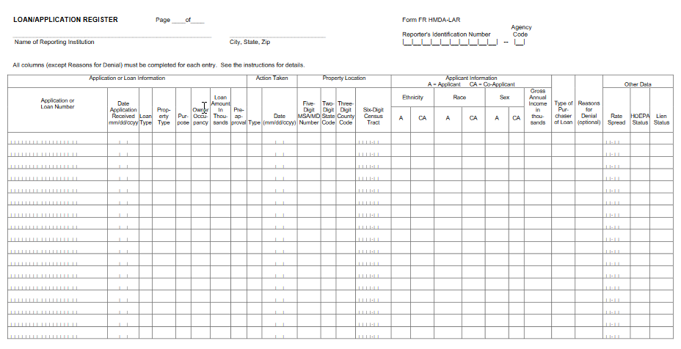

Steps in the Analysis

Frequency distributions
Open the Home Mortgage Disclosure Act (HMDA) data set provided with this exercise.
Run frequencies in SPSS for the variables listed below. The name in parentheses is the variable name.
- SPSS Commands: Analyze Descriptive Statistics Frequencies; Move variables into box; OK).
- Loan originated or denied (action_taken_name),
- Loan purpose: home purchase, refinance, home improvement (loan_purpose_name),
- Loan type – either guaranteed by government program such as FHA, VA, or RHS, or conventional (loan_type_name)
- Denial reasons – 3 variables (denial_reason_1, denial_reason_2, denial_reason_3)
- Applicant’s ethnicity (applicant_ethnicity_name)
- Applicant’s race – 3 variables – applicants may select up to 5 races to identify themselves (applicant_race_name_1, applicant_race_name_2, applicant_race_name_3)
- Applicant’s gender (applicant_sex_name)
- Owner occupancy status of the property – second homes, vacation homes, and rental properties are classified as “not owner occupied” (owner_occupancy_name)
- Property type (property_type_name)
- SPSS Shortcut: To get summary statistics of a particular variable (including frequencies), you may simply right-click on the variable in Data View.
SPSS Output:
Frequency tables include four columns of numbers.
The “frequency” column tells you the number of loan applications that correspond to each category in the variable.
For the HMDA 2017 State of California data (all records):
For the variable action_taken_name, there are 3 categories: “application approved but not accepted,” “application denied by financial institution,” and “loan originated.” The SPSS output shows that of a total of 1,048,575 loan applications, 53,535 were approved but not accepted, 117,287 were denied, and 877,753 were originated.
The “percent” column converts the frequencies to percentages using all cases (1,048,575) as the denominator. For the variable action_taken_name, 5.1% of the loans were approved but not accepted, 11.2% were denied, and 83.7% were originated.
The “valid percent” column accounts for missing cases. For action_taken_name all the percentages are valid because none of the information is missing. For some of the variables we will examine later (e.g., applicant income) some of the information was unavailable (perhaps the applicant didn’t know or refused to answer the question) and the “valid percent” will reflect the difference by using only those cases with valid (complete) information. The denominator will be reduced for these variables.
The “cumulative percent” column cumulates the valid percentages into a running total. Look at the table for action_taken_name. The first entry in the cumulative percent column is 5.1 because 5.1% of the cases were approved but not accepted. The second entry is 16.3 because 16.3% were either approved but not accepted or denied by the financial institution. The third entry is 100.0 because all 100% of the cases were either approved but not accepted, denied, or resulted in a loan originated by the financial institution. This feature is more useful with categories that are continuous or ordinal such as “strongly disagree,” “disagree,” neither agree nor disagree,” “agree,” “strongly agree.”
Note – for the denial variables (denial_reason_name_1, 2, and 3), most cases were approved, and were not denied. So, in these cases the values for denial_reason_name_1, 2, and 3 are blank. For example, looking at the frequency output for denial_reason_name_1 the category is blank for 969,736 loan applications.

  - Rank-order, crosstabs
Social scientists look for variations. Variations in data may occur over time, in different places, or among different groups of people. If there is no variation in data it suggests that everyone or everything is the same with respect to those measures.
Let’s say we want to look at loan applications, approvals and denials by county. We would do a crosstabulation which creates a table showing the frequencies, or number of cases, for each combination of variables.
- SPSS Commands: Analyze Descriptive Statistics Crosstabs; Put county_name in the Row(s) box and action_taken_name in the Column(s) box; OK.
SPSS Output:
You will see a table with each county name listed as a row and the three categories of action_taken_name (application approved but not accepted; application denied by financial institution; loan originated) and total in columns across the top. Each cell indicates the number of cases that correspond to that combination of rows and columns. For example, using the 2017 State of California data (all records), in Humboldt County there were 2,394 loan applications in total, of which 382 were denied and 1,906 resulted in loans originated. (Note that there are 608 missing cases - applications that didn’t indicate a county.)
Export SPSS output into Excel and explore:
You can export the output table into an Excel spreadsheet by right-clicking on the SPSS output table and following the prompts.
After exporting into Excel, we can compute the rejection rate of loan applications by county. (Divide the number of applications that were denied by the total number of applications).
Using the sort function in Excel, rank the counties from highest rejection rate to lowest. Colusa County had the highest rejection rate (26.4%) and San Luis Obispo County had the lowest (2.8%). Refer to the county map in the Appendix (page 24). Does there appear to be a geographical pattern in the loan rejection rate by county? Compare the pattern you find in your data to the map on page 25, which shows Median Household Income for Counties 2013-2017.

  - Recoding variables: Income brackets
Let’s say one preliminary hypothesis is that rejection of mortgage applications is related to applicants having low income. There are two variables in the HMDA data that are measures of income. These include:
- The percentage of the median family income for the census tract where the property is located compared to the median family income for the Metropolitan Statistical Area /Metropolitan Division that the property is located in. (tract_to_msamd_income)
- Applicant’s income in thousands (applicant_income_000s)
Generating a frequency table of either of these variables will create a very long output table that is not very useful.
For example, a frequency table of applicant_income_000s displays the number of applicants with a particular income, and each row may represent a $1 increment, and may contain only 1 person. For this reason, in order to use this variable, we must create brackets. In the map on page 25, for example, there are 5 brackets of median family income.
In our analysis, we will create 10 brackets:
- 0 – $49,999
- $50,000 – $74,999
- $75,000 – $99,999
- $100,000 – $149,999
- $150,000 – $199,999
- $200,000 – $249,999
- $250,000 – $299,999
- $300,000 – $349,999
- $350,000 – $499,999
- $500,000 and up
To create brackets of income, we will use the “recode” function in SPSS.
- SPSS Commands: Transform Recode into different variables; Move applicant_income_000s into the Numeric Variables box. Under “Output Variable” create a new name for your recoded variable (app_inc_recode_3) Then Old and New Values…
- Note 1: you could recode your variable into the same variable without creating a new one, but this will wipe out the original data and will prevent you from recoding it into different brackets in the future, so it’s not recommended.
- Note 2: The data set already contains this recoded variable, app_inc_recode_2.
Now you will put in the ranges of income in the box as shown:
- Click “Range, LOWEST through value:” and enter 39.999 in the box. (Remember, the variable is income in 1,000s). Then click New Value and enter 1 in the box; Add.
- Click “Range” and enter 40.0 and 49.999 in the boxes. Then click New Value and enter 2 in the box; Add.
- Continue for all 7 categories of income.
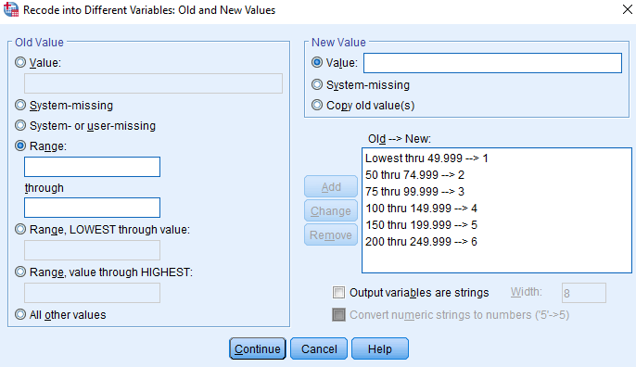
- Now, when you examine your data, you should see the new variable.
- Go to variable view (click on tab at the bottom) and on the row for app_inc_recode_3 click on “Values,” and enter the value labels for the brackets (i.e., 1.00 = “less than or equal to 49,999”….)
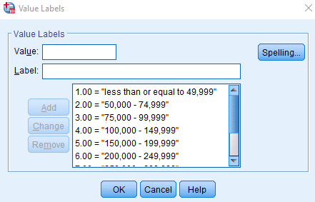

  - Histograms
Histograms are graphical representations of frequencies. A histogram can tell us if our data is normally distributed, which is important to further statistical analysis. In this example, let’s create a histogram of app_inc_recode_2.
- SPSS Commands: Analyze Descriptive Statistics Frequencies; Put app_inc_recode_2 in the Variable(s) box; Charts Histograms Continue OK.
You will see the output below. Double-clicking this output chart will bring up an editor window that you can use to change the axes titles, axes increments, fonts, colors, and other aspects of the graph.
What the histogram shows us is that the largest number of applicants, about 239,000, had incomes in the range of $100,000 to $149,999. This is consistent with the summary descriptive statistics below.
- SPSS Commands: Analyze Descriptive Statistics Frequencies; Put applicant_income_000s in the Variable(s) box; Statistics Click Mean and Median OK.

Statistics
applicant_income_000s
N | Valid | 991654
 | Missing | 56921
Mean |  | 158.83
Median |  | 105.00
Minimum |  | 1
Maximum |  | 610715
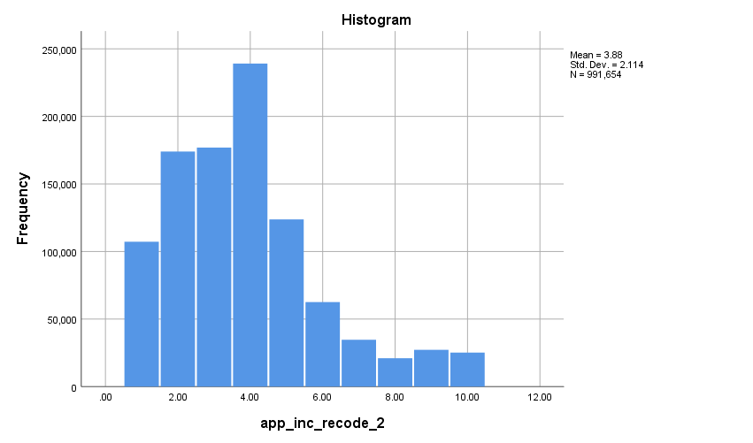
Later, we might want to revise or “fine tune” our brackets so that we have a bracket for the applicants who are between $105,000 (the median) and $159,000 (the mean); this way we can easily show the number who are above/below the mean and median.
Note that the histogram is skewed; the mean is higher than the median, due to the applicants with very high incomes.

  - Creating a new variable: Combine race and ethnicity

In order to determine if there is discrimination in mortgage lending, HMDA mandates that lenders collect and report data on the race and ethnicity of loan applicants.

Applicants and co-applicants may choose up to 5 races to identify themselves and there are 5 categories that they may choose from: White; Black or African American; Asian; Native Hawaiian or Other Pacific Islander; American Indian or Alaska Native.

Applicants and co-applicants may choose one of two ethnicities: Hispanic or Latino, or Not Hispanic or Latino.

In the HMDA data, the following variables represent race/ethnicity:

- applicant race_name_1 thru applicant_race_name_5
- co_applicant_race_name_1 thru co_applicant race_name_5
- applicant_ethnicity_name
- co_applicant_ethnicity_name

Let’s examine the data on applicant race and ethnicity.

In the frequency table for applicant_race_name_1 below, we see that in addition to the 5 categories of race, there are 2 categories indicating that information was not collected from some applicants.

applicant_race_name_1
 |  | Frequency | Percent | Valid Percent | Cumulative Percent
Valid | American Indian or Alaska Native | 9714 | .9 | .9 | .9
 | Asian | 147245 | 14.0 | 14.0 | 15.0
 | Black or African American | 43180 | 4.1 | 4.1 | 19.1
 | Information not provided by applicant in mail, Internet, or telephone application | 169071 | 16.1 | 16.1 | 35.2
 | Native Hawaiian or Other Pacific Islander | 10595 | 1.0 | 1.0 | 36.2
 | Not applicable | 14712 | 1.4 | 1.4 | 37.6
 | White | 654058 | 62.4 | 62.4 | 100.0
 | Total | 1048575 | 100.0 | 100.0

In the frequency table for applicant_ethnicity_name below, we see that in addition to the 2 categories of ethnicity, there are 2 categories indicating that information was not collected from some applicants.

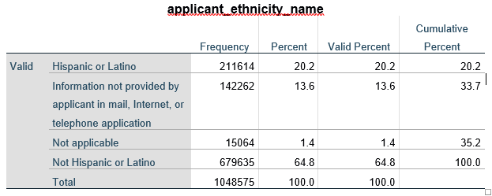

Demographers often combine race and ethnicity when analyzing population data. A commonly-used list of demographic categories is:

  - White, Non-Hispanic
  - African American, Non-Hispanic
  - Asian, Non-Hispanic
  - Native Hawaiian or Other Pacific Islander, Non-Hispanic
  - American Indian or Alaska Native, Non-Hispanic
  - Two or More Races, Non-Hispanic
  - Hispanic, All Races

Sometimes, if the numbers of people in categories 4 through 6 are relatively small, these will be aggregated and reported as “Other.”

To create the above categories, we need to combine the race and ethnicity variables. This means we will use the recode function with if/then conditions for inclusion into the new categories.

Note: I have created this combined variable, App_Race_Eth, and it’s included in the dataset provided with this exercise. For those who want to practice creating a new variable, or are using a different dataset, the steps are described below. Or, you may wish to repeat these steps to create the same variable for the co-applicants. Otherwise, you may use the variable provided (App_Race_Eth) and skip to Exercise 6. Crosstabs, below.

First, we create new variables called “app_race_code_1 thru 5” which will take on a value of 1 through 7 based on the values of the variable (1 thru 5 as listed above; 6 = not applicable and 7 = information not provided…).

- SPSS Commands: Transform Recode into Different Variables; input Old and New values into the box. SPSS will save these, so doing the variables 2 through 5 is much quicker.

Old Values | New Values
White | 1
Black or African American | 2
Asian | 3
Native Hawaiian or Other Pacific Islander | 4
American Indian or Alaska Native | 5
Not applicable | 6
Information not provided by applicant in mail, Internet, or telephone application | 7

- Using “recode into same variable” assign values of 0 to the “system- or user-missing” blank cells in the app_race_code variables. This is useful for app_race_code_2 and beyond, because those applicants who identified themselves as only 1 race have left these cells blank. If race_code_2 has a value, it means the person identifies as mixed-race.

- Go into Variable View and define the values of the app_race_code series so you don’t forget what they mean.

Repeat the above process to create “app_eth_code” from “applicant_ethnicity_name.”

- SPSS Commands: Transform Recode into Different Variables; input Old and New values into the box.

Old Values | New Values
Hispanic | 1
Non-Hispanic | 2
Not applicable | 3
Information not provided by applicant in mail, Internet, or telephone application | 4

Now, we will create a new variable called App_Race_Eth by recoding app_race_code_1 into a different variable called App_Race_Eth. To create the new variable we will choose cases based on the criteria below using “if/then” statements in SPSS. We can only do 1 if/then statement at a time so we will recode into App_Race_Eth a total of 7 times.

The categories of App_Race_Eth are:

- White, Non-Hispanic
app_race_code_1 = 1 (White) AND app_eth_code = 2 (Not Hispanic or Latino) AND app_race_code_2 = 0 (if app_race_code_2 = 0 it means that the applicant has identified him/herself as being of only 1 race).
Old values = 1; New values = 1

- African American, Non-Hispanic
app_race_code_1 = 2 (Black or African American) AND app_eth_code = 2 AND app_race_code_2 = 0
Old values = 2; New values = 2

- Asian, Non-Hispanic
app_race_code_1 = 3 (Asian) AND app_eth_code = 2 AND app_race_code_2 = 0
Old values = 3; New values = 3

- Native Hawaiian or Other Pacific Islander, Non-Hispanic
app_race_code_1 = 4 (Native Hawaiian or Other Pacific Islander) AND app_eth_code = 2 AND app_race_code_2 = 0
Old values = 4; New values = 4

- American Indian or Alaska Native, Non-Hispanic
app_race_code_1 = 5 (American Indian or Alaska Native) AND app_eth_code = 2 AND app_race_code_2 = 0
Old values = 5; New values = 5

- Mixed Race, Non-Hispanic
app_race_code_2 > 0 AND app_eth_code = 2
Old values = 1, 2, 3, 4, 5; New values = 6

- Hispanic, All Races
app_eth_code = 1
Old values = 1, 2, 3, 4, 5; New values = 7

- SPSS Commands: Transform Recode into Different Variables; Put app_race_code_1 and App_Race_Eth” into the Numeric Variable and Output Variables boxes. Click “Old and New Values…” and input the values in 1 thru 7 above, depending on which category you’re doing. (For example, if you are creating the category for Asian Non-Hispanic, enter Old values 3, New values 3.) Then, click “IF” and enter the If/then statement in 1 thru 7 above, depending on which category you’re doing. See below.
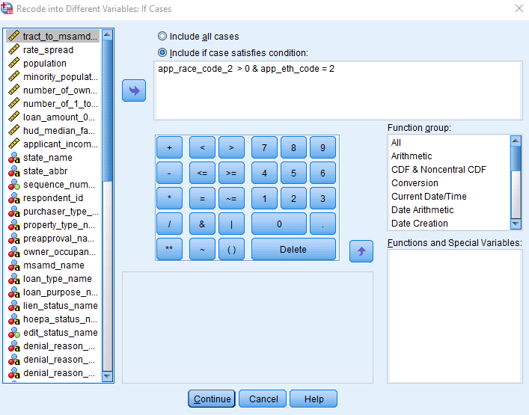
  - Crosstabs, Chi-Square: Race & ethnicity x action taken

Our inquiry is whether different demographic groups are treated the same or differently in the mortgage application process. We hypothesize that there will be significant differences; due to the history of redlining and discrimination in housing we hypothesize that White, Non-Hispanic mortgage applicants will be approved at higher rates than other groups.

Now that we have our demographic variable for race and ethnicity App_Race_Eth, we can crosstabulate this with action_taken_name to see if different groups of applicants are approved and rejected at the same rate. The crosstabulation command will create an output table of frequencies that indicate the number of cases that fall into the particular categories.

Let’s see whether the different groups were approved or rejected at the same rate.

- SPSS Commands: Analyze Descriptive Statistics Crosstabs; Put App_Race_Eth in the Rows box and action_taken_name in the Columns box OK.

SPSS Output:

The output table is shown below. Each demographic group is listed as a row and the three categories of action_taken_name (application approved but not accepted; application denied by financial institution; loan originated) and total are in the columns across the top. Each cell indicates the number of cases that correspond to that combination of rows and columns. For example there were 12,905 Asian, Non-Hispanic applicants who were rejected.
Using this data, does it appear that different groups were rejected at different rates, or were all treated the same?
- Which group had the lowest rejection rate?

- Which group had the highest?

- What was the overall rate of rejection?

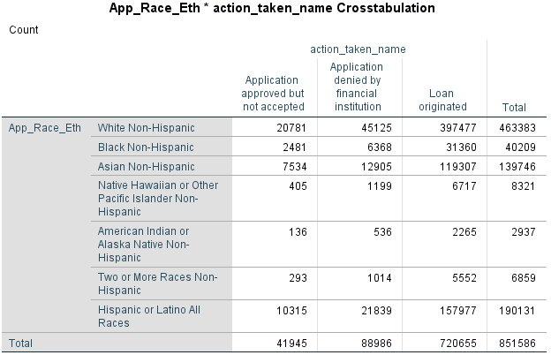

Next, let’s look at whether the frequencies we’ve obtained above are significantly different than what we’d expect to obtain due to random chance.
For example, there were 851,586 total applicants, of which 40,209 (4.7%) were Black, Non-Hispanic. There were a total of 88,986 applications that were rejected. Since 4.7% of the applicant population is Black, we’d expect 4,202 of the total who were rejected to be Black applicants. Instead, we see that 6,368 Black applicants were rejected.
On the flip side, 54.6% of the total applicants were White, Non-Hispanic. Were 54.6% of the rejected applicants White, Non-Hispanic?
We want to know whether these differences are significant. We can answer this question by using the Chi-Square test.
- SPSS Commands: Analyze Descriptive Statistics Crosstabs; Put App_Race_Eth in the Rows box and action_taken_name in the Columns box. Statistics Chi-Square. Cells Counts (select Observed); Percentages (select Row) OK.

- Note: In this analysis we are investigating whether an applicant’s race/ethnicity has an effect on how they are treated in the mortgage application process. So the independent variable is App_Race_Eth and the dependent variable is action_taken. In the crosstabs computation it doesn’t matter whether the independent or dependent variable is placed in the rows or the columns, but the percentages should be computed for the independent variable (in this case, the rows).

SPSS Output:

The SPSS output is shown below. First, the crosstabulation table clearly shows us the different rejection rates for each demographic group. For example, 9.7% of White, Non-Hispanic applicants were rejected compared to 18.2% of American Indian and 15.8% of Black, Non-Hispanic applicants.

The result is statistically significant with a large value of Chi-Square. So our research hypothesis is supported.

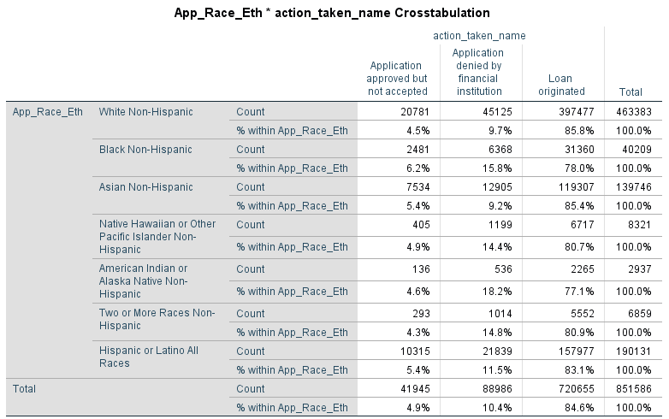
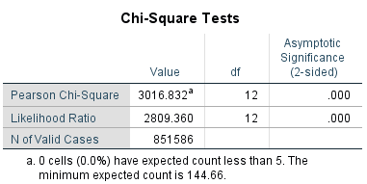

  - Crosstabs, Chi-Square: Race & ethnicity x action taken x applicant’s income

The work that we did in Exercises 2 and 3 suggested that mortgage rejection could be related to the applicants’ incomes, and we recoded the applicants’ income variable into a new variable with 10 brackets (app_inc_recode_2).
Let’s see whether income is related to the two previous variables we examined: race/ethnicity and action taken. What do you expect the relationships between the three variables will be?
Run crosstabs:

app_inc_recode_2 x App_Race_Eth
app_inc_recode_2 x action_taken

Describe your findings. With income as the independent variable (rows), read down the “application denied” column.

  - Controlling for applicant’s income

Our research question is whether different demographic groups experience differential treatment in the mortgage application process—whether racial and ethnic discrimination occurs. However, the results in Exercise 7 showed that applicant’s income is related to both Race/Ethnicity and mortgage approval. Perhaps racial and ethnic minorities are rejected at higher rates than Whites because their incomes are lower. For this reason we want to control for applicants’ income.
We do this by telling SPSS to divide our population into sub-groups based on income, and crosstabulate App_Race_Eth x action_taken for each sub-group. We control for income by analyzing applicants who are all at the same income level. This way we can see whether there are still differences in rejection/approval rates for the different race/ethnic groups.
- SPSS Commands: Analyze Descriptive Statistics Crosstabs; Put App_Race_Eth in the Rows box and action_taken_name in the Columns box and app_inc_recode_2 in the Layer 1 of 1 box. Statistics Chi-Square. Cells Counts (select Observed); Percentages (select Row) OK.

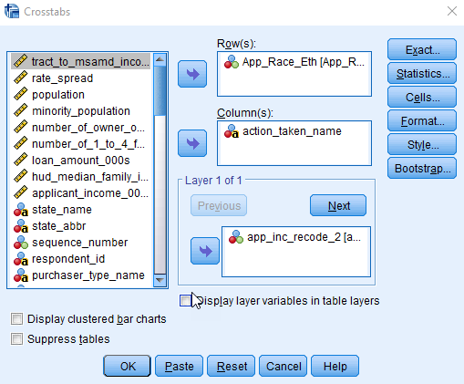

The part of the output tables are shown on the following pages. If the relationship between an applicant’s race/ethnicity and mortgage approval was due to income, then the results for each of the income brackets wouldn’t be significant. Instead, we see that there is still a strong relationship.

Chi-Square Tests
app_inc_recode_2 |  | Value | df | Asymptotic Significance (2-sided)
less than or equal to 49,999 | Pearson Chi-Square | 463.681^{b} | 12 | .000
 | Likelihood Ratio | 435.866 | 12 | .000
 | N of Valid Cases | 89289
50,000 - 74,999 | Pearson Chi-Square | 428.093^{c} | 12 | .000
 | Likelihood Ratio | 397.121 | 12 | .000
 | N of Valid Cases | 146208
75,000 - 99,999 | Pearson Chi-Square | 433.869^{d} | 12 | .000
 | Likelihood Ratio | 400.227 | 12 | .000
 | N of Valid Cases | 147083
100,000 - 149,999 | Pearson Chi-Square | 557.060e | 12 | .000
 | Likelihood Ratio | 506.838 | 12 | .000
 | N of Valid Cases | 196618
150,000 - 199,999 | Pearson Chi-Square | 249.966^{f} | 12 | .000
 | Likelihood Ratio | 224.093 | 12 | .000
 | N of Valid Cases | 101422
200,000 - 249,999 | Pearson Chi-Square | 86.619^{g} | 12 | .000
 | Likelihood Ratio | 76.724 | 12 | .000
 | N of Valid Cases | 51141
250,000 - 299,999 | Pearson Chi-Square | 87.998^{h} | 12 | .000
 | Likelihood Ratio | 78.963 | 12 | .000
 | N of Valid Cases | 28424
300,000 - 349,999 | Pearson Chi-Square | 51.243^{i} | 12 | .000
 | Likelihood Ratio | 46.155 | 12 | .000
 | N of Valid Cases | 17252
350,000 - 499,999 | Pearson Chi-Square | 89.096^{j} | 12 | .000
 | Likelihood Ratio | 73.361 | 12 | .000
 | N of Valid Cases | 22281
500,000 and up | Pearson Chi-Square | 115.495^{k} | 12 | .000
 | Likelihood Ratio | 97.170 | 12 | .000
 | N of Valid Cases | 20008
Total | Pearson Chi-Square | 3038.139ª | 12 | .000
 | Likelihood Ratio | 2808.915 | 12 | .000
 | N of Valid Cases | 819726
a. 0 cells (0.0%) have expected count less than 5. The minimum expected count is 132.26.
b. 0 cells (0.0%) have expected count less than 5. The minimum expected count is 24.32.
c. 0 cells (0.0%) have expected count less than 5. The minimum expected count is 28.76.
d. 0 cells (0.0%) have expected count less than 5. The minimum expected count is 24.28.
e. 0 cells (0.0%) have expected count less than 5. The minimum expected count is 28.84.
f. 0 cells (0.0%) have expected count less than 5. The minimum expected count is 12.11.
g. 0 cells (0.0%) have expected count less than 5. The minimum expected count is 7.13.
h. 1 cells (4.8%) have expected count less than 5. The minimum expected count is 2.90.
i. 4 cells (19.0%) have expected count less than 5. The minimum expected count is .98.
j. 4 cells (19.0%) have expected count less than 5. The minimum expected count is 1.90.
k. 3 cells (14.3%) have expected count less than 5. The minimum expected count is 2.94.

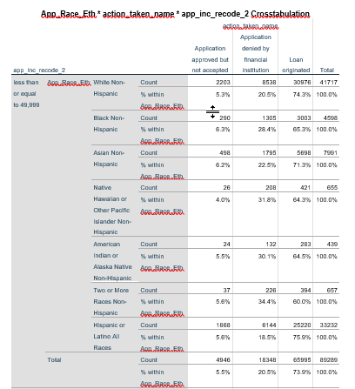

  - Further analysis – your turn

Now it’s your turn – here are some ideas for further analysis.

- If you did the analysis for the complete data set, do you get the same results using the second data set (home purchase, 1-4 family dwellings, owner-occupied)?

- Income is just one of many factors that could explain why a mortgage application is rejected. Others include credit history, debt-to-income ratio, and insufficient collateral. The HMDA dataset includes denial reasons (denial_reason_name_1 thru 3). Could denial reasons explain the differences in rejection rates among different demographic groups? Are there differences in denial reasons among different demographic groups? Re-create the analysis above using denial reasons instead of income.

Hint: Most applicants were denied based on one reason, but some were denied based on 3 reasons. Using the recode function, you can create a new variable that accounts for applicants who have 2 or 3 reasons that they were denied similar to the way we created a new race/ethnicity variable.

- Are there differences between genders in mortgage denial rates? Re-create the analysis above to examine differences between male and female applicants.

- Approval or denial of a mortgage application is just part of the story. Are there differences between demographic groups in terms of the interest rate that the applicant receives, or the amount of the loan that the applicant receives? Use the variables rate_spread and loan_amount_000s to examine this question.

- Repeat the analysis for a particular county (or group of counties) in California.

- Compare California to another state.

- Have there been changes over time?

APPENDIX 1. COUNTY MAPS

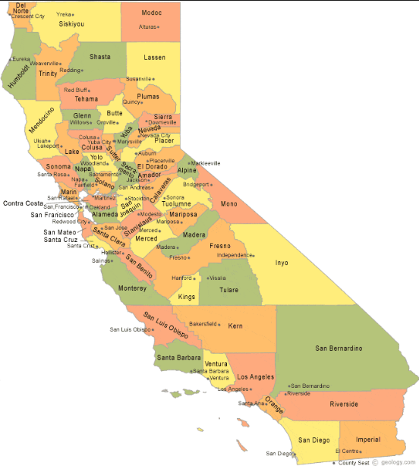
Source: geology.com https://geology.com/state-map/california.shtml

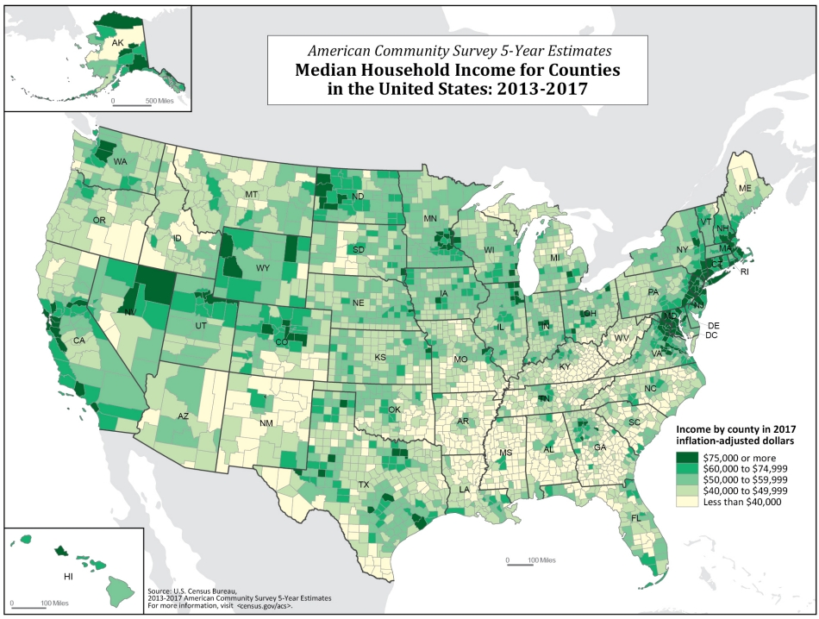
Source: U.S. Census American Community Survey https://www.census.gov/content/dam/Census/library/visualizations/2018/comm/acs-5yr-mhi-all-counties.jpg

https://www.consumerfinance.gov/data-research/hmda/explore
Interactive maps are available at Mapping Inequality: Redlining in New Deal America https://dsl.richmond.edu/panorama/redlining/#loc=4/36.71/-96.93&opacity=0.8 ; for descriptions of the project also see Miller, Greg. 2016. “Newly Released Maps Show How Housing Discrimination Happened.” National Geographic https://news.nationalgeographic.com/2016/10/housing-discrimination-redlining-maps/ and Domonoske, Camila. 2016. “Interactive Redlining Map Zooms in on America’s History of Discrimination, National Public Radio (October 19, 2016). https://www.npr.org/sections/thetwo-way/2016/10/19/498536077/interactive-redlining-map-zooms-in-on-americas-history-of-discrimination
Bartlett, R., Morse, A., Stanton, R., Wallace, N. 2018. Consumer-Lending Discrimination in the Era of FinTech. UC Berkeley Public Law Research Paper https://faculty.haas.berkeley.edu/morse/research/papers/discrim.pdf and Turner, M.A., Skidmore, F., Eds. 1999. Mortgage Lending Discrimination: A Review of the Existing Evidence. The Urban Institute. https://www.urban.org/sites/default/files/publication/66151/309090-Mortgage-Lending-Discrimination.PDF
Concumer Financial Protection Bureau. “About HMDA” https://www.consumerfinance.gov/data-research/hmda/
Consumer Financial Protection Bureau. https://www.consumerfinance.gov/data-research/hmda/explore
https://www.ffiec.gov/hmda/forms.htm
According to the CFPB website, “An MSA is a region with a relatively high population density at its core (usually a single large city) and close economic ties throughout. Larger MSAs are divided into MDs.” https://cfpb.github.io/api/hmda/fields.html

