Exercise 4: Creating Scale Scores and Checking Reliability

Author: Leilani Madrigal
Department of Kinesiology
California State University, Long Beach
Long Beach, CA 90840
Email: Leilani.madrigal@csulb.edu

Note to the Instructor: The data set used in this exercise (Sport Injury and Anxiety) is data that was collected and put together for the purpose of this exercise module. This exercise uses COMPUTE VARIABLE, RECODE INTO DIFFERENT VARIABLE, and RELIABILITY ANALYSIS to check accuracy and reliability of created scale scores. A good reference on using SPSS is SPSS for Windows Version 23.0 A Basic Tutorial by Linda Fiddler, John Korey, Edward Nelson (Editor), and Elizabeth Nelson. You have permission to use this exercise and to revise it to fit your needs. Please send a copy of any revision to the author. Included with this exercise (as separate files) are the SPSS file necessary to carry out the exercise (SPSS file_ex4), the scoring instructions for RSSIQ, TSK, SAS-2 (respective PDF files), answers for the instructor (Exercise 4_answers), and the SPSS output for the exercises (Exercise 4_output). Please contact the author for additional information.

Attached are files for this exercise:
- SPSS file_ex4 (SPSS file)
- Scoring for RSSIQ (PDF)
- Scoring for TSK (PDF)
- Scoring for SAS-2 (PDF)
- Exercise 4_answers (MS word document)
Exercise 4_output (SPSS output file)
Goals of Exercise
The goal of this exercise is to learn to create scale scores for existing measures in datasets. This includes recoded variables that are reversed scored, creating mean or sum scale scores and checking the reliability of those scales.

Creating Scale Scores
Using the SPSS file_ex4.sav, which has data that passed initial checks, it is now time to begin creating the scale scores for the different measures of the data set. In examining the data set, this means a measure score should be created for the RSSIQ: Return Concerns, Renewed Perspective, TSK: Total Score, and SAS-2 (somatic anxiety, worry, concentration disruption). Furthermore, it is important that students first obtain how measures are calculated and scored prior to collecting data. For instance, the SAS-2 (sport anxiety scale) calculates a total score but you can also obtain subscale scores for somatic anxiety, cognitive anxiety, and concentration disruption. The associated items for each are below:
Somatic Anxiety (items SAS2,SAS6, SAS10, SAS12, SAS14)
Worry (items SAS3, SAS5, SAS8, SAS9, SAS11)
Concentration Disruption (Items SAS1, SAS4, SAS7, SAS13, SAS15)

Open up the SPSS file and click on “Transform” “Compute Variable”. Let’s start with creating the subscale of “somatic anxiety” for the SAS-2. In the box labelled “Target Variable” is where you type in the name of the scale you are creating. Type: Somatic_Anxiety. Then under function group, scroll down and click on “Statistical”, then select Mean and click on the ↑ you will then see in the box “Numberic Expression” MEAN (?,?). Now you must select the items of the Somatic Anxiety scale and replace them one at a time in the parentheses. To do this, click on the item, then the arrow to move them to the numeric expression box. Delete the question marks and click over ever item, separating each by a comma. Your final display should look like the picture below:

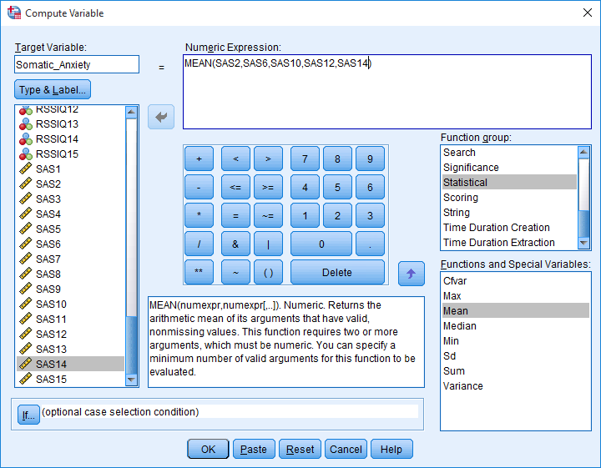

Once all items are entered, then click OK. You will see that the scale score has been calculated by looking at the data set, the variable is now included under “variable view” and you can see the associated values of the scale score under “data view”. It’s important to see how scales are scored, in the example above I used a MEAN score calculation, but for some, you may need to use the SUM function to caluclate the scale score.

Creating Scale Scores with Reverse scored Items.
There will be times where items for scales will need to be reverse scored. An example of this is item TSK4 from the TSK scale (in fact, items TSK4, TSK8, TSK12, and TSK16 all need to be reversed scored). Prior to creating the scale score for TSK, you will need to reverse score items for that scale. When creating the recoded variable, I advocate for creating a different variable to do so. This allows you to maintain the original data of the item as well as the recoded version of that item. To do this, click on “Transform” “Recode into Different Variables”. You would then click on the item that needs to be recoded. Click on “TSK4” and then the arrow to move it to the Input Variable Output variable box. You are then prompted to give the output variable a name and label. For this, only a name is needed. I like to use the same variable name with the addition of a small r to denote that it is the recoded variable. So if the item was original “TSK4” it is now named “TSK4_r”. Then click “change”. Next you will click on “Old and New Variables”. There are several ways you can recoded variables, but for the purpose of using this function to recode reversed scored scale items we will keep it simple. Notice the box for old value and new value. For the TSK scale, this is a 5 point likert-type scale so you would want to follow the steps below to change the old value to the new value. Put 1 in Old Value and 5 in New Value, then click ADD. You will do this for all the 5 points of the likert-type scale. Remember to click “ADD” after each value. Once complete it should look like the box below:

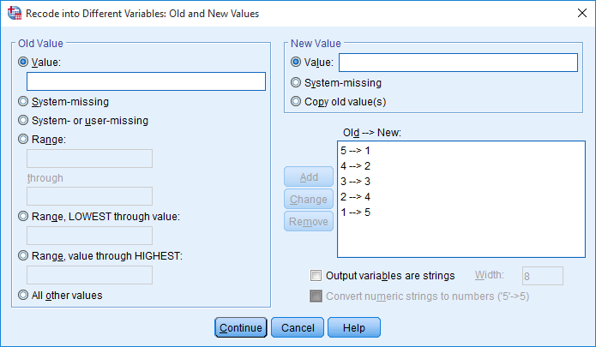

Then click “continue” “ok”.
If there are multiple items that need to be reversed score in the same scale, you can recode all items at the same time. Just make sure you give each variable a name (by denoting a little r after the original name).

You will see the new recoded variables at the end of the variable list under “variable view” as well as associated data in the “data view”.

Then you can create the scale score for the associated scale following the steps as above. Remember when noting which items should be calculated in the scale score that you use the reversed coded items if required.

Exercise 1. Practice creating a scale score for “TSK”. Remember for this scale, the items are TSK1-TSK17. Items 4,8,12,and 16 are reverse scored, so you will need to first recode those items.

Calculating Reliability for Scales.
Beyond creating the scale scores in your dataset, another step is to check the reliability of those scales. This allows us to check the internal consistency of how well those scales are measuring the variables we believe it is measuring. To check reliability, click on “Analyze” “Scale” “Reliability Analysis”. The default is Cronbach’s Alpha, for other reliability assessment types please review Research Methods for the Behavioral Sciences 2nd Edition by Gregory J Privitera. Let’s do “Somatic Anxiety” as an example. First all items associated with Somatic Anxiety should be moved to the box labelled “Items”. In the box “Scale Label” you can type in Somatic Anxiety. Next click on “Statistics”. Main boxes to check under “Descriptives for” are Item, Scale, Scale if Item deleted. Then click “Continue” and “ok”. Below is an example of the output.

Reliability Statistics
Cronbach's Alpha | N of Items
.836 | 5

Item Statistics
 | Mean | Std. Deviation | N
SAS2 | 1.9248 | .83143 | 133
SAS6 | 1.4812 | .82206 | 133
SAS10 | 1.6917 | 1.00137 | 133
SAS12 | 1.4211 | .85467 | 133
SAS14 | 1.4962 | .81300 | 133

Item-Total Statistics
 | Scale Mean if Item Deleted | Scale Variance if Item Deleted | Corrected Item-Total Correlation | Cronbach's Alpha if Item Deleted
SAS2 | 6.0902 | 8.674 | .405 | .861
SAS6 | 6.5338 | 7.493 | .706 | .784
SAS10 | 6.3233 | 6.736 | .695 | .787
SAS12 | 6.5940 | 7.046 | .787 | .760
SAS14 | 6.5188 | 7.858 | .621 | .807

Scale Statistics
Mean | Variance | Std. Deviation | N of Items
8.0150 | 11.348 | 3.36872 | 5

Note that the Cronbach’s alpha = .836 for this scale. In most cases, this value would be enough to report for each scale. A feature I like to look at is the “Item-Total Statistics” box, the very last column is labelled “Cronbach’s alpha if item deleted”, this will indicate how high the alpha would be if you deleted an item. However, by deleting items to established scales you compromise the validity of that scale so I only advice removing items to increase reliability if there is strong theoretical support for doing so.

Your turn to practice
Exercise 2:
- Calculate the scale scores for; Renewed Perspectives and Return Concerns of the RSSIQ; Total Score for the TSK, and Worry, Concentration Disruption, and Somatic Anxiety of the SAS-2.
  - Use a sum score for TSK, SAS2-somatic, SAS2-worry, and SAS2-concentration disruption.
  - Use a mean score for RSSIQ Renewed Perspectives and Return Concerns
- Calculate the descriptive statistics (Mean, Standard Deviation) for the new scales you created
- Calculate the reliabilities for each scale. Remember for this step, you do not use the scale you created, but the items associated with that scale.

Create a table with the information you found below:

Scale | Mean | Standard Deviation | Cronbach’s Alpha
RSSIQ –renewed perspective

RSSIQ – return concern

TSK –total score

SAS2- somatic

SAS2- worry

SAS2- concentration disruption

