Exercise 2: Setting up an SPSS file

Author: Leilani Madrigal
Department of Kinesiology
California State University, Long Beach
Long Beach, CA 90840
Email: Leilani.madrigal@csulb.edu

Note to the Instructor: The data set used in this exercise (Sport Injury and Anxiety) is data that was collected and put together for the purpose of this exercise module. This exercise uses CREATING VARIABLES, as well as assigning VALUES, and coding MISSING DATA. MEANS. A good reference on using SPSS is SPSS for Windows Version 23.0 A Basic Tutorial by Linda Fiddler, John Korey, Edward Nelson (Editor), and Elizabeth Nelson. You have permission to use this exercise and to revise it to fit your needs. Please send a copy of any revision to the author. Included with this exercise (as separate files) are the cleaned excel file to carry out the exercise (Clean Excel File), the online questionnaire to assist with completing the exercises (Online Questionnaire PDF), and the completed SPSS file to use as a review at the end of this exercise (SPSS file_data). Please contact the author for additional information.

Attached are files for this exercise:
- cleaned excel file (excel format)
-Online Questionnaire (PDF)
-completed SPSS file (SPSS_data)

Goals of Exercise
The goal of this exercise is to learn how to set up an SPSS file prior to entering data (online or hard copy data). Specifically students will learn how to create variable names, add associated values, and code for missing data.

Creating an SPSS file and adding in variable names
Prior to entering data into SPSS, you must first set up the file. When first opening SPSS, you will indicate that you will be creating a “new data set”. On the opening screen you will see a blank untitled screen similar to the picture below.
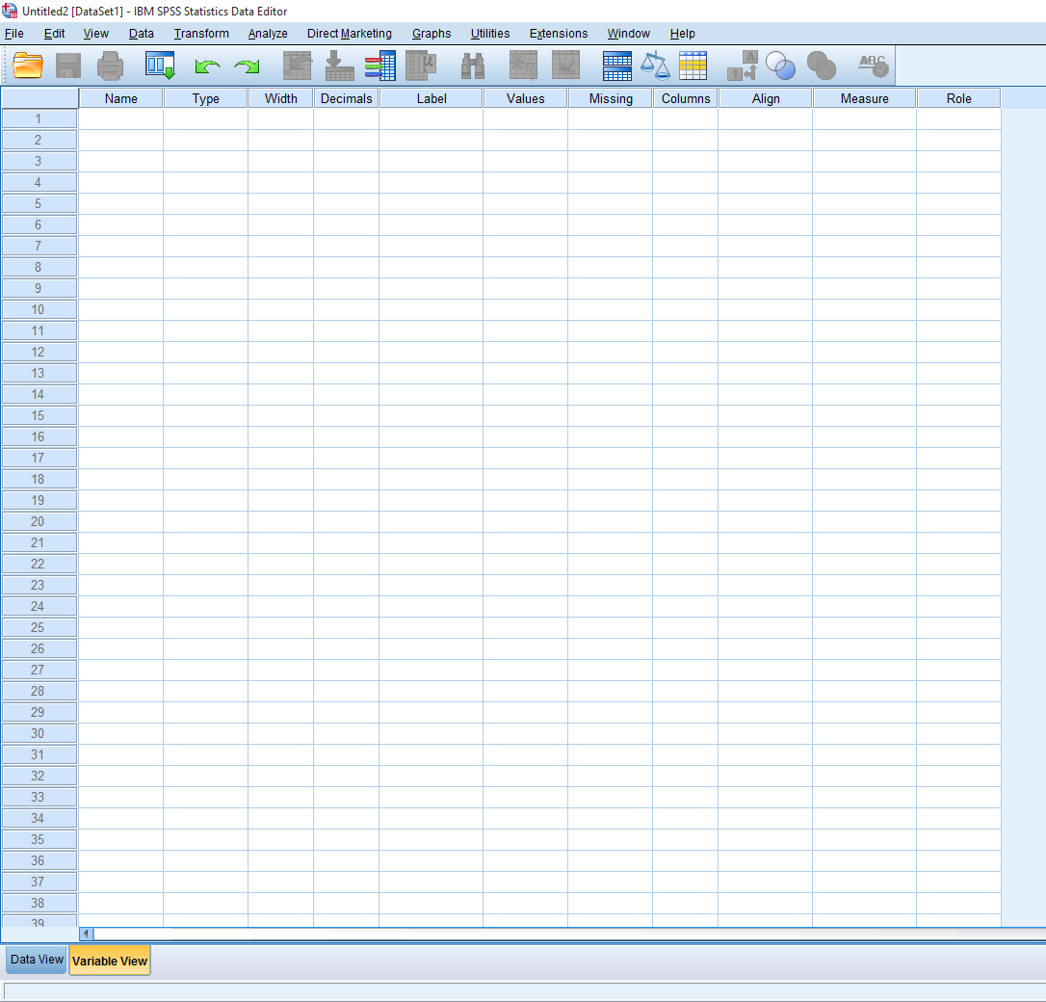

Notice at the bottom of the screen there is a “Data View” and “Variable View”, click the Variable View button. Once on the Variable View Screen you will notice several columns beginning with “name”. Using the codebook tab on clean excel file, try typing in the demographic variable names for #1-5.

Did you get any error messages when trying? If so, that is expected. SPSS does not like certain things when naming variables such as always begin with a letter, all variable names must be unique; duplicates are not allowed, and do not use spaces between variable names. Variable names are not sensitive to upper or lower case. So if you have a variable on your survey that is the “class status” in which participants response with their current class status of freshman, sophomore, junior or senior, you may call that “sch_stat” in the variable name. You are limited to character usage in the variable name column, but you can expand what that abbreviation means in the “label” column. It is a good rule of practice to fully write out the label for each variable. Oftentimes when I abbreviate scales, (e.g., LOT1) I do not remember the exact wording of that item. It is helpful to have that item fully written out in the label for each variable in the entire data set. It may seem like tedious work now, but this additional work DOES HELP later.

Exercise 1: Input the variables names for #1-5 of the data collection online survey, make sure you fully write out each of their descriptions in the label column.

Creating an SPSS file, adding associated values
So you may have noticed this when you first tried creating a variable, but the moment you finished naming the variable, the rest of the columns auto populated. This module will only focus on variable names, labels, values, and missing columns. For a review on columns of: type, width, decimals, measure, role, please use SPSS for Windows Version 23.0 A Basic Tutorial. Now that your first 5 variable names and values have been entered, some of those variables require an additional step of adding in values. Can you identify which variables those may be? Let’s take the school status variable as an example. If someone indicates a sophomore, SPSS needs a numerical value associated with that variable (if you plan to calculate %, frequencies or some other descriptive statistic). So looking at the online questionnaire, we know participants only had 4 options to choose for school status: freshman, sophomore, junior, and senior. We now let SPSS know values associated with those choices. For ease in clarity, it makes sense to indicate 1= freshman, 2= sophomore, 3= junior, and 4= senior. For school status, look on the values column and click on the upper right corner (shown by a small grayed box (…). Click on that box and a new dialog box will open which will allow you to create value labels. See box below for example of first value. It is important that you click on “add” after each value has been assigned. Once all values are added you can then click “ok” to exit.

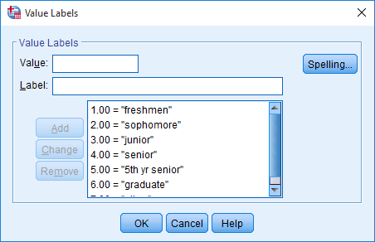

Exercise 2: Add in the associated values for # 2, 3, 4, 5 of the data collection online survey.

Have you been saving your work? This is a vital step that should be done periodically when you are setting up your SPSS file (or entering data later on). Click on File, Save AS, and make sure you save the file in a location you can find. For ease, I typically save it either on my desktop or associated thumbdrive or folder of a location I know how to find.

Creating an SPSS file, missing values.
Just as you did in the last exercise (Exercise 1: Exporting Data from Online Platforms), you replaced any missing data with a code of 999. You must now tell SPSS that this value indicates missing data. For each variable you create, you will need to follow this step. Under “missing”, click on the “…” box in the upper right hand corner. This will prompt a dialogue box to open. Under discrete missing values, enter 999 in the first box, then click “ok”. You will notice under missing the value 999 appear. Do that for each value you create.

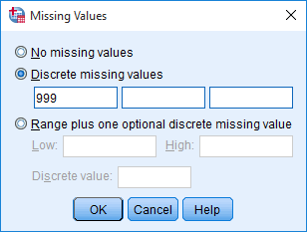

Exercise 3: Go through and finish entering all the variables from the online questionnaire, make sure you type out each label and assign any values that they may need. Make sure to indicate the missing values for each variable. Remember to save your work periodically. This SPSS file you created will be used in the next exercise.

Transferring Data from excel file to the SPSS file.
Now that you have created the SPSS file, you can now transfer the data from your excel file (use Clean Excel File). You can copy and paste the entire data set from the excel file (just highlighting the values) and paste it onto the “data view’ of your SPSS file. However, to reduce the chance of error, I suggest copying and pasting 1-4 columns of data at a time and checking to make sure everything matches up. Sometimes it is easy to scroll down on an excel file and realize you didn’t copy the first 50 responses for a set of variables, so take your time and copy and paste the date into your SPSS file.

