Background Information:

Process Tracing is a research method in which researchers act as “detectives” by looking at as much evidence as they can find to understand a causal process. Process tracing involves studying each step in a causal chain to identify plausible hypotheses while simultaneously ruling out other explanations.

There are three main goals in process tracing:
(1) To richly describe a phenomenon, including the sequence of events that lead to it.
(2) To rule out as many rival/ alternative theories as possible.
(3) To test a primary hypothesis along each step in the causal path to see if it holds up to the evidence.

Importantly, not all evidence is equally compelling. While there are many ways to describe the usefulness of evidence (see Table 1 Collier, D. (2011). Understanding process tracing. PS: Political Science & Politics, 44(4), 823-830), it is useful to think of evidence as combinations of either Necessary/Unnecessary and Sufficient/Insufficient conditions.

A necessary condition is a condition that must be present for something to happen, but is not enough to make that thing happen. Evidence that is a necessary condition means that if your hypothesis is accurate, at the very least we must observe X piece of evidence, but X evidence alone is not enough for us to know our hypothesis is accurate.

A sufficient condition is a condition that is sufficient (“enough”) to produce some event. A sufficient condition means that observing Y piece of evidence is enough for us to know that our hypothesis is accurate.

Activity:
This activity is adapted from Collier, D. (2011). Understanding process tracing. PS: Political Science & Politics, 44(4), 823-830).

Students will need to access a copy of Arthur Conan Doyle’s “Silver Blaze” (https://sherlock-holm.es/stories/pdf/a4/1-sided/silv.pdf).

Answer the questions below as you read through the “Silver Blaze” story.

FYI:
This neck decoration is a cravat: This is wax vesta (a match):
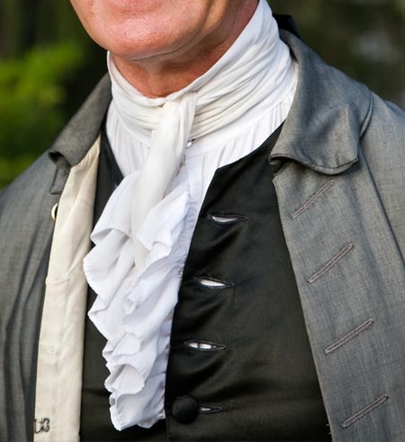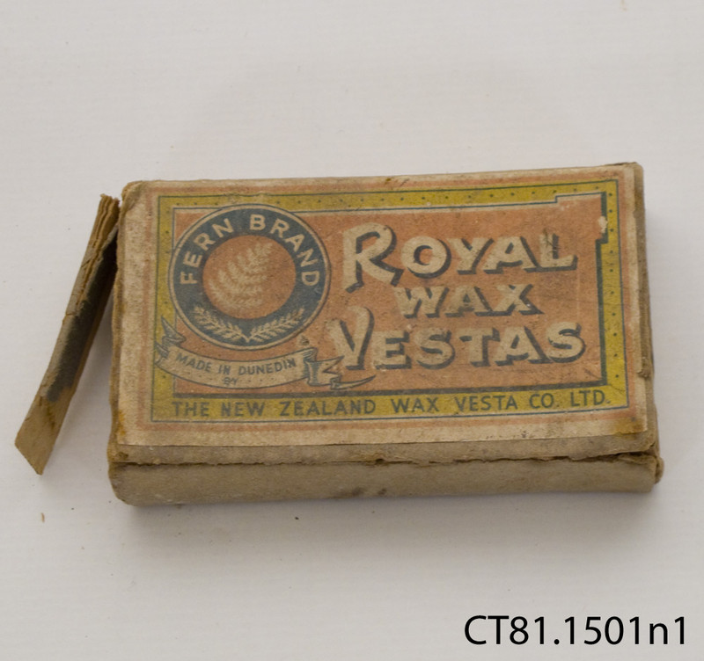

And a milliner is a hat maker.

- Read the first paragraph, what are the main questions Sherlock Holmes wants to answer?

- Read through the first column on page four. Record a preliminary timeline of relevant events that Sherlock knows before he begins his “field work” (that is, the details of the story he explains to Watson while on the trip to Dartmoore).

- Based on the timeline above, what kind of evidence would Sherlock need to find to solve the crime of who killed the Starker? How might he get this evidence?

- Fitzroy is the first suspect for the murder of Starker.

Below is the evidence against Fitzroy. For each piece of evidence, determine whether the evidence is necessary for the hypothesis to be true and whether the evidence is sufficient for the hypothesis to be true. That is, each piece of evidence can be:
  - Not necessary and not sufficient
  - Necessary but not sufficient
  - Not necessary but sufficient
  - Necessary and sufficient

Evidence suggesting Fitzroy is Guilty | Necessary? Sufficient?
Fitzroy was seen at the stable before the horse disappeared
Fitzroy was out in the storm at the same time the murder occurred
Fitzroy’s bets benefit from Silver Blaze losing
Starker is holding Fitzroy’s cravat

- At this point, do you think we have sufficient evidence to convict Fitzroy? Why or why not?

- Can you think of a piece of evidence that would be sufficient to convict Fitzroy?

- Read until the end of the story. Below are a few pieces of evidence inconsistent with (or seemingly unrelated to) the hypothesis that Fitzroy killed Straker. For each piece of evidence, list potential alternative explanations for the death of Straker.

Evidence inconsistent/unrelated to Fitzroy | Alternative explanations
Fitzroy does not have a knife wound from Straker’s knife
The dog didn’t bark to wake up the stable boys when Silver Blaze was taken out
The horse wanders to the neighboring stable
The stew served for dinner was one of the few foods that could hide the taste of the opium

- Holmes solves the murder! Map out the sequence of events (the causal path) showing how/why Straker tried to throw the race and was killed.

- For each step in the causal path, list the evidence Holmes finds that supports the hypothesis that Straker wanted to cheat and was kicked by the horse.

Application to your individual projects:

- Re-draw the causal/theoretical path model for your project from module 3.

- At each step in the path, what evidence would you need to show support for your argument?

- Describe at least one alternative explanation. What evidence would refute that explanation? And, what evidence would provide support for that explanation?

Take turns sharing (and improving upon!) your answers with your group.

