“For the social philosopher, for the social scientist, words are not ``mere’;
they are the tools of his trade and a vital part of his subject matter.”
-Hanna Pitkin, The Concept of Representation (p1)

Background Information: Abstract ideas, or concepts, such as democracy, power, identity, representation, trust, community, or conflict, are central to social science research. Defining what these concepts mean and where/when/how they apply – a process called conceptualizing – is an important early step in the research process.

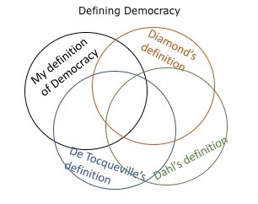

Importantly, one term – democracy, for example – can mean different things to different scholars (see figure to the left). To avoid ambiguity, scholars must define key concepts precisely so their readers know which version of the term they are using. If concepts are poorly defined, then readers may struggle to follow the logic of a theoretical argument and research project.

Conceptualizing requires making observations about the world and reading what other scholars say about the same concepts. Often, someone else will have already defined a concept a way that we find compelling. It is totally acceptable to use another scholar’s definition of a concept in our projects, so long as we accurately cite and attribute their definition. If scholars have not defined a concept for us – or, more likely, many have defined the concept slightly differently – we must do the creative work of deciding which existing or new definition of the concept is best for our projects.

If you find that other scholars define a concept in a way that is substantially different than how you want to define it, consider adding a qualifier. For example, if you want to study how people participate in making decisions in small, informal settings, you might use the term “informal democracy” rather than “democracy” to avoid conceptual stretching (making the definition of a concept so broad that it loses its usefulness).

While there is no best way to conceptualize, there are a set of questions one can work through to facilitate the process. The left column of Table 1on the next page lists the suggested questions/steps to consider when conceptualizing. The right column applies these steps to the concept of democracy. Of course, there are myriad ways to conceptualize democracy; this is just one example. With conceptualizing, only rarely are there clear right and wrong answers. Instead, conceptualizing is a process of defining a concept in a way that is useful and meaningful for your project.

Steps | Applied to Democracy
Step 1: How have other scholars defined this process? Do they generally agree? If not, why? | Yes, many people have defined democracy. Some focus solely on procedures (are there elections and turnover of power) while others focus freedoms (i.e, freedom of the press, civil society, political participation, etc.)
Step 2: Are there dimensions to the concept? How many? What are they? | I like thinking about both procedures and outcomes, so I will have a two-dimensional concept. The first dimension is participatory procedures, the second dimension is political freedom.
Step 3: What are the positive and negative poles of each of my dimensions (that is the high and low limits. | For participatory procedures, the positive pole is direct participation on all public decisions. The negative pole is the absence of participatory procedures (no voting, no representatives to talk to, etc).  For Freedom, the positive pole is the presence of rich freedoms of speech/ press/ thought/ participation. The negative poles are no individual political freedoms.
Step 4: What is the structure of the dimensions: continuous, categorical? | I think both dimensions are continuous—there can be variation in the degree to which a country possesses participatory procedures and political freedoms.
Step 5: Can I map out and draw my concept? Or, can I create a typology of the concept? | 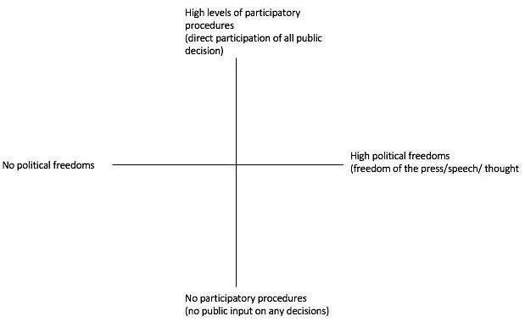
Step 6: What are the boundaries of my concept? | 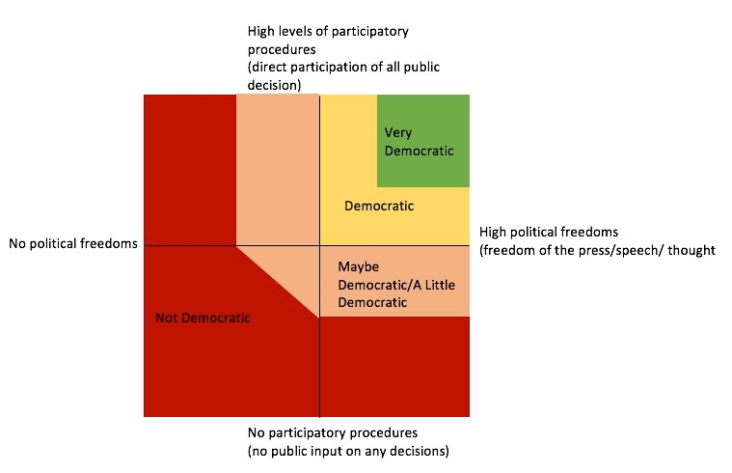

Group Activity Instructions: Get into groups of 3 or 4. The instructor will randomly assign a concept to your group. Using your combined knowledge (and google), work through the steps 1-7 below before attempting to conceptualize a concept on your own.

- Before speaking with other members of your group, jot down what you think this concept means below.

Share your definition with the group.

- As a group, do a quick google to see how others (the dictionary and/or researchers) have defined the concept. Jot down their definitions below.

- As a group, decide whether your concept should be unidimensional (one dimension) or multi-dimensional (usually two, but you can try three if you’re feeling ambitious). What are the dimensions?

- What are the positive and negative poles of your dimensions? Describe them below.

- Are the dimensions continuous (along a spectrum), binary (yes or no/ present or absent), or ordinal (none, some, a lot)?

Why did you decide to structure your dimensions this way?

- As a group, map out and label the dimensions of your concept below. See step 5 for an example.

- A one-dimensional concept is often a straight line; two-dimensions is usually a plot with an x and y axis. If you have 3 + dimensions, you get to be creative!)

- Think about the boundaries (or types) of your concept. That is, decide at what point in the plot above your concept goes from present to absent. (See Step 6 for an example.) Draw these boundaries on your plot above.

When your group has settled on a depiction of your concept, select one member to draw the concept on the board.
YOUR PROJECTS:
Answer the questions below about your individual projects. Feel free to collaborate with the people around you if you hit a hurdle.

- Thinking of the research question you developed in the last class, list at least three concepts that YOU will address in your paper below.

- Of those concepts listed above, choose the one that is the murkiest? What is your best guess at a definition of this concept?

- Do a quick google search. How does the dictionary and/or other researchers define this concept?

- What are the dimensions to your concept?

- What are the positive and negative poles of your dimensions?

- Are your dimensions dichotomous or continuous? Why?

- Map out and label the dimensions of your concept below.

- Think about the boundaries (or types) of your concept. That is, decide at what point in the plot above your concept goes from present to absent. (See Step 6 for an example.) Draw these boundaries on your plot above.

- Turn to a partner and describe your concept and conceptualization to them.

