Background Information:

A starting place for a research project is picking a topic and then developing a specific research question. A research topic is an interest area within a general subject. Within a given topic, there are myriad potential research questions that scholars seek to answer within one research project.

So, for example, within the subject of political science, many people conduct research on the topic of judicial institutions. Within the topic of judicial institutions, one scholar may pose the motivating research question: To what extent do judicial selection procedures affect which types of judges are selected to state courts? Often as students/scholars engage existing scholarly literature, they continue to narrow and refine their research questions. For example, a student may refine the above question into: How does the “merit selection” process for state supreme courts judges facilitate or impede the selection of women judges? While it is nice to pick one research question and stick with it, updating questions as we learn more information is a very common – and good! – thing to do.

There are four key features of a research question:
- The scholarly community doesn’t already know the answer. Or, at least, there is some uncertainty about the answer.
  - “Uncertainty” can take many forms: for example, maybe we do not know if an established pattern holds in a new context or with updated data. Questioning whether an established pattern holds in a different context is a nice way to begin a research project.
- The question must be empirically testable and it must be falsifiable, which means that data exists (or will exist after we collect it) that can test our question and refute it.
- The question must be narrow enough to be answered within the scope of the project.
  - That is, we don’t want to ask a research question that would require a book length analysis to be answered for a term paper project.
- A good research question is not simply a yes or no question, but asks why, when, under what conditions, or how some phenomena occurs.

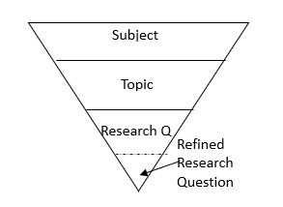

NAME:
Group Activity. Each student gets a copy of this packet, and students need to get into groups of 4 (or 5)

- Take a moment to jot down at least three subjects (or, even better, topics) you may be interested in researching.

- After you’ve written down three subjects or topics above, circle the subject/topic you like the most and fill that subject/topic into the center bubble of the concept map below. The more specific your center bubble subject/topic, the more useful the rest of the brainstorming might be.

Then, brainstorm THREE topics/subtopics that are narrower than your starting subject/topic. Leave two of the concept map arms blank.
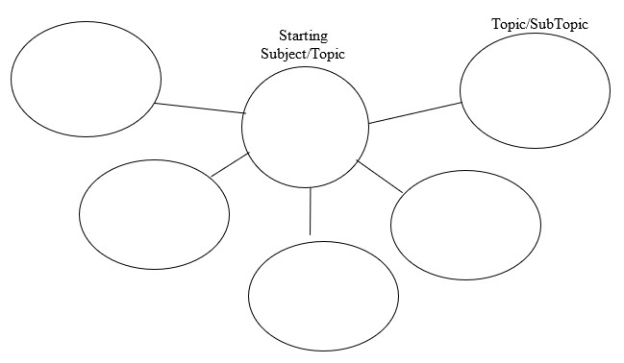

Everyone in the group share your starting topic and subtopics with the group. Then, pass your paper to your right.

Partner’s name: _________________

- Partner: add ONE topic/subtopic to the concept map above. Jot down why you added that topic in the space below and describe this addition to the paper’s owner.

Then, pass this paper to your right (so two people from the original owner of the paper.)
New partner’s name: ____________________

- Partner: add ONE Topic to the concept map above. Jot down why you added that topic in the space below and describe this addition to the paper’s owner.

Pass papers back to the original owner.
- Consider the additions from your group-mates. Write down your favorite topic/subtopic from the concept map below. Describe why this is your favorite.

- Write down THREE potential research questions (a-c) related to the subtopic you selected in step 5 below. Leave spots d and e blank.

a.

b.

c.

d.

e.

Pass papers to the left.
New Partner’s name:___________________

- Look at the topic in section 5, above. Think of a research question related to this topic (that isn’t already recorded in a, b, c of section 6). Record your question in space “d” above.

Pass papers to the left again (two people to the left of the original owner)
New Partner’s name: __________

- Look at the topic in section 5, above. Think of a question related to this topic (that isn’t already recorded in a, b, c of section 6). Record your question in space “e” above.

Pass papers to the left again (three from owner)
New Partner’s name: __________

- Put an * next to the question in section 6 you think is most interesting. Briefly describe why you think that question is most interesting in the space below.

Pass papers back to the original owner.

- Look at questions a - e under section 6 on the previous page. Re-write your favorite question below.

Pass papers to the right.
New partner’s name: _______________

- What are two ways in which you could narrow this question? (Think of refining who/when/where the question applies)

Pass this packet back to its owner.
For the rest of the class, answer these questions.

- Refining your question requires some knowledge about the subject that you may or may not know already, so….. Google (regular google, not google scholar) the question. Skim several articles…Are news outlets, blogs, or other webpages talking about this question? What do they say about it?

- Use Google Scholar to look up your research question (try a few different ways of organizing words)…

-Are there lots of articles? Do the titles seem relevant to the question you identified?

-Write down two (or more) article names below that seem the most relevant, skim the articles and briefly summarize the main idea.

- Of what you’ve read today, has anyone proposed an answer that you find persuasive? If so, what is it? If not, why are you not persuaded?

- Do you think the questions you asked today would make a good research question? Why or why not

